Environmental conditions dictate the long-term photosynthetic and developmental response of lettuce to cold plasma priming: Supplementary material

Fig. 1S. Chlorophyll fluorescence parameters:
Detailed analysis of chlorophyll fluorescence parameters. (a) F₀, (b) F_{m}, (c) F_{v}/F_{m}, (d) Ψ₀ and (e) ΦE₀ in greenhouse and phytotron environments. Different letters indicate statistically significant differences between treatments within each environment and time point (α = 0.05; Kruskal–Wallis test followed by pairwise Wilcoxon test with FDR correction).
The horizontal lines represent medians, boxes indicate the 25th and 75th percentiles, and whiskers represent the 10th and 90th percentiles.

a
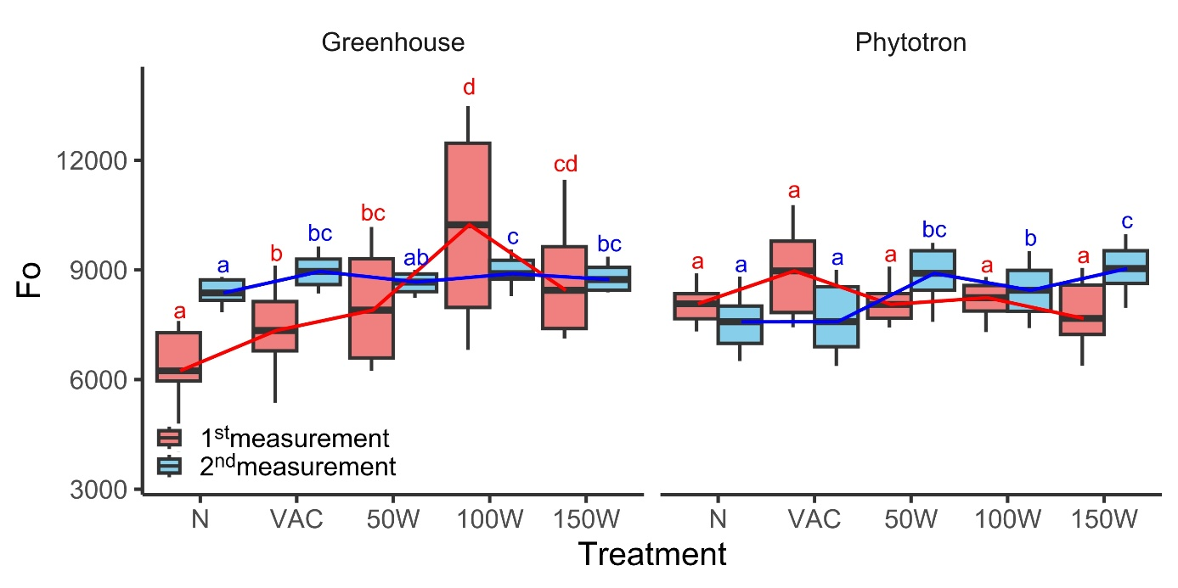
b
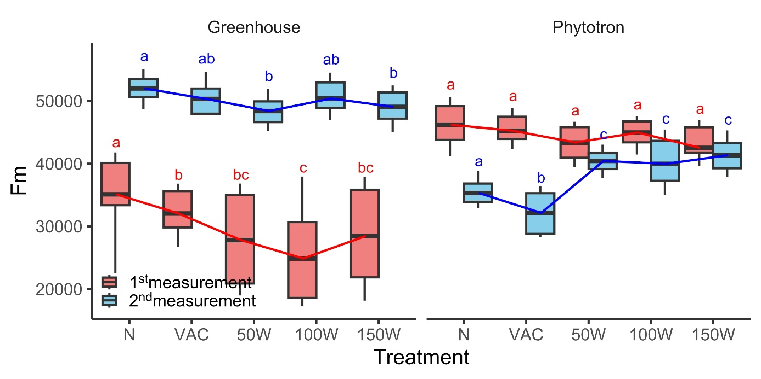
c
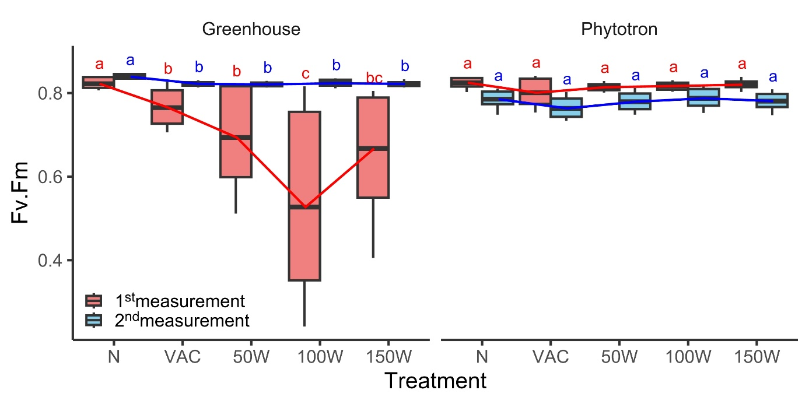
d
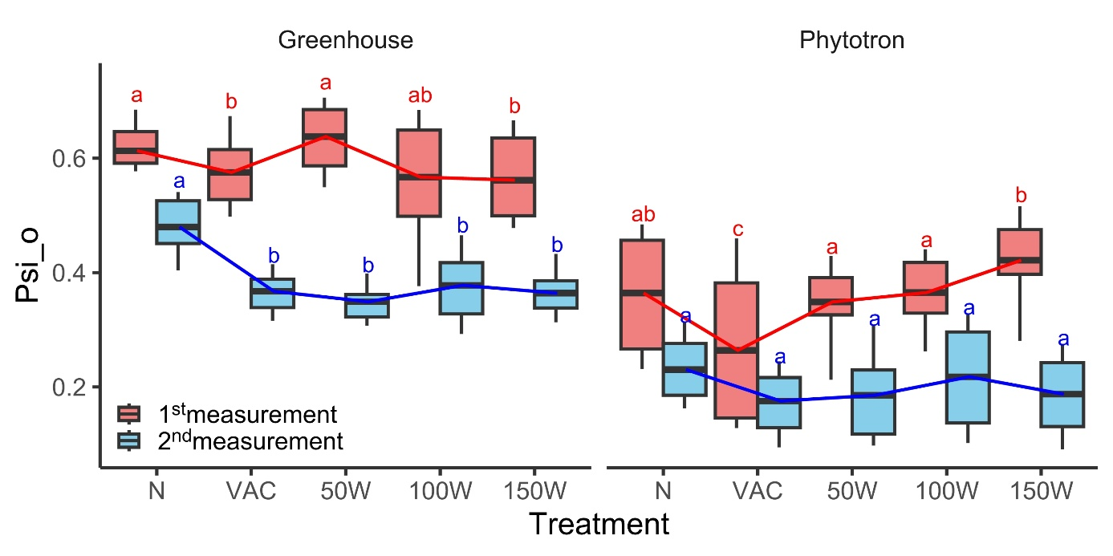
e
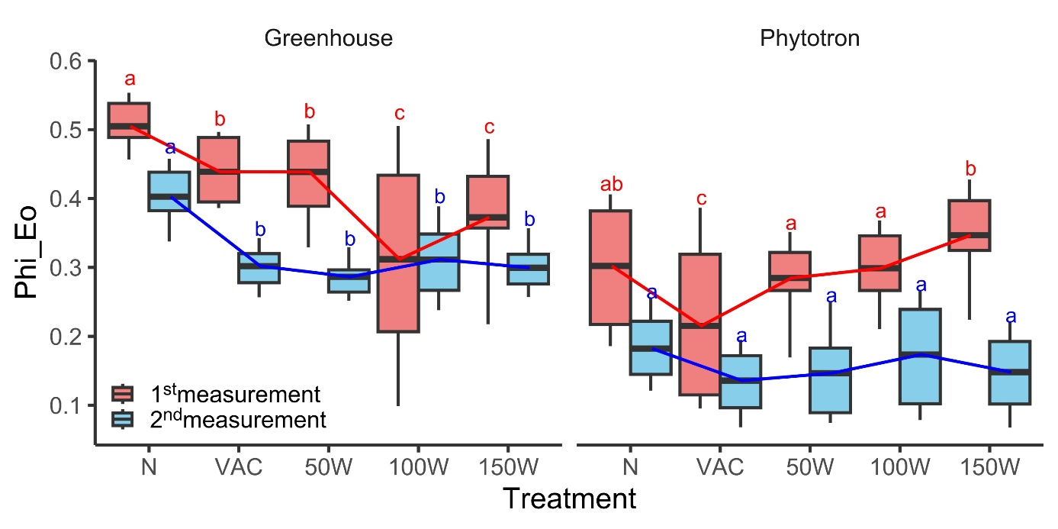
Fig. 2S. Reflectance indices measured in greenhouse and phytotron environments.
Reflectance indices: (a) NDVI, (b) MCARI, (c) CRI1, and (d) CRI2 in greenhouse and phytotron environments. Statistical differences between treatments were evaluated using the Kruskal–Wallis test followed by a pairwise Wilcoxon test with FDR correction. Significant differences (α = 0.05) are indicated by different letters. Horizontal lines represent medians, boxes indicate the 25th and 75th percentiles, and whiskers represent the 10th and 90th percentiles.

a
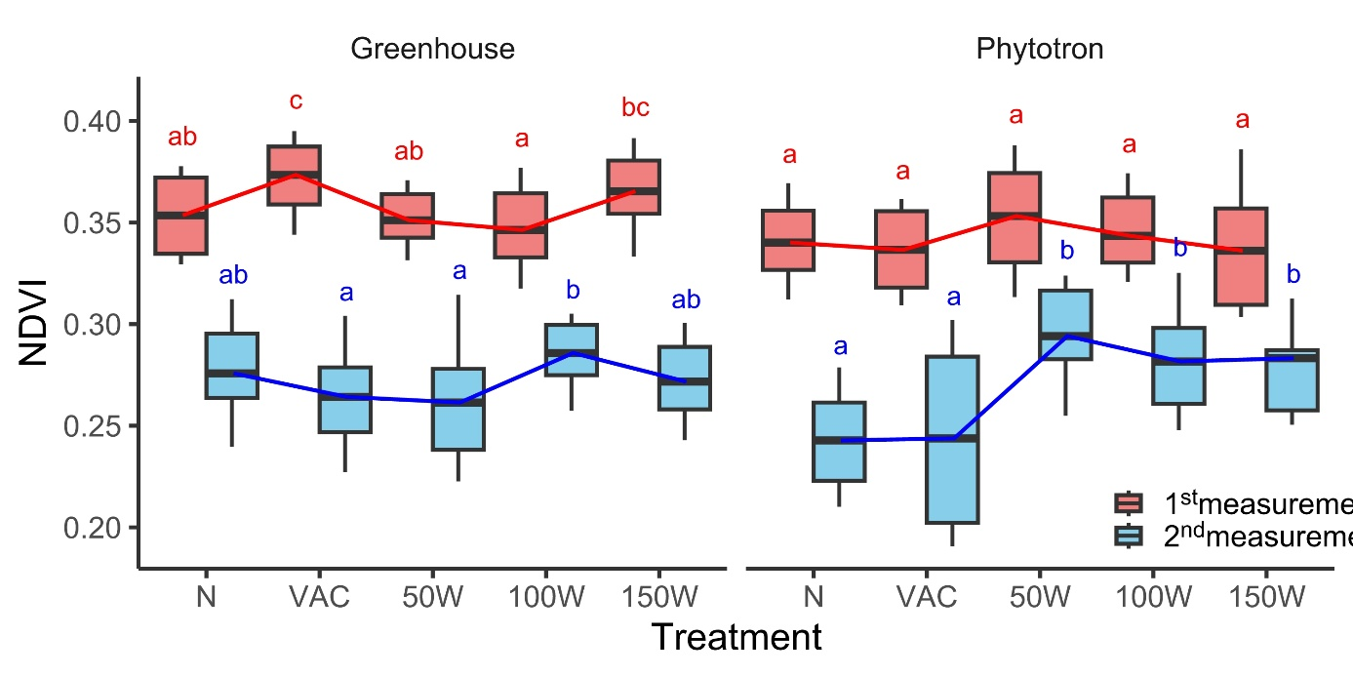
b
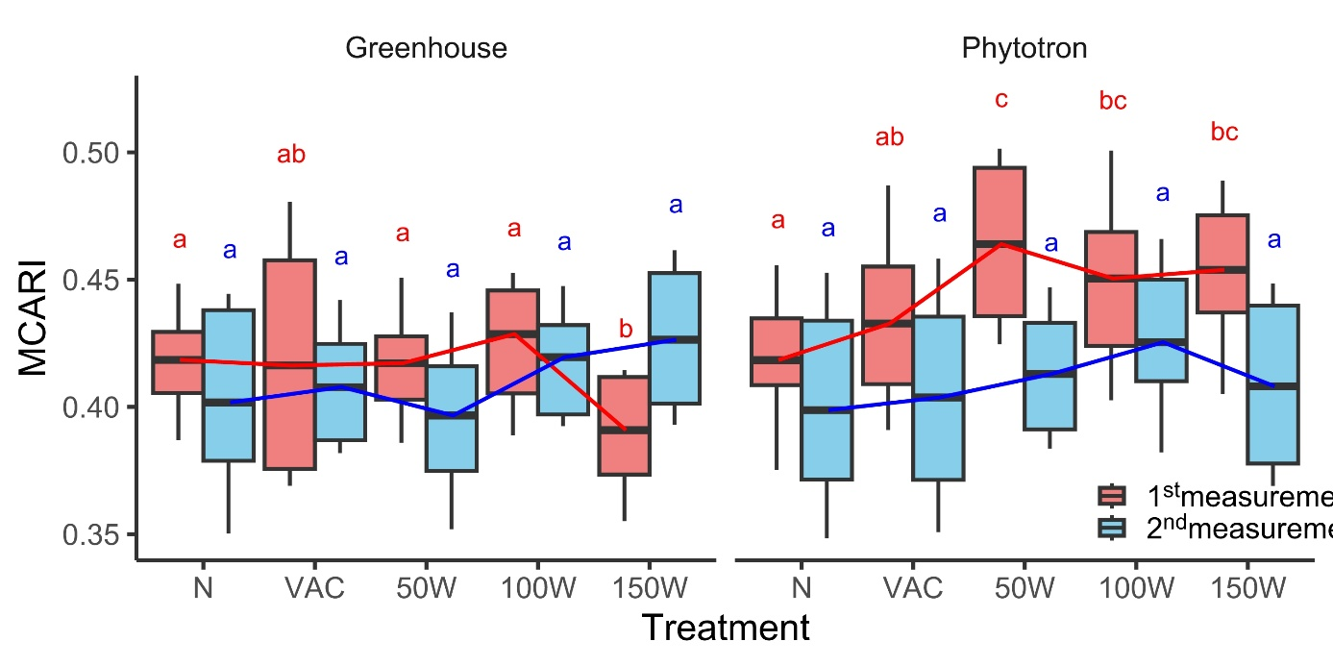

c
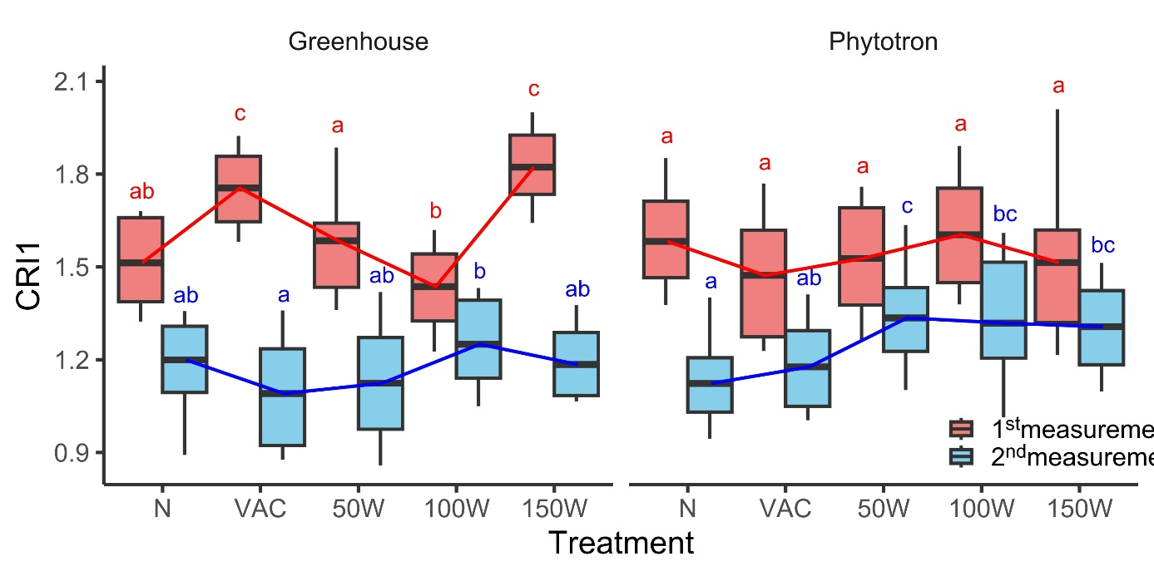
d
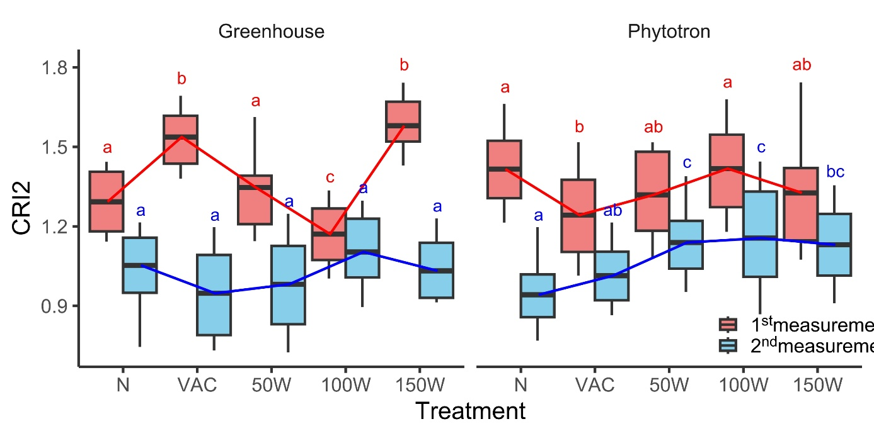
Fig. 3S. Statistical evaluation of chlorophyll fluorescence parameters Vj and Vi in lettuce plants grown under greenhouse and phytotron conditions.
The table summarizes mean values of Vj and Vi together with statistical comparisons against the untreated control (N). Statistical analyses were performed independently for each environment and measurement using Wilcoxon rank-sum tests followed by Benjamini–Hochberg false discovery rate correction. Asterisks indicate significant differences from the untreated control (FDR-adjusted p < 0.05).
