Supplementary Appendix
Appendix 1. Details of the studied working face
Working face | Size  (m) | Ground elevation  (m) | Ground  level  (m) | Maximum crack width (cm) | Maximum  sink depth (mm)
52302 | 4484×300 | 1162.4-1255.3 | 985.13-1020.99 | 42 | 2833
Coal seam dip angle  (degree) | Topsoil thickness  (m) | Horizontal movement coefficient  — | Sedimentation coefficient  — | Mining rate (m/d) | Mining thickness  (m)
1-3 | 30 | 0.26 | 0.76 | 12 | 7

Table 2. The soil environment factors for the two sample fields
Factors | OM  g kg^{–1} | TN  g kg^{–1} | TP  g kg^{–1} | NN  mg kg^{–1} | AN  mg kg ^{–1} | C:N | C:P | BD  g cm^{–3}
SA | 3.20±0.39 | 0.29±0.03 | 0.20±0.03 | 0.23±0.04 | 0.98±0.03 | 10.72±0.29 | 16.37±1.69 | 1.64±0.41
SA | 3.58±0.12 | 0.32±0.02 | 0.19±0.02 | 1.56±0.34 | 1.15±0.15 | 11.25±0.95 | 19.20±2.85 | 1.59±0.42
SA | 3.93±0.44 | 0.34±0.04 | 0.20±0.02 | 2.97±1.57 | 1.04±0.04 | 11.31±0.24 | 25.11±1.19 | 1.66±0.27
Ave. | 3.57±0.22 | 0.32±0.02 | 0.20±0.03 | 1.59±0.31 | 1.05±0.06 | 11.10±0.45 | 20.22±2.08 | 1.63±0.29
CK | 2.49±0.14 | 0.22±0.01 | 0.21±0.04 | 2.81±0.55 | 0.94±0.02 | 11.45±0.10 | 12.43±1.69 | 1.62±0.21
CK | 2.44±0.14 | 0.22±0.02 | 0.19±0.02 | 1.19±0.49 | 1.95±0.09 | 11.25±0.13 | 19.20±1.91 | 1.60±0.38
CK | 4.96±1.02 | 0.49±0.12 | 0.23±0.04 | 1.72±0.26 | 1.03±0.01 | 10.48±1.36 | 22.29±4.58 | 1.64±0.24
Ave. | 2.96±0.23 | 0.31±0.06 | 0.21±0.03 | 1.90±0.70 | 1.31±0.13 | 11.06±0.58 | 17.97±2.56 | 1.62±0.35
OM, Organic Matter; TN, Total Nitrogen; TP, Total Phosphorus; NN, Nitrate nitrogen; AN, Ammonium Nitrogen; C:N, Total Carbon:Total Nitrogen; C:P, Total Carbon:Total Phosphorus; BD, Bulk Density. Data are mean ± S.D. (n = 3).

Appendix 3. Summary of parameters and formulas used for assessing chlorophyll fluorescence transient.
Fluorescence parameters | Description | Reference
F₀=F_{50μs} | Minimal fluorescence, when all PSII RCs are open | (Strasser, et al. 2004)
F_{m}=F_{P} | Maximal fluorescence at P-step, when PSII RCs are closed | (Strasser, et al. 2004)
F_{v}=F_{m}–F₀ | Maximum variable fluorescence | (Strasser, et al. 2004)
F_{v}/F_{m}=(F_{m}–F₀)/F₀ | Maximal photochemical efficiency of PSII | (Strasser, et al. 2004)
F₀/F_{m} | Thermal dissipation quantum yield | (Ma, et al. 2017)
V_{J}=(F_{2ms}–F₀)/(F_{m}–F₀) | Relative variable fluorescence at J-step (2 ms) | (Strasser, et al. 2004)
V_{K}=(F_{300μs}–F₀)/(F_{m}–F₀) | Relative variable fluorescence at 300 μs (K-band) | (Bussotti 2004)
M₀=4(F_{300μs}–F₀)/(F_{m}–F₀) | Approximated initial slope of the fluorescent transient | (Jedmowski and Brüggemann 2015)
ABS/RC=M₀*(1/V_{J})*[1–(F₀/F_{m})] | Absorption flux per RC | (Strasser, et al. 2002)
TRo/RC=M₀*(1/V_{J}) | Trapping flux leading to Q_{A} reduction per RC | (Qiu, et al. 2012)
ET_{O}/RC=M₀*(1/V_{J})*(1–V_{J}) | Trapping energy used for electron transport per RC | (Strasser, et al. 2004)
DI_{O}/CS | Energy dissipation per unit area | (Strasser, et al. 2004)
DF(abs)=log(PI) | Photosynthetic index | (Strasser, et al. 2004)
PI_{ABS} | Performance index based on absorbed light energy | (Ma, et al. 2017)
ET_{O}/TRo | Probability that a trapped exciton moves an electron into the electron transport chain beyond Q_{A}⁻ (at t=0) | (Ma, et al. 2017)
TRo/ABS | Maximum quantum yield for primary photochemistry (at t=0) | (Ma, et al. 2017)
ET_{O}/ABS | Quantum yield for electron transport (at t=0) | (Ma, et al. 2017)

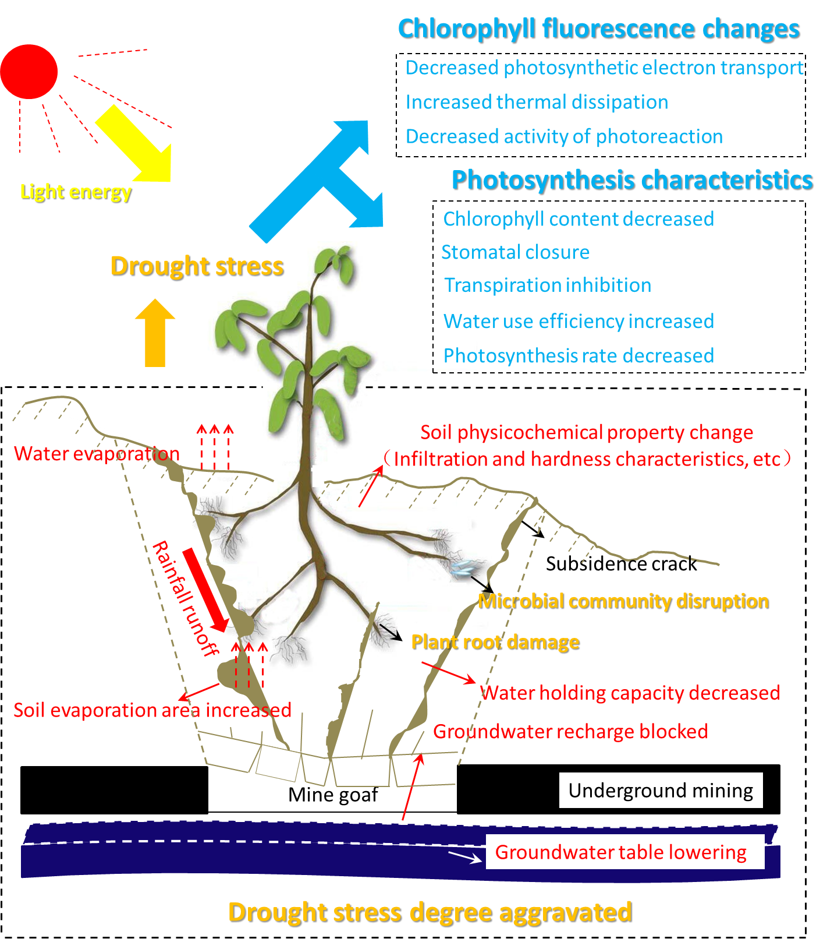
Appendix fig. 1. Mechanism of the effects of mining subsidence on photosynthesis and chlorophyll fluorescence in plant leaves. Surface cracks, caused by coal mining subsidence, lead to the decrease of soil moisture content, and finally lead to drought stress on plant growth.

