Figure S1

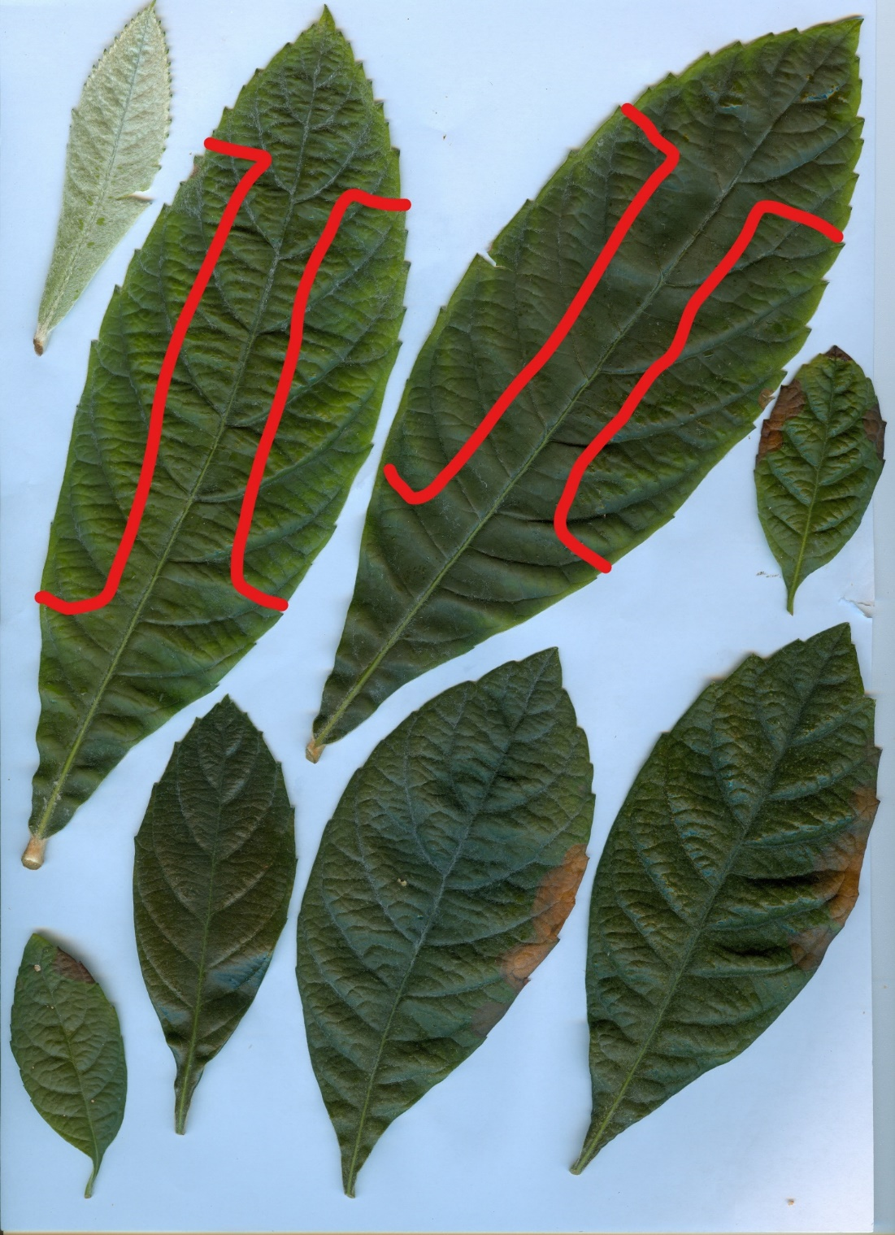
Fig. S1. Leaves of loquat from seedlings hydroponically growth for 42 days with a solution containing 48 mM of NaCl. Red lines delimitate the portion of the leaves (3rd and 4th fully developped) utilized for the biochemical determinations as well as for gas exchange measurements. Basal leaves shown typical symptoms of salt toxicity to the margin of leaf lamina.

