Supplementary information

Legends: Supplementary Tables
Table 1S. Climatic data on the days of measurement of photosynthesis in the irrigated (IR) and rainfed (RF) field conditions in different seasons. Relative humidity (RH), temperature (T) and vapor pressure deficit (VPD)

Legends: SupplementaryFigures
Fig. 1S. Monthly average soil matric potential at 20 cm soil depth in the irrigated and rainfed plots measured during June 2015-May 2016

Table 1S. Climatic data on the days of measurement of photosynthesisin the irrigated (IR) and rainfed (RF) field conditions in differentseasons. Relative humidity (RH), temperature (T) and vapor pressure deficit (VPD)
Seasons | Soil matric potential [kPa] |  | Maximum RH  [%] |  | Average RH  [%] |  | Minimum RH  [%] |  | Maximum T  [°C] |  | Average T  [°C] |  | Minimum T  [°C] |  | Maximum VPD  [kPa] |  | Average  VPD  [kPa] |  | Minimum VPD  [kPa]
Seasons | IR | RF | IR | RF | IR | RF | IR | RF | IR | RF | IR | RF | IR | RF | IR | RF | IR | RF | IR | RF
Rainy | -7 | -22.8 | 97.3 | 99.9 | 83.0 | 90.3 | 55.9 | 69.9 | 33.7 | 33.8 | 27.8 | 28.1 | 22.7 | 24.0 | 2.2 | 2.3 | 1.3 | 1.4 | 0.5 | 0.5
Cool | -18.9 | -52.3 | 73 | 67.0 | 53.0 | 46.5 | 39.2 | 28.7 | 32.0 | 31.9 | 24.7 | 24.5 | 18.7 | 18.3 | 2.9 | 3.5 | 1.7 | 2 | 0.3 | 0.4
Hot | -12.4 | -90.7 | 83.5 | 76.9 | 56.1 | 43.4 | 34.4 | 22.5 | 26.2 | 40.5 | 25.8 | 31.9 | 25.5 | 24.3 | 5.7 | 6.1 | 3.4 | 3.7 | 1.2 | 1.5

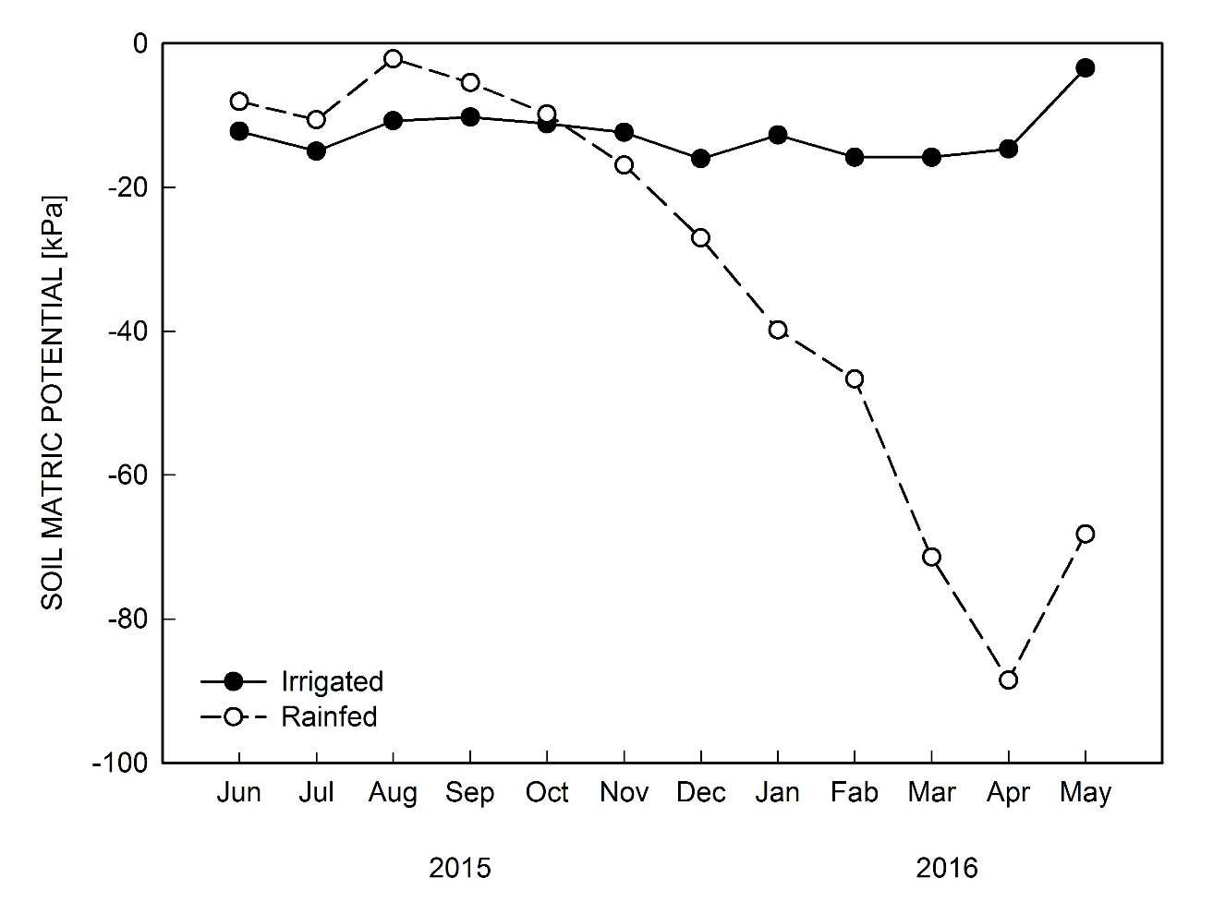
Fig. 1S. Monthly average soil matric potential at 20 cm soil depth in the irrigated and rainfed plots measured during June 2015-May 2016

