Supplement

Physiological changes in winter wheat genotypes due to biotic stress caused by Zymoseptoria tritici

G. MIHAILOVA, Z. STOYANOVA, R. RODEVA, B. BANKINA, G. BIMŠTEINE,
and K. GEORGIEVA

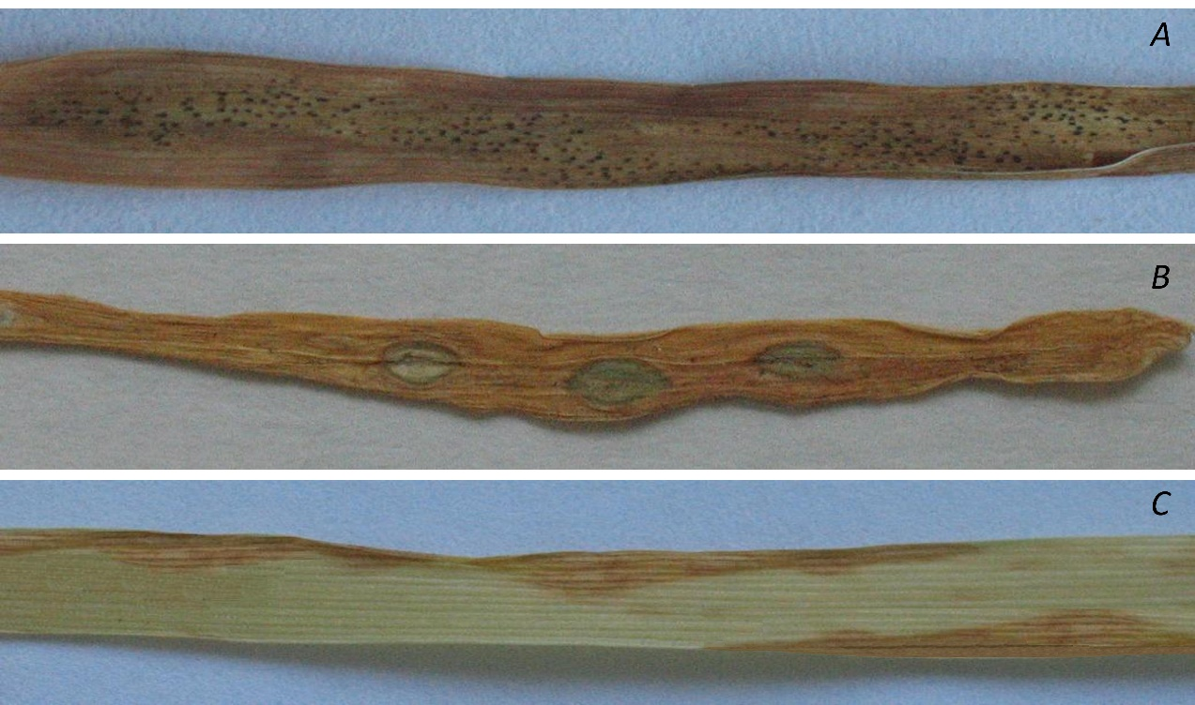

Fig. 1S. Symptoms caused by Zymoseptoria tritici on the second leaf of cultivars with different level of resistance at 23 d post inoculation: (A) highly susceptible (Enola); (B) highly resistant (Arina); and (C) moderately resistant (Milena). The susceptible genotype Enola was completely destroyed and large necrotic areas containing numerous pycnidia were present. Only a few small gray-green elliptic spots without pycnidia were observed on highly resistant cv. Arina. On both moderately resistant wheat genotypes (cv. Milena and line L325) a necrotic area developed mainly on the leaf tip and periphery.

Fig. 2S. Changes in the carotenoid (x+c) content caused by inoculation of winter wheat genotypes Arina (highly resistant), Enola (highly susceptible), Milena, and L325 (moderately resistant) with Zymoseptoria tritici at 0, 2, 17, and 23 days post inoculation. Data represent the mean ± standard error of n = 6; the same letters within a graph indicate no significant differences assessed by Fisher's LSD test (P≤0.05) after performing ANOVA.

Fig. 3S. Effect of inoculation with Zymoseptoria tritici on the maximum quantum efficiency of PSII, estimated by the ratio F_{v}/F_{m}, in wheat genotypes Arina (highly resistant), Enola (highly susceptible), Milena, and L325 (moderately resistant) measured at 0, 2, 17, and 23 days post inoculation. Data represent the mean ± standard error of n = 6; the same letters within a graph indicate no significant differences assessed by Fisher's LSD test (P≤0.05) after performing ANOVA.

Fig. 4S. Changes in the ratio of chlorophyll fluorescence decrease to the steady-state chlorophyll fluorescence, RFd, caused by inoculation of wheat genotypes Arina (highly resistant), Enola (highly susceptible), Milena, and L325 (moderately resistant) with Zymoseptoria tritici at 0, 2, 17, and 23 days post inoculation. Data represent the mean ± standard error of n = 6; the same letters within a graph indicate no significant differences assessed by Fisher's LSD test (P≤0.05) after performing ANOVA.

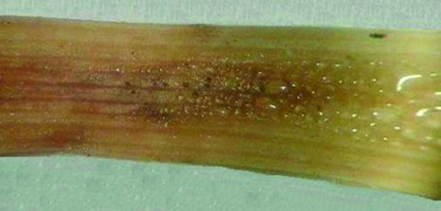

Fig. 5S. Small droplets of water on and around the lesions with melanizing pycnidia on the infected leaf of highly susceptible wheat cultivar Enola at 23 days post inoculation with Zymoseptoria tritici.

Fig. 6S. Effect of inoculation with Zymoseptoria tritici on the relative proportion of the energy absorbed and dissipated as heat in the PSII antennae, 1 − (F_{v}'/F_{m}'),after 0, 2, 17, and 23 days post inoculation of winter wheat genotype Arina (highly resistant), Enola (highly susceptible), Milena, and L325 (moderately resistant). Data represent the mean ± standard error of n = 6; the same letters within a graph indicate no significant differences assessed by Fisher's LSD test (P≤0.05) after performing ANOVA.

