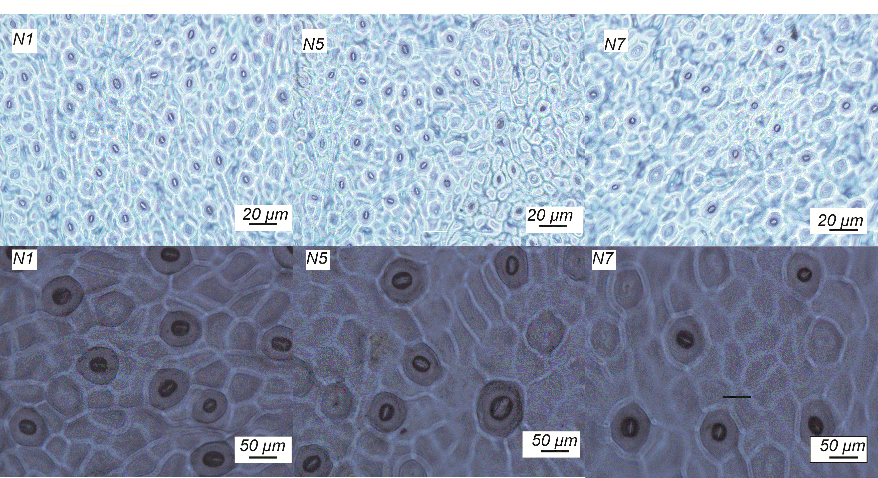
Fig. 1S. Stomatal morphology of ʻHuangguoganʼ citrus plants under different N supplement. N1, N5, and N7 represent N addition rate of 0, 120, and 180 g(N) year^{–1}, respectively.

