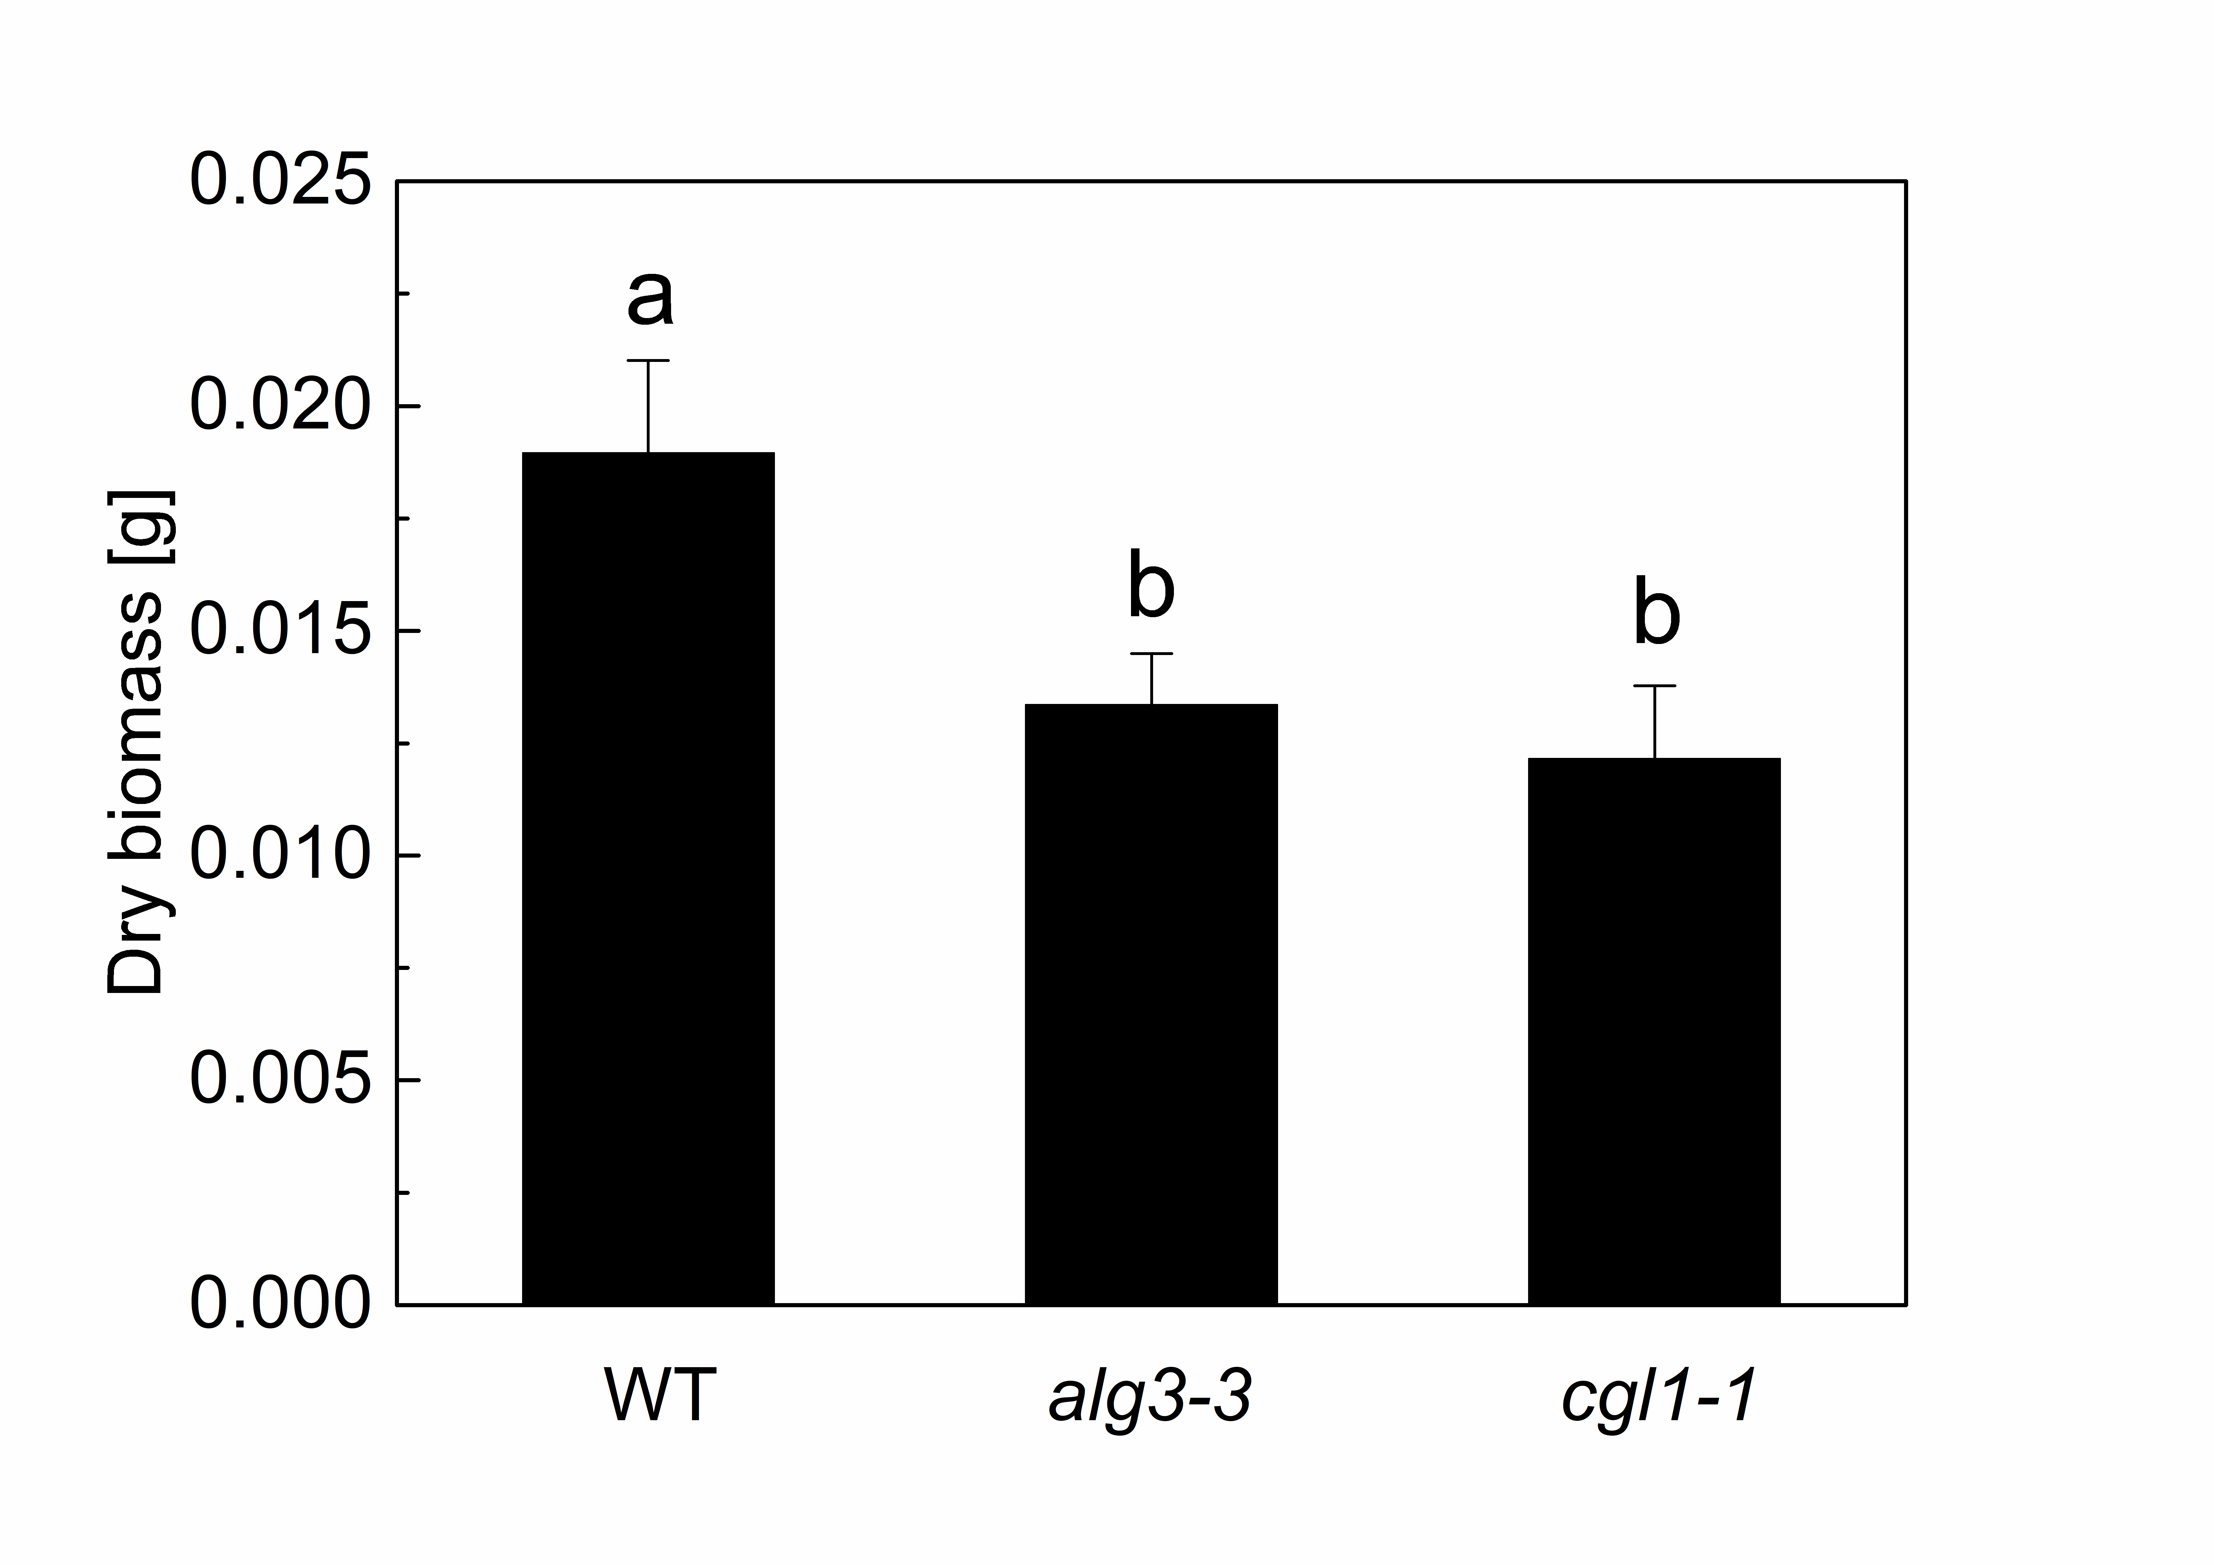

Fig. 1S. Dry biomass of the plants. The data represent the mean ± SD (n = 5). The different letters indicate significant differences assessed by one-way ANOVA multiple comparisons using Tukey's test (P≤0.05).
Fig. 2S. Chlorophyll content of the plant on fresh leaf mass basis. (A) chlorophyll a content, (B) chlorophyll b content, (C) the total chlorophyll content. All the data represent mean ± SD of n = 5; the same letters indicate no significant differences assessed by one-way ANOVA multiple comparisons using Tukey's test (P≤0.05).

