Table 1S. Effect of different treatments on height, stem diameter, leaf number, fresh number, dry weight, and seedling index of two pepper varieties at 20 d after treatment. Each value (mean ± SD) represents the average of three independent experiments of one treatment. Different letters denote statistically significant differences (P<0.05) from other treatments by Duncan's multiple comparison tests. CK (normal temperature and light; 28/18°C and 300 μmol photons m⁻² s⁻¹), L (low light; 28/18°C and 100 μmol m⁻² s⁻¹), and LL (low temperature combined with low light; 15/5°C and 100 μmol m⁻² s⁻¹).

Variety | Treatment | Height  [cm] | Stem diameter [mm] | Leaf number [per plant] | Fresh mass  [g per plant] | Dry mass  [g per plant] | Seedling index  [per plant]
L5 | CK | 20.17 ± 0.17ª | 4.65 ± 0.07ª | 14 ± 0.58ª | 6.27 ± 0.10ª | 1.09 ± 0.06ª | 0.52 ± 0.01ª
L5 | L | 20.67 ± 0.44ª | 3.94 ± 0.08^{b} | 12 ± 1.2^{ab} | 7.09 ± 0.27ª | 0.84 ± 0.03^{b} | 0.38 ± 0.00^{b}
L5 | LL | 18.00 ± 0.40^{b} | 4.14 ± 0.06^{b} | 10 ± 0.33^{b} | 4.42 ± 0.12^{b} | 0.74 ± 0.03^{b} | 0.27 ± 0.02^{c}
H4 | CK | 19.77 ± 0.48^{b} | 4.97 ± 0.03ª | 12 ± 0.88ª | 7.36 ± 0.15^{b} | 0.89 ± 0.06ª | 0.45 ± 0.02ª
H4 | L | 24.07 ± 0.52ª | 4.70 ± 0.26ª | 14 ± 0.88ª | 8.98 ± 0.16ª | 1.01 ± 0.03ª | 0.45 ± 0.01ª
H4 | LL | 20.17 ± 1.39^{b} | 3.84 ± 0.12^{b} | 9 ± 0.58^{b} | 4.73 ± 0.09^{c} | 0.62 ± 0.04^{b} | 0.27 ± 0.03^{b}

Table 2S. Effects of different varieties on fluorescence parameters of pepper seedlings of cultivars L5 and H4 at 20 d after treatment. Each value (mean ± SD) represents the average of three independent experiments of one treatment. Different letters denote statistically significant differences (P<0.05) from other treatments by Duncan's multiple comparison tests. CK (normal temperature and light; 28/18°C and 300 μmol photons m⁻² s⁻¹), L (low light; 28/18°C and 100 μmol m⁻² s⁻¹), and LL (low temperature combined with low light; 15/5°C and 100 μmol m⁻² s⁻¹). F_{v}/F_{m} – maximal photosystem quantum yield; q_{N} – nonphotochemical quenching coefficient; q_{P} – photochemical quenching coefficient; NPQ – nonphotochemical quenching; q_{L} – photochemical quenching.

Variety | Treatment | F_{v}/F_{m} | q_{N} | q_{P} | NPQ | q_{L}
L5 | CK | 0.702 ± 0.003^{b} | 0.748 ± 0.006^{c} | 0.932 ± 0.007ª | 0.365 ± 0.007^{b} | 0.875 ± 0.014ª
L5 | L | 0.739 ± 0.003ª | 0.750 ± 0.004^{b} | 0.705 ± 0.023^{b} | 0.392 ±0 .007^{b} | 0.532 ± 0.028^{b}
L5 | LL | 0.621 ± 0.009^{c} | 0.868 ± 0.009ª | 0.608 ± 0.013^{c} | 0.558 ± 0.020ª | 0.507 ± 0.015^{b}
H4 | CK | 0.681 ± 0.011^{b} | 0.697 ± 0.016^{b} | 0.901 ± 0.007ª | 0.287 ± 0.015^{b} | 0.819 ± 0.015ª
H4 | L | 0.719 ± 0.004ª | 0.731 ± 0.006^{b} | 0.701 ± 0.004^{b} | 0.350 ± 0.009^{b} | 0.531 ± 0.002^{b}
H4 | LL | 0.596 ± 0.006^{c} | 0.899 ± 0.008ª | 0.634 ± 0.031^{c} | 0.657 ± 0.038ª | 0.552 ± 0.036^{b}

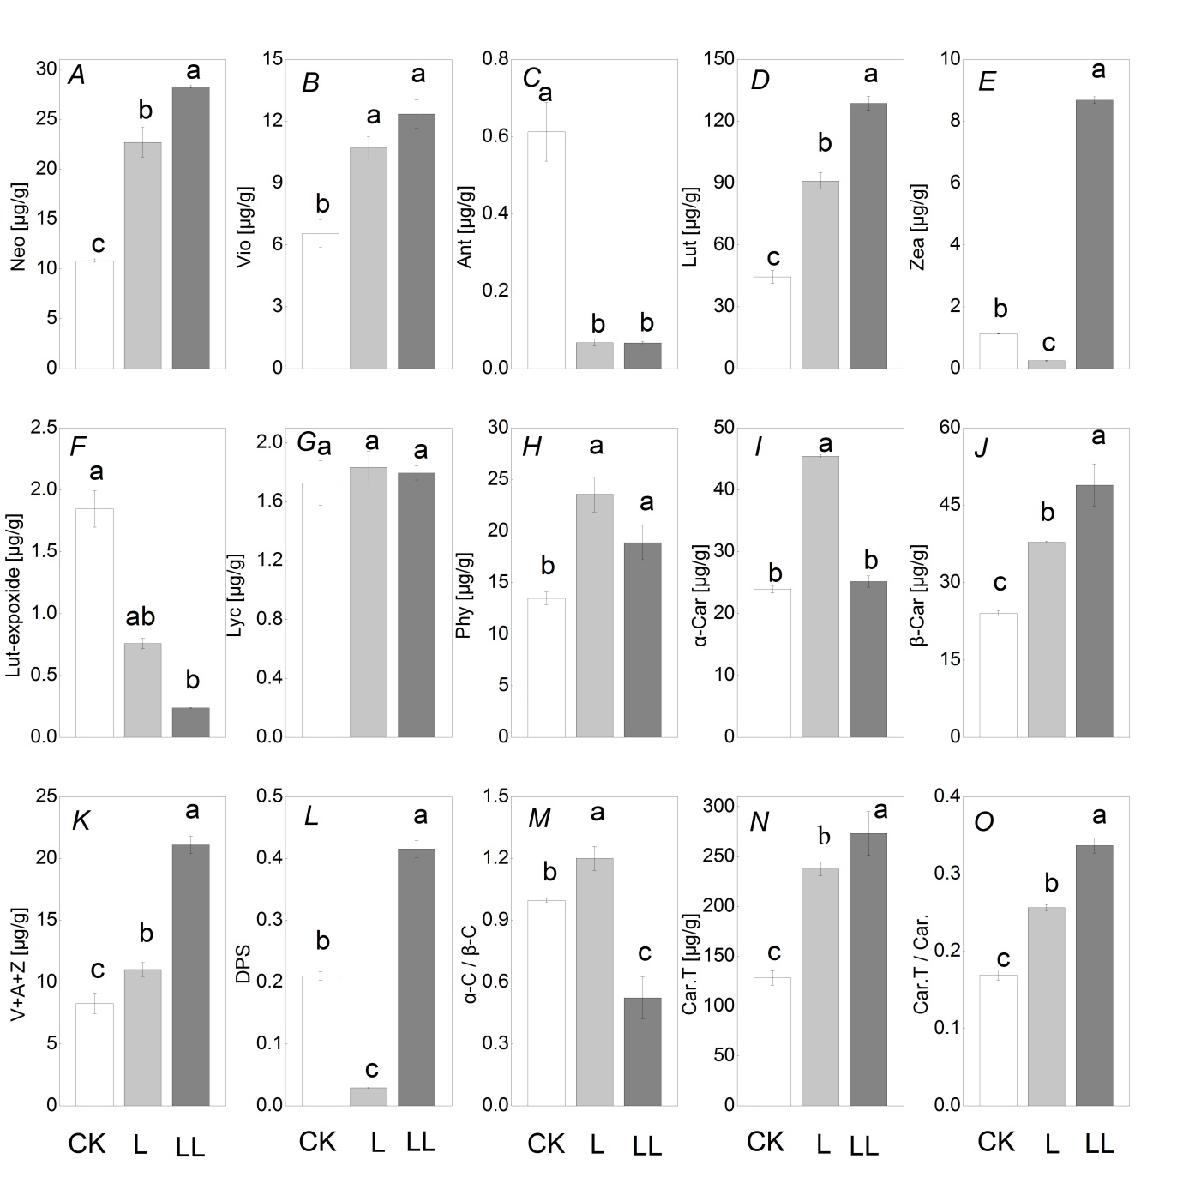

Fig. 1S. Changes in the carotenoid compositions in the leaves of cultivar L5 (Longjiao 5) 20 d after treatment: CK (normal temperature and light, 28/18°C and 300 μmol m⁻² s⁻¹), L (low light, 28/18°C and 100 μmol m⁻² s⁻¹), and LL (low temperature combined with low light, 15/5°C and 100 μmol m⁻² s⁻¹). A, Neo – neoxanthin; B,
Vio – violaxanthin; C, Ant – antheraxanthin; D, Lut – lutein; E, Zea, zeathin; F, Lut-epoxide – lutein-epoxide; G, Lyc – lycopene; H, Phy – phytoene; I, α-Car – α-carotenoid; J, β-Car – β-carotenoid; K, V+A+Z – sum of
V-cycle pigments (violaxanthin, antheraxanthin, and zeathin); L, DPS – de-epoxidation state defined as (A+Z)/(V+A+Z); M, α-Car/β-Car; N, Car. T – sum of the 10 carotenoids (neoxanthin, violaxanthin, antheraxanthin, lutein, zeathin, lutein-epoxide, lycopene, phytoene, α-carotenoid, β-carotenoid); O, Car.T/Car. – the 10 carotenoids/the carotenoid. Each value (mean ± SD) represents the average of three independent replicates of one treatment. Different letters denote statistically significant differences (P<0.05) from other treatments based on Duncan's multiple range test.

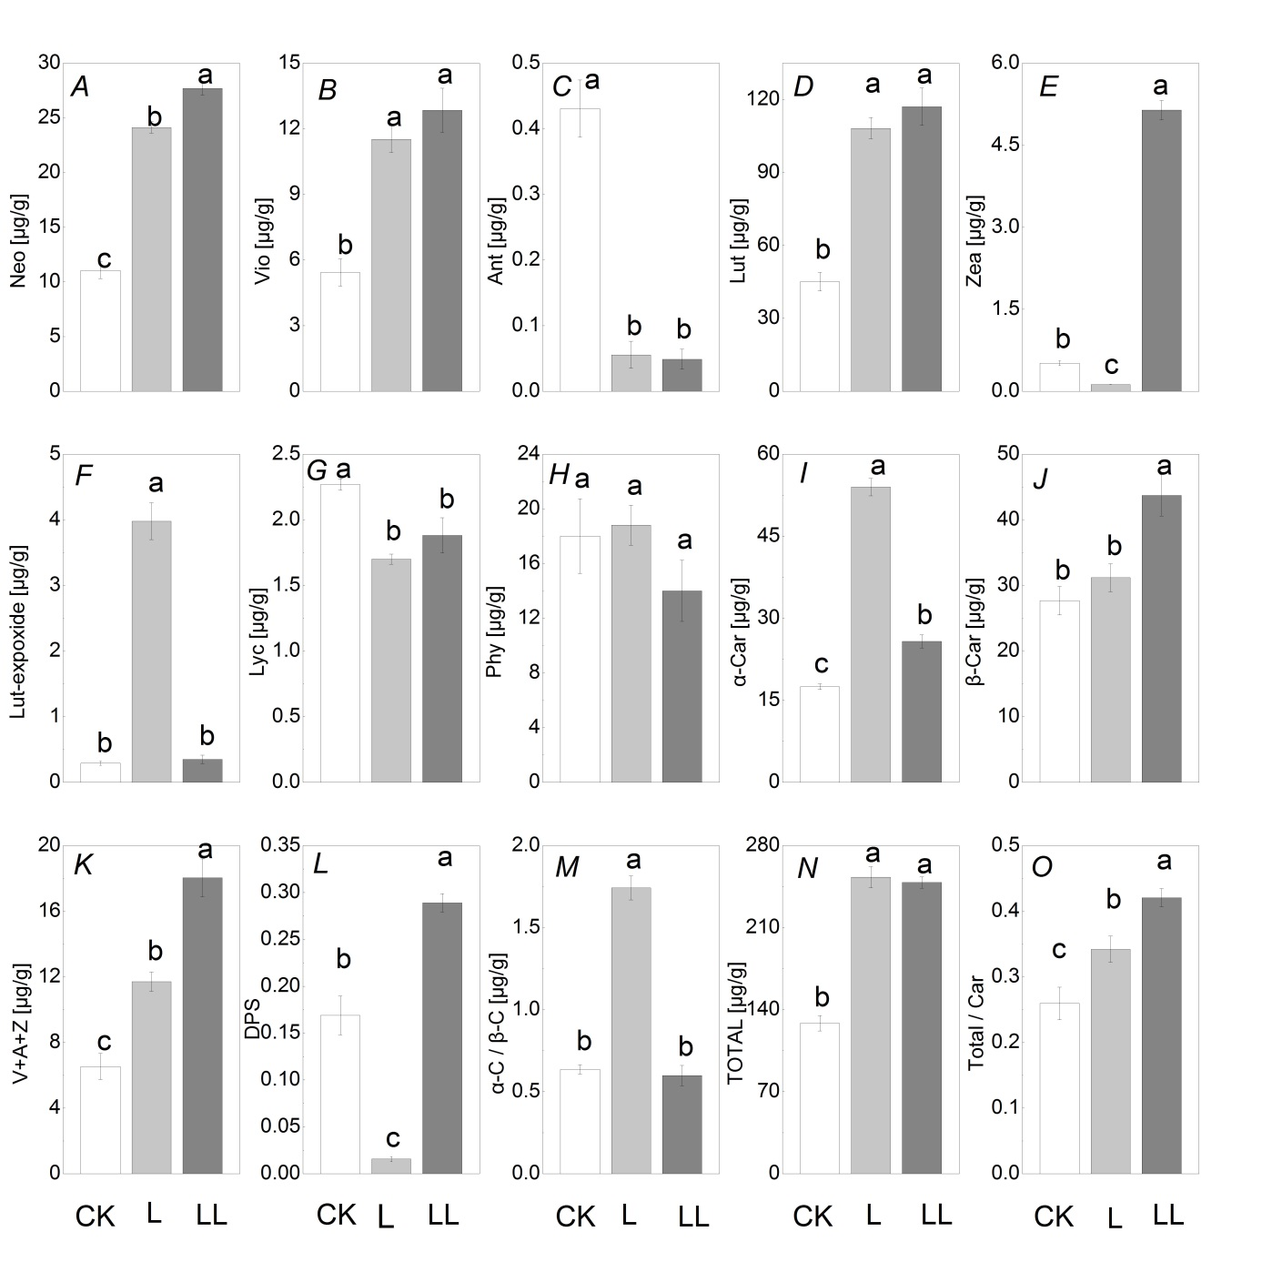

Fig. 2S. Changes in the carotenoid compositions in the leaves of cultivars H4 (Hangjiao 4) 20 d after treatment: CK (normal temperature and light, 28/18°C and 300 μmol m⁻² s⁻¹), L (low light, 28/18°C and 100 μmol m⁻² s⁻¹), and LL (low temperature combined with low light, 15/5°C and 100 μmol m⁻² s⁻¹). A, Neo – neoxanthin; B,
Vio – violaxanthin; C, Ant – antheraxanthin; D, Lut – lutein; E, Zea, zeathin; F, Lut-epoxide – lutein-epoxide; G, Lyc – lycopene; H, Phy – phytoene; I, α-Car – α-carotenoid; J, β-Car – β-carotenoid; K, V+A+Z – sum of
V-cycle pigments (violaxanthin, antheraxanthin, and zeathin); L, DPS – de-epoxidation state defined as (A+Z)/(V+A+Z); M, α-Car/β-Car; N, Car. T – sum of the 10 carotenoids (neoxanthin, violaxanthin, antheraxanthin, lutein, zeathin, lutein-epoxide, lycopene, phytoene, α-carotenoid, β-carotenoid); O, Car.T/Car. – the 10 carotenoids/the carotenoid. Each value (mean ± SD) represents the average of three independent replicates of one treatment. Different letters denote statistically significant differences (P<0.05) from other treatments based on Duncan's multiple range test.

