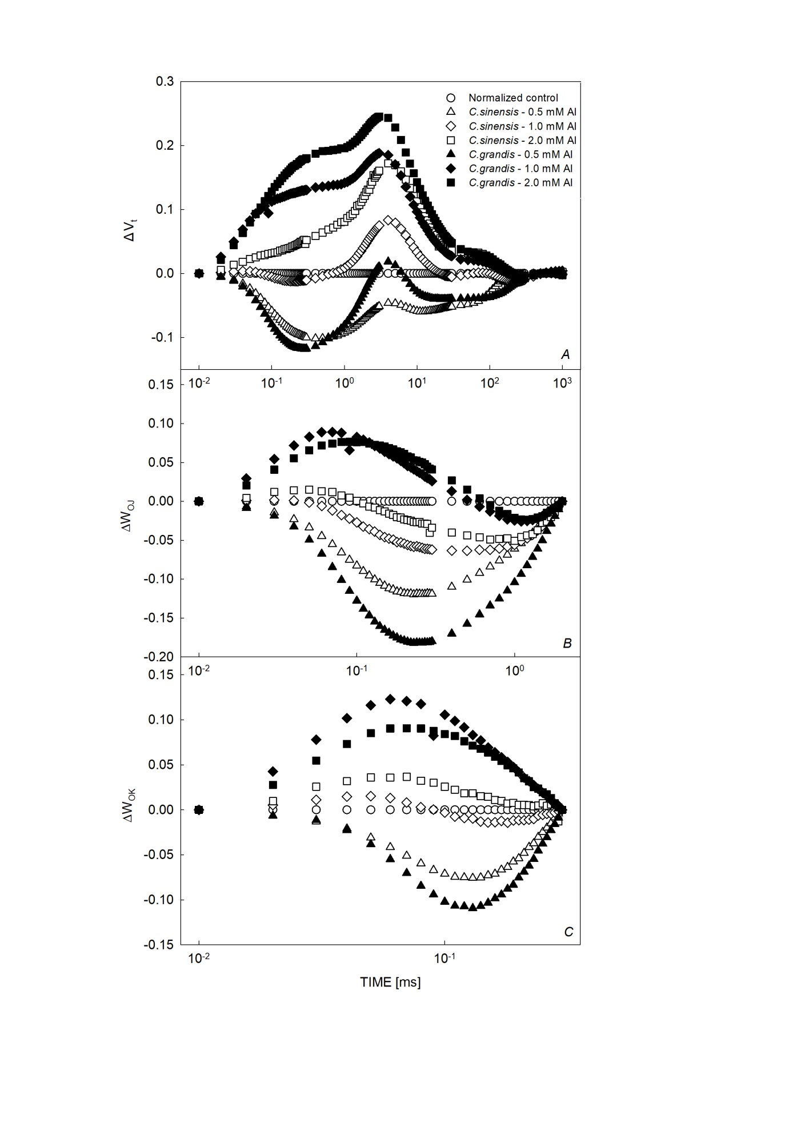
Fig. 1S. The effects of increasing Al stress on the leaf Chl a fluorescence transient of Citrus sinensis and Citrus grandis seedlings.

