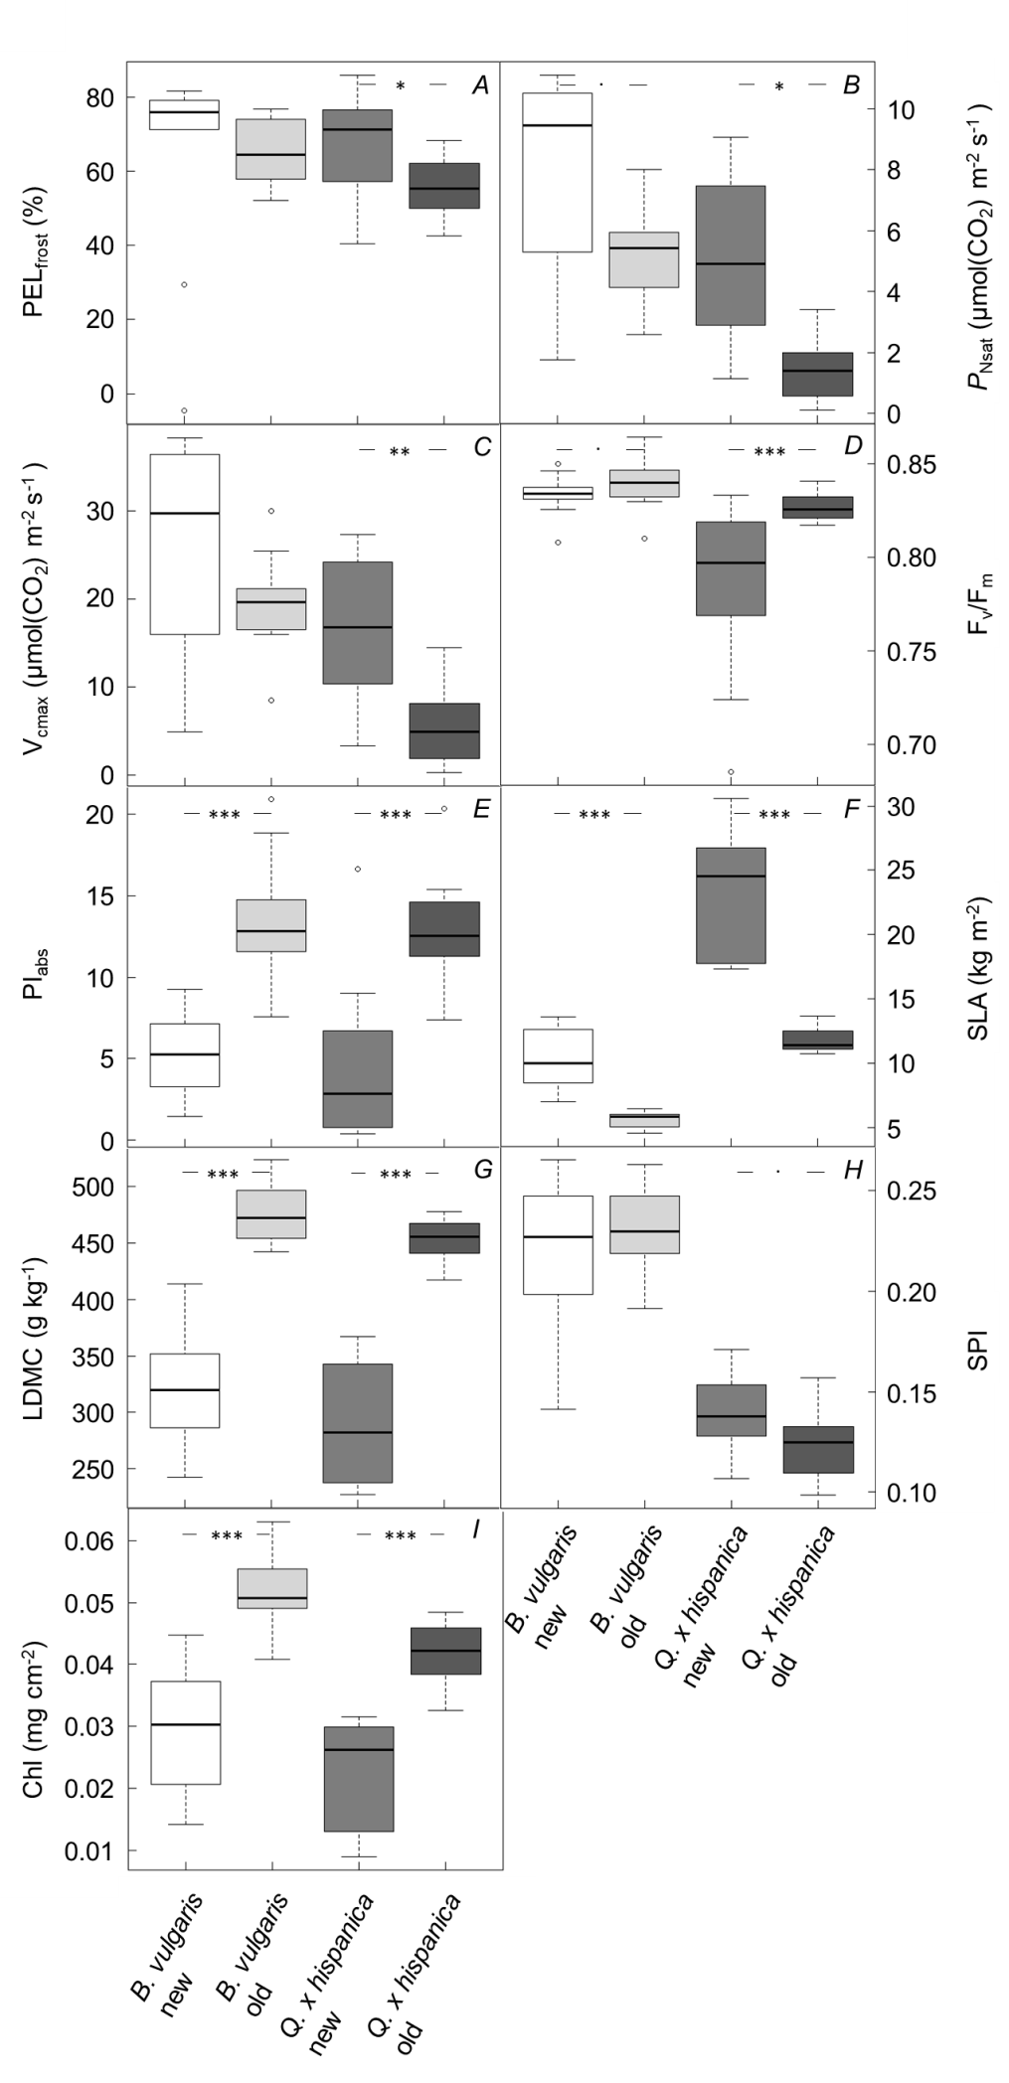
Fig. 1S. Graphical representation of the comparison between old and new leaves of Berberis vulgaris and Quercus × hispanica. Displayed are the measurements of frost resistance as PEL_{eff}, photosynthesis rates (P_{Nsat}), maximum carboxylation capacity (V_{cmax}), efficiency of PSII (F_{v}/F_{m}), performance index (PI_{abs}), specific leaf area (SLA), leaf dry matter content (LDMC), stomatal pore area index (SPI) and chlorophyll content (Chl). Above each graph, the statistical results are given as n.s. – not significant, ‘·’ – p<0.1, ‘*’ – p<0.05, ‘**’ – p<0.01, and ‘***’ – p<0.001.

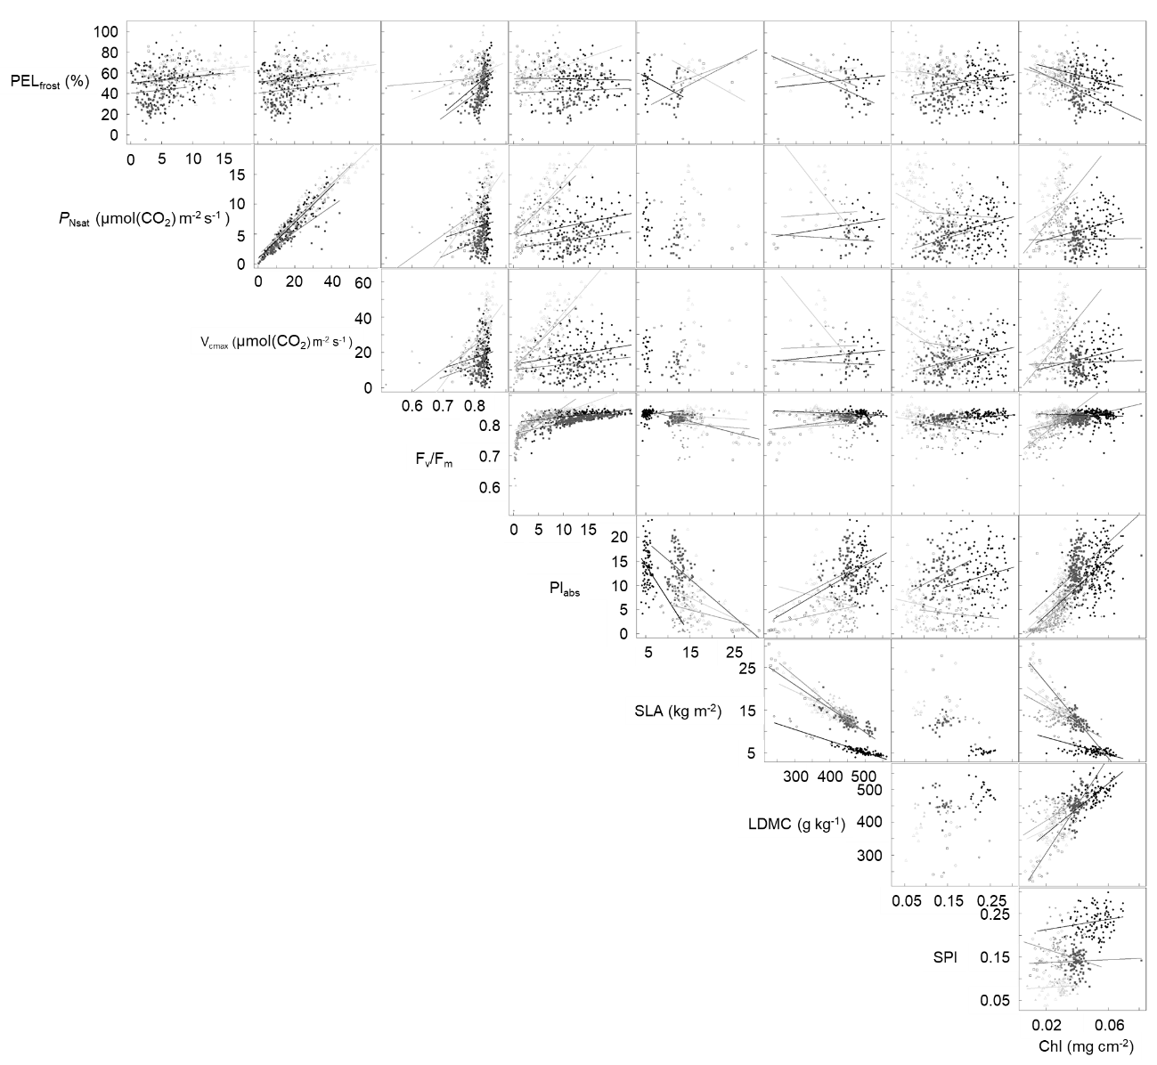

Fig. 2S. Pairwise relationships between all parameters measured. Species are represented by colour, the evergreen species Berberis vulgaris and Quercus × hispanica are displayed in black circles and dark grey squares, respectively. The two summer green species are Betula pendula (pale grey triangles) and Q. pubescens (light grey diamonds). Leaves, which were visually newly formed and not fully grown are indicated by open symbols. Given is the frost resistance measured as effective percentage of electrolyte leakage (PEL_{eff}), the net photosynthetic rate at saturating irradiance and ambient atmospheric CO₂ concentrations (P_{Nsat}), the maximum carboxylation rate (V_{cmax}), the maximum quantum yield of PSII (F_{v}/F_{m}), the absorption based performance index (PI_{abs}), the specific leaf area (SLA), the leaf dry matter content (LDMC), the stomatal pore area index (SPI), as well as the chlorophyll content (Chl). Lines represent linear regressions as based on the minimum adequate model.

