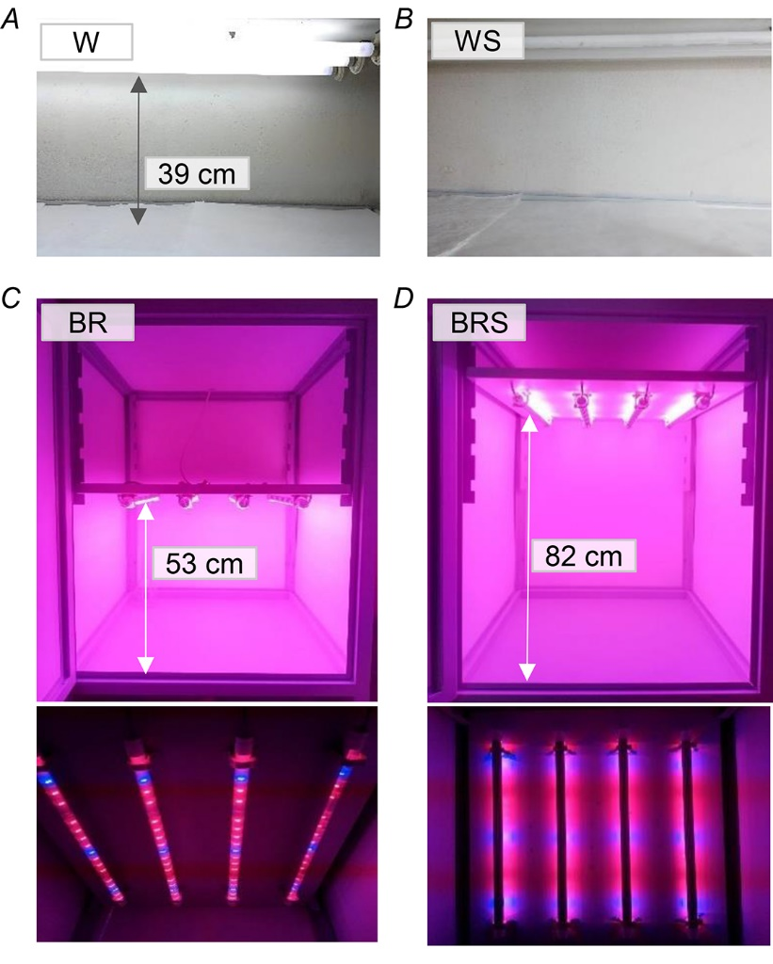

Fig. 1S. Experimental cultivation conditions: W – white fluorescent light (A); WS – white fluorescent light with shadow (B); BR – blue and red LED light (maximal illumination is achieved by minimal distance between the shelf and the lamp panel with lamps turned downwards) (C); BRS – blue and red LED light with shadow (minimal illumination is achieved by maximal distance between the shelf and the lamp panel with lamps turned upwards) (D). The distance from the shelf to the lamp panels is shown for information.

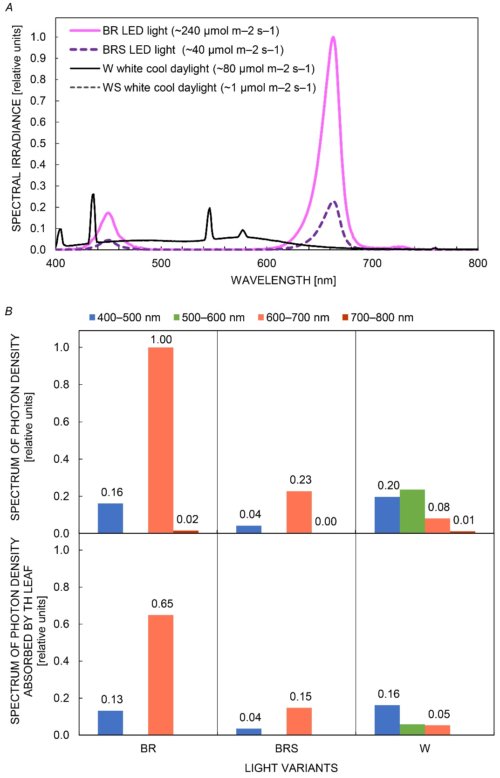

Fig. 2S. Emission spectra of the LED and luminescence sources (A) were measured by spectroradiometer Specbos1201 and the spectral irradiance is presented relative to the highest measured value. The photon density and the photon density absorbed by the leaf (B) in spectral regions from the visible light were calculated based on the data in (A) and on the published absorption spectra of photosynthetic pigments. Plant variants: W – white light; BR – blue and red light; BRS – blue and red light with shadow. The WS variant – white light with shadow, has similar spectra as W but with irradiance close to zero.

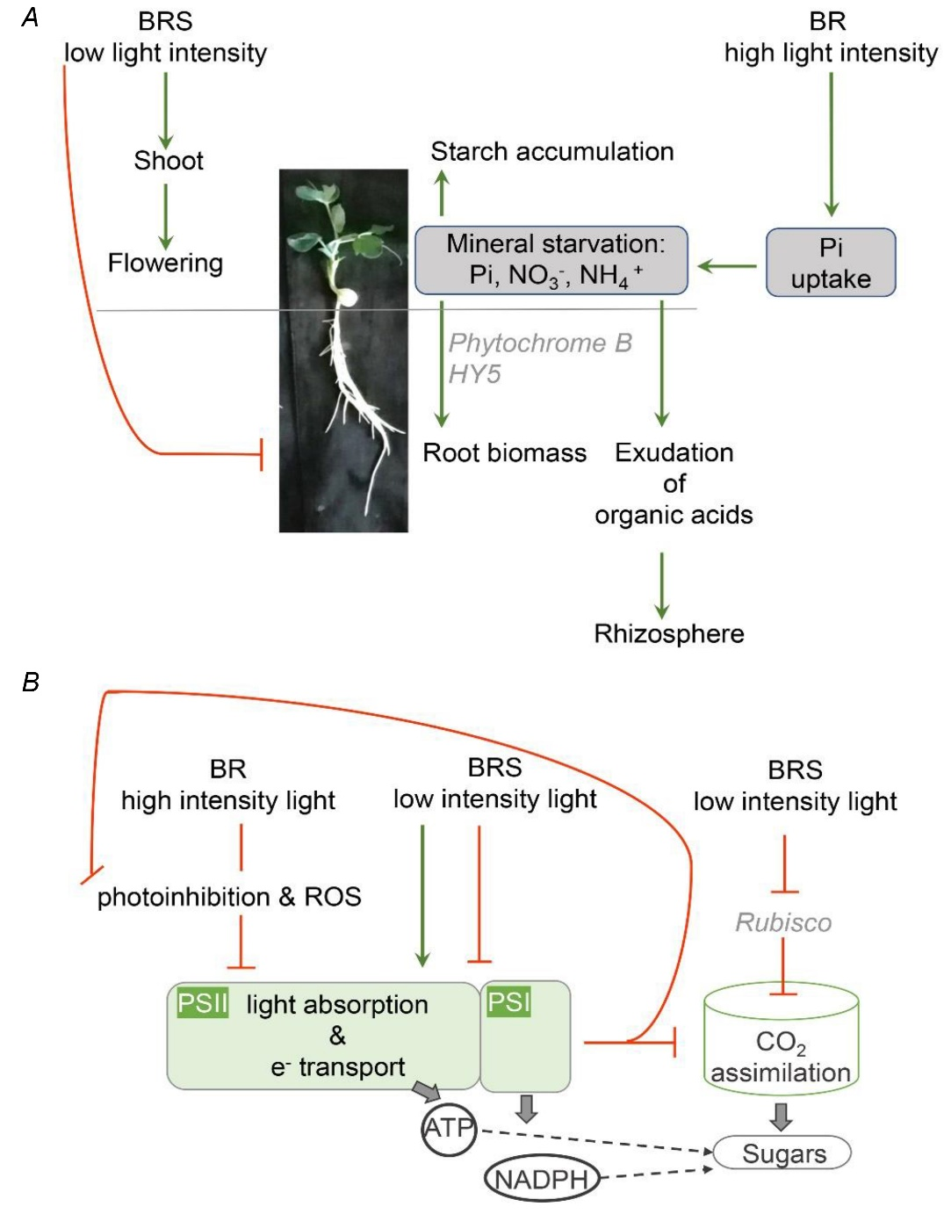

Fig. 3S. Models for the effect of the blue-red LED light recipe: on growth (A) and photosynthesis (B). Plant variants:
BR – blue and red light; BRS – blue and red light with shadow. HY5 – ELONGATED HYPOCOTYL5 transcription factor; Pi – phosphorus; NO₃⁻ – nitrate ions; NH₄⁺ – ammonium ions; ROS – reactive oxygen species; arrows – stimulation; bar-headed arrows – inhibition.

