Table 1S. The treatment description and PPFD on sunny days. Means (± SD, n = 3). The light intensities on sunny days were measured at noon in July and August. GK – control group; Z₁ – moderate shading group; Z₂ – severe shading group. PPFD – photosynthetic photon flux density. The light intensity treatments are set according to the bionic light conditions of wild E. senticosus.

Treatment | Light transmission [%] | Bionic conditions | PPFD July  [μmol·m^{–2}·s^{–1}] | PPFD August  [μmol·m^{–2}·s^{–1}]
GK | 100% | Forest edge | 150.45 ± 3.52 | 147.25±2.74
Z₁ | 38.8% | Forest gap | 58.37 ± 2.15 | 57.13 ± 2.95
Z₂ | 19.9% | Understory | 29.85±1.61 | 29.28 ± 1.92

Table 2S. Delustering voltages, collision voltages, and collision chamber emission voltages of the medicinal compounds. DP – delustering voltages; CE – collision voltages; CXP – collision chamber emission voltage.

Analyte | Ion pairs[m/z] | DP [V] | CE [V] | CXP [V]
Eleutheroside E | 765.3→603.1 | 70 | 62 | 23
Rutin | 611.1→464.8 | 80 | 20 | 13
Kaempferol | 287.1→153.2 | 70 | 51 | 10
Isofraxidin | 223.1→206.3 | 60 | 40 | 9
Eleutheroside B | 155→92.9 | 70 | 21 | 17
Hyperoside | 395.1→232.1 | 70 | 40 | 17

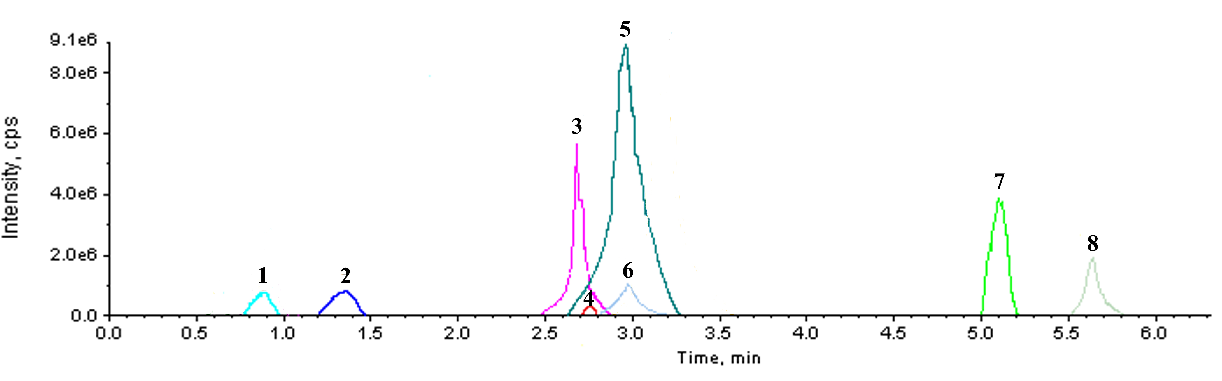
Fig. 1S. UPLC-MS chromatograms of 8 medicinal components. 1. L-phenylalanine; 2. syringin; 3. eleutheroside E; 4. isofraxidin; 5. hyperoside; 6. rutin; 7. kaempferol; 8. oleanolic acid.
Fig. 2S. Secondary mass spectrum of 8 medicinal components. L-phenylalanine (A); syringin (B); eleutheroside E (C); isofraxidin (D); hyperoside (E); rutin (F); kaempferol (G); oleanolic acid (H).

