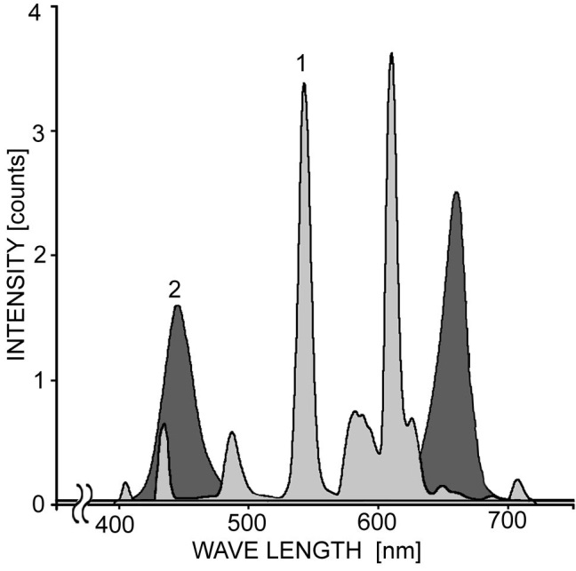
Fig. 1S. Emission spectra of the light sources used in the experiments. White fluorescent lamp with a set of peaks in the visible spectrum (1), white LED matrix with two maxima at 445 nm and 660 nm (2).

