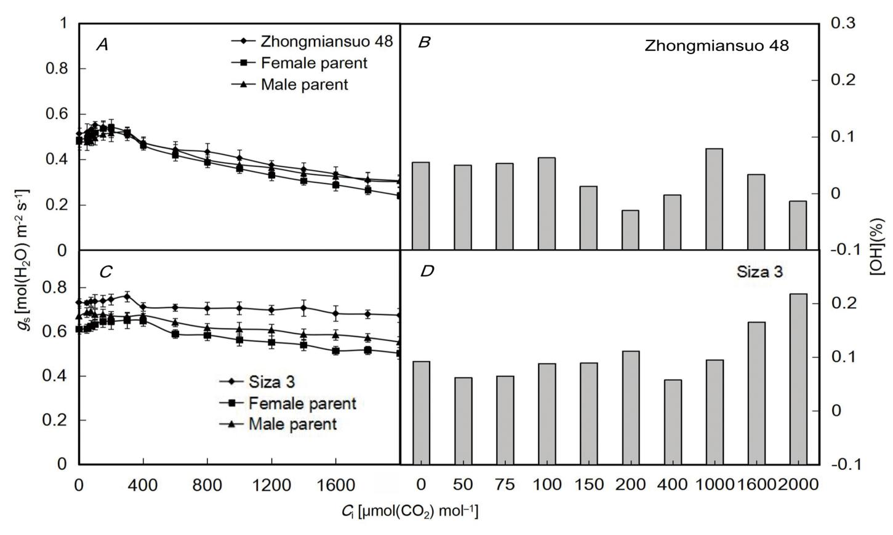

Fig. 1S. CO₂-response curves of the g_{s} and the associated OH. CO₂-response curves of the g_{s} of Zhongmiansuo 48 and its parents (A); OH of the g_{s} of Zhongmiansuo 48 (B); CO₂-response curves of the g_{s} of Siza 3 and its parents (C); OH of the g_{s} of Siza 3 (D); OH – over better-parent heterosis.

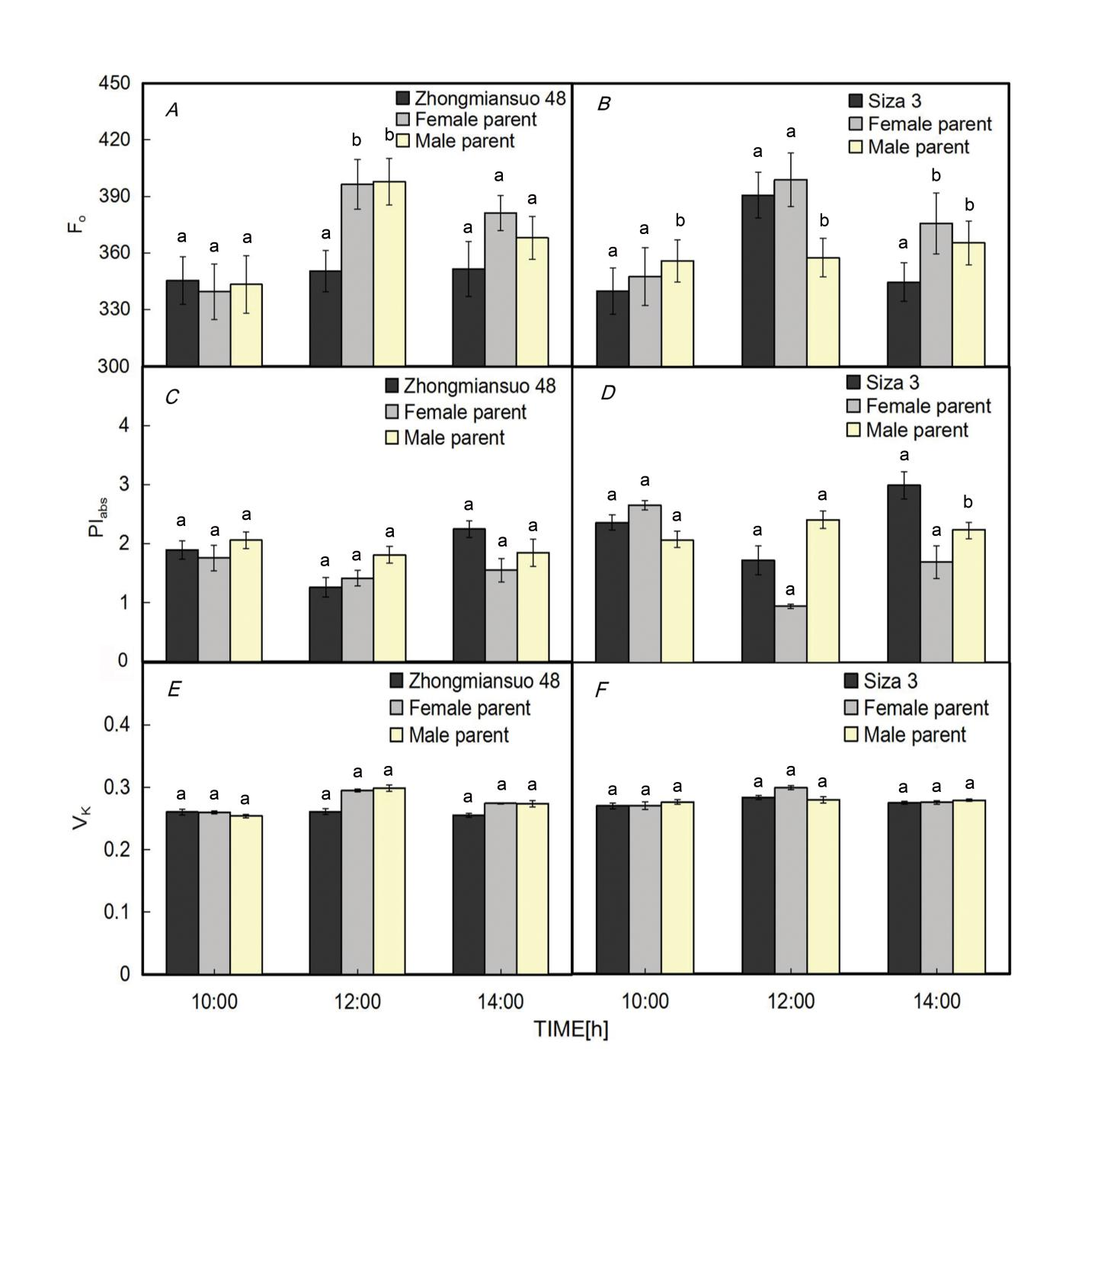
Fig. 2S. F₀, PI_{abs}, and V_{k} parameters of Zhongmiansuo 48, Siza 3, and their parents. F₀ parameters of Zhongmiansuo 48 and its parents (A); PI_{abs} parameters of Zhongmiansuo 48 its their parents (C); V_{k} parameters of Zhongmiansuo 48 and its parents (E); F₀ parameters of Siza 3 and its parents (B); PI_{abs} parameters of Siza 3 and its parents (D); V_{k} fluorescence parameters of Siza 3 and its parents (F). F₀ – original fluorescence, PI_{abs} – performance index of absorption, V_{k} – fluorescence intensity at the K-step. Values are means ± SD (n = 6). Different lowercase letters above the error bars denote significant differences at P≤0.05.

Table 1S. Parameters of the CO₂-response curves. α: initial carboxylation efficiency, C_{isat}: CO₂ saturation point, P_{max}: maximum photosynthesis rate, Γ: CO₂ compensation point, R_{p}: photorespiration rate. Values are means ± SD (n = 3). Different lowercase letters denote significant differences at P≤0.05.

Cultivar | α | C_{isat} | P_{max} | Γ | R_{p}
Cultivar | α | (μmol m^{–2} s^{–1}) | (μmol m^{–2} s^{–1}) | (μmol m^{–2} s^{–1}) | (μmol m^{–2} s^{–1})
Zhongmiansuo 48 | 0.1888ª ± | 1,066.96^{b} ± | 52.29^{b} ± | 77.43^{b} ± | 13.46^{b} ±
Zhongmiansuo 48 | 0.0204 | 68.57 | 3.67 | 4.33 | 1.2
Female parent | 0.1970ª ± | 1,059.81^{b} ± | 52.29^{b} ± | 76.02^{b} ± | 13.41^{b} ±
Female parent | 0.0143 | 52.98 | 3.67 | 4.91 | 2.02
Male parent | 0.1882ª ± | 1,185.07ª ± | 59.97ª ± | 88.29ª ± | 22.22ª ±
Male parent | 0.025 | 50.33 | 3.18 | 5.11 | 1.33
Siza3 | 0.2958ª ± | 1,292.47ª ± | 84.43ª ± | 77.01^{c} ± | 16.08^{b} ±
Siza3 | 0.0183 | 41.5 | 3.25 | 3.97 | 1.13
Female parent | 0.2321^{b} ± | 1,280.97ª ± | 67.93^{c} ± | 82.20^{b} ± | 19.60ª ±
Female parent | 0.0233 | 67.13 | 5.17 | 3.18 | 0.75
Male parent | 0.2055^{c} ± | 1,266.72ª ± | 70.21^{b} ± | 98.90ª ± | 21.43ª ±
Male parent | 0.0333 | 49.93 | 4.92 | 5.17 | 1.04

