Table 1S. Correlative relationships between chlorophyll fluorescence parameters and elements of productivity of wheat species and interspecific hybrids at various plant growth stages. α – initial slope of rapid light curve; ETR_{max} – PSII maximum electron transport rate; E_{k} – minimum saturation irradiance; Y(II)₆₅, Y(II)₆₂₅ – effective photochemical quantum yield of PSII; Y(NPQ)₆₅, Y(NPQ)₆₂₅ – quantum yield of nonphotochemical energy conversion in PSII due to downregulation of the light-harvesting function; Y(NO)₆₅, Y(NO)₆₂₅ – quantum yield of nonphotochemical energy conversion in PSII other than that caused by downregulation of the light-harvesting function at PPFD 65 µmol m^{–2} s^{–1} and 625 µmol m^{–2} s^{–1} at rapid light curve. Correlation is significant at * – p≤0.05 and ** – p≤0.01.

Growth stage | Chlorophyll fluorescence parameters | Productivity parameters
Growth stage | Chlorophyll fluorescence parameters | Spike length | Spikelets per spike | Florets per spike | Grains per spike | Grain forming
Tillering | Y(NO)₆₅ |  |  | –0.61*
Stem extension | Y(II)₆₂₅ |  | 0.62*
Stem extension | Y(NO)₆₂₅ | 0.71*
Stem extension | Y(NPQ)₆₅ |  | –0.62*
Stem extension | Y(II)₆₅ |  |  |  | 0.67* | 0.65*
Stem extension | α |  |  |  |  | 0.77**
Subflag leaf | Y(NPQ)₆₂₅ |  | –0.80**
Subflag leaf | Y(II)₆₂₅ |  | 0.61*
Subflag leaf | Y(NO)₆₂₅ |  | 0.74**
Subflag leaf | ETR_{max} |  | 0.80**
Subflag leaf | E_{k} |  | 0.78**
Flag-leaf formation | ETR_{max} |  | –0.74**
Flag-leaf formation | α |  | –0.69*
Flag-leaf formation | E_{k} |  |  | –0.77**
Flag-leaf formation | Y(II)₆₂₅ |  | –0.78**
Anthesis, developed flag-leaf | Y(NO)₆₂₅ |  |  |  |  | –0.66*
Anthesis, developed flag-leaf | Y(II)₆₅ |  |  |  |  | 0.70*
Anthesis, developed flag-leaf | Y(NO)₆₅ |  |  |  |  | –0.62*
Anthesis, developed flag-leaf | α |  |  |  |  | 0.69*

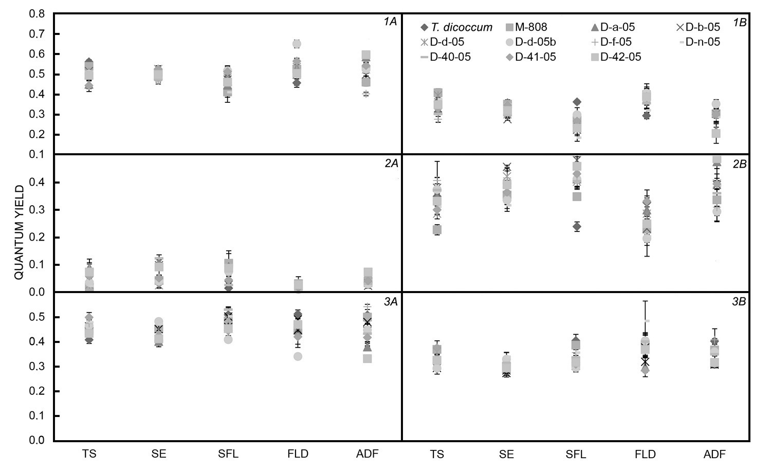
Fig. 1S. Allolines and parent genotypes mean values of PSII quantum yield of photochemical quenching (1), nonphotochemical energy conversion due to downregulation mechanisms (2) and nonorganized energy passive dissipation in form of heat and fluorescence (3) at the RLCs at PPFD of 65 (A) and 625 (B) μmol m^{–2} s^{–1} at different vegetation stages. TS – tillering stage, SE – stem extension, SFL – subflag leaf, FLD – flag-leaf development stage, ADF – anthesis, developed leaf.

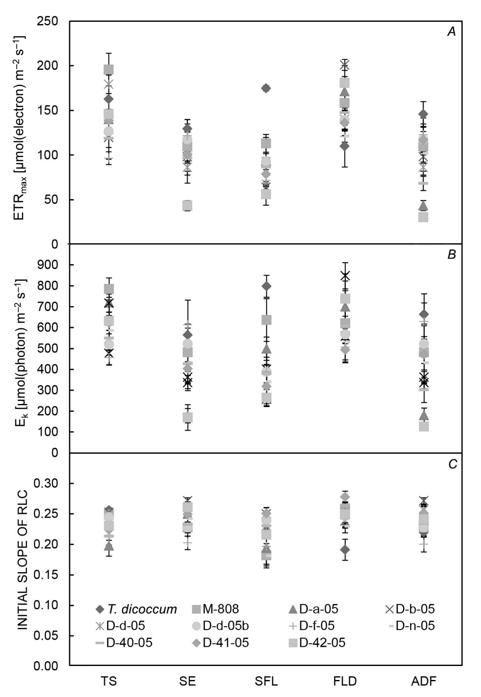
Fig. 2S. Photosynthetic capacity parameters of allolines and parent genotypes in RLC at different vegetation. ETR_{max} (A) – maximum electron transport rate, E_{k} (B) – the minimum saturation level, α (C) – the initial slope of RLC at low PPFD values. TS – tillering stage, SE – stem extension, SFL – subflag leaf, FLD – flag-leaf development stage, ADF – anthesis, developed leaf.

