Supplementary files

Table 1S. The primers for qRT-PCR.

Primers | Forward sequence [5'–3’] | Reverse sequence [5'–3’]
PEPC-9.1 | GACCTTCAGGTTGCTGGACA | TGGTAGTCTGGGTCACGGAT
PEPC-9.2 | GTCTGCCAGGCTTACACGAT | ACTCACTGGTTGGGTTCAGC
PEPC-21 | GGCCTTGTTGATTTGGATCGG | AAGATTGCACCCCCATCAGG
PEPC-27.1 | TCGGCGCGTACATTATCTCC | GTCAGCGAGCTTCTCGAACA
PEPC-27.2 | GTCGACTGGTACAAGGAGCG | GACACGCCGGACGATTTTC
RUBIS-9.1 | AATCGGGGACCCTAATGACG | CCCCTGGCCATGACACAAAT
RUBIS-10.1 | TTGGATGGGATTGCATGTGGT | CTCTGCCACCTTGGTACACT
RBCS-3.1 | CTCAATCGGCCACACCTGAT | TTTGGCAACGTCAGCAATGG
RBCS-3.2 | ACAATTGAATCGGGCCAACG | CAGGGGCTCAAGTCTACTGC
PPDK-11 | TCTCCTCAAATAGTGAATGCGGT | GTTACTACTTCGTATGGTCGGTAGT

Table 2S. The quality of sequencing transcriptome of Oryza officinalis. Oof-1, Oof-2, and Oof-3 sample means.

Sample | Raw reads | Clean reads | Clean bases | Error [%] | Q20 [%] | Q30 [%] | GC [%] | Total  mapped | Multiple mapped | Unique  mapped
Oof-1 | 66712490 | 66327302 | 9.17G | 0.02 | 98.27 | 94.9 | 51.99 | 24613454  (37.11%) | 531459  (0.80%) | 24081995  (36.31%)
Oof-2 | 49853354 | 49507876 | 6.8G | 0.02 | 98.21 | 94.73 | 50.29 | 16182959  (32.69%) | 392778  (0.79%) | 15790181  (31.89%)
Oof-3 | 52163594 | 51763326 | 7.17G | 0.02 | 98.17 | 94.69 | 51.82 | 17482391  (33.77%) | 394826  (0.76%) | 17087565  (33.01%)
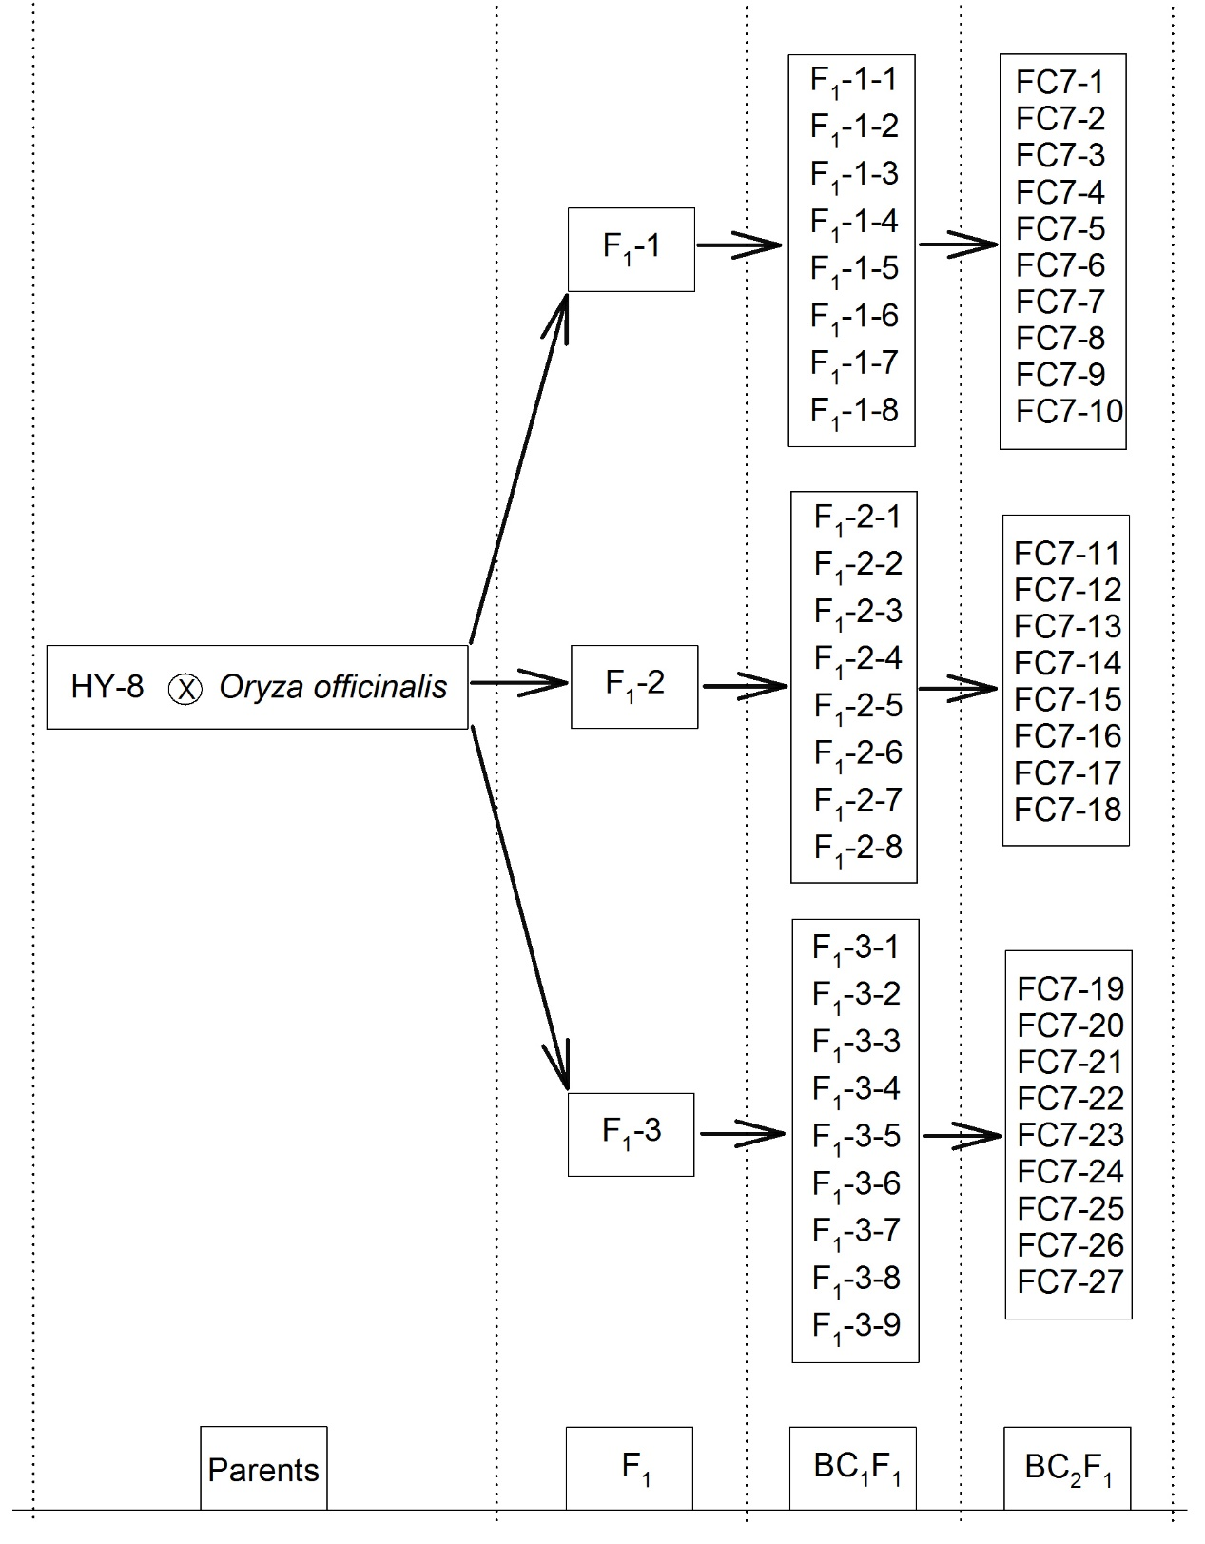
Fig. 1S. The lineage of hybrid progenies of O. officinalis. Each column from left to right represents a generation. After F₁ generation is obtained by a distant cross, different backcross generations are obtained by backcross with HY-8 continuously.

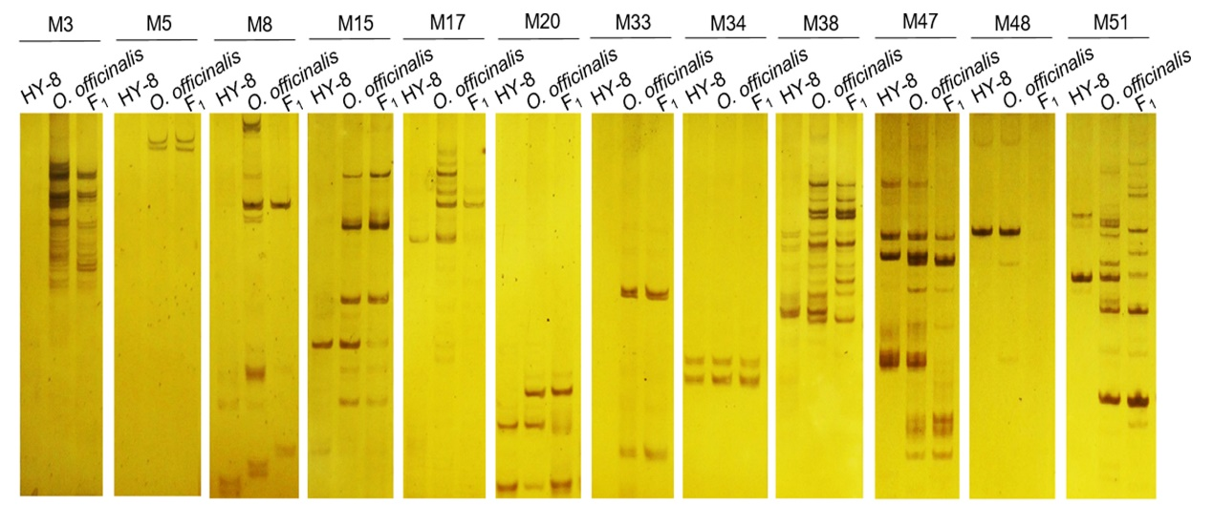
Fig. 2S. Hybrid progenies identification by SSR. M15, M17, M20, M38, M47, and M51 are SSR markers.

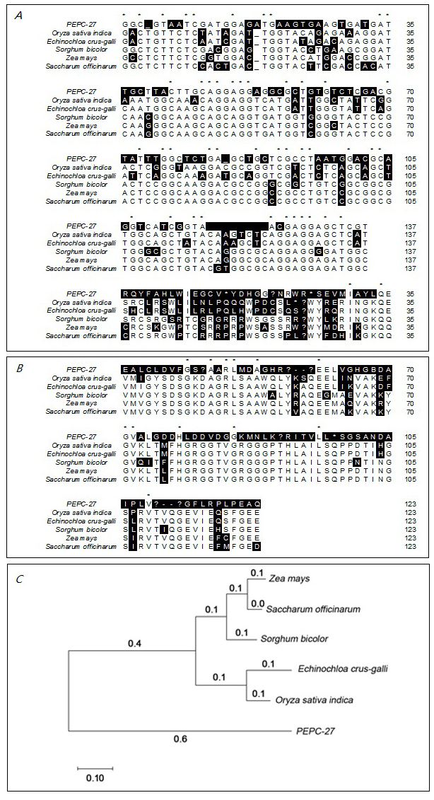
Fig. 3S. The homology comparison of the amplified gene sequence of PEPC by primer PEPC-27 with other species-related sequences. (A) CDS sequence; (B) protein sequence; (C) homology tree.

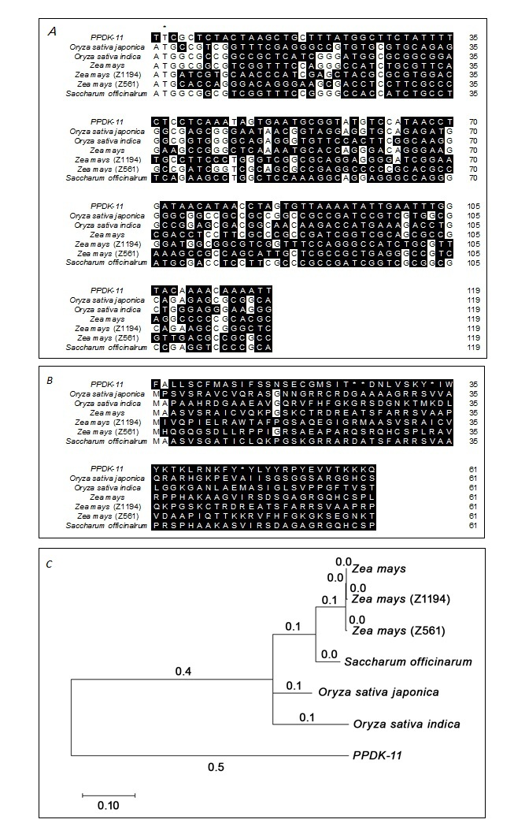

Fig. 4S. The homology comparison of amplified gene sequences of PPDK by primer PPDK-11 with other species-related sequences. (A) CDS sequence; (B) protein sequence; (C) homology tree.

