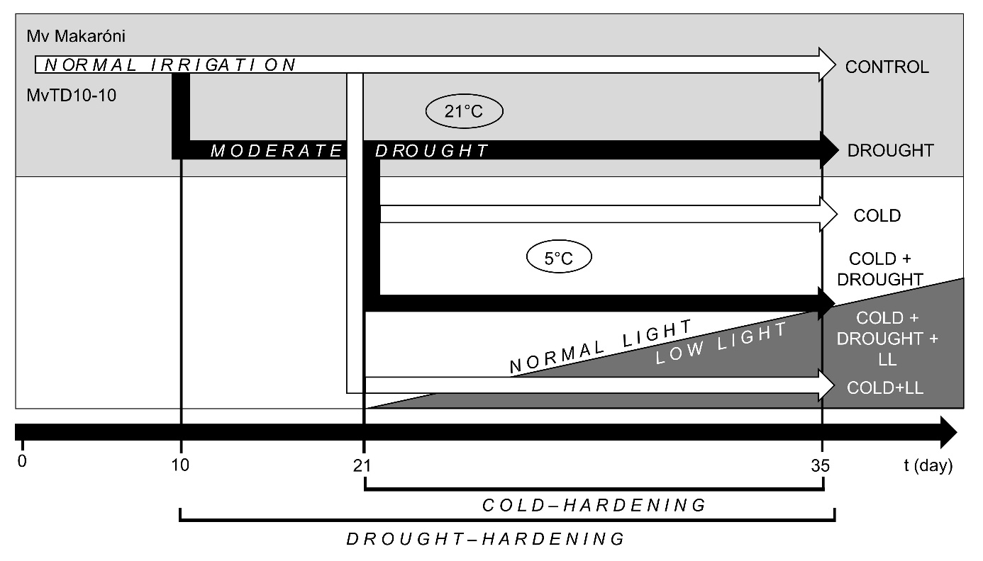
Fig. 1S. Overview of the experimental schedule – timing and treatments.

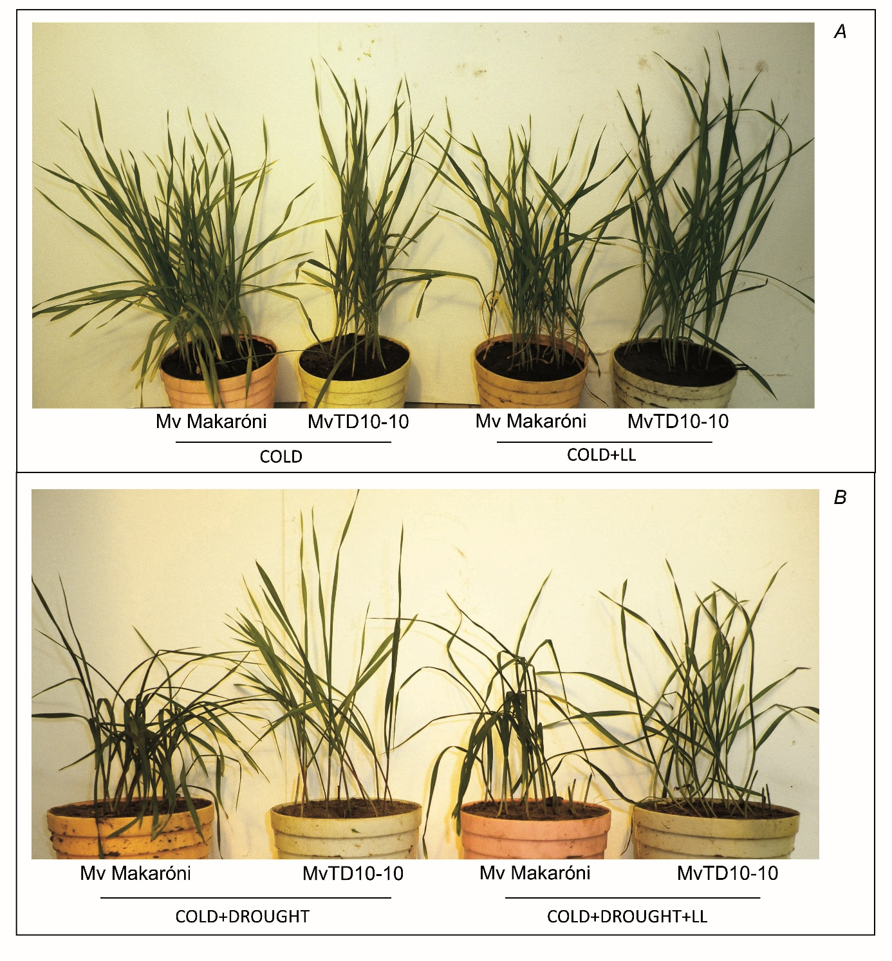
Fig. 2S. The appearance of cold-tolerant Mv Makaróni and cold-sensitive MvTD10-10 durum wheat cultivars under COLD, COLD+LL, COLD+DROUGHT, COLD+DROUGHT+LL conditions.

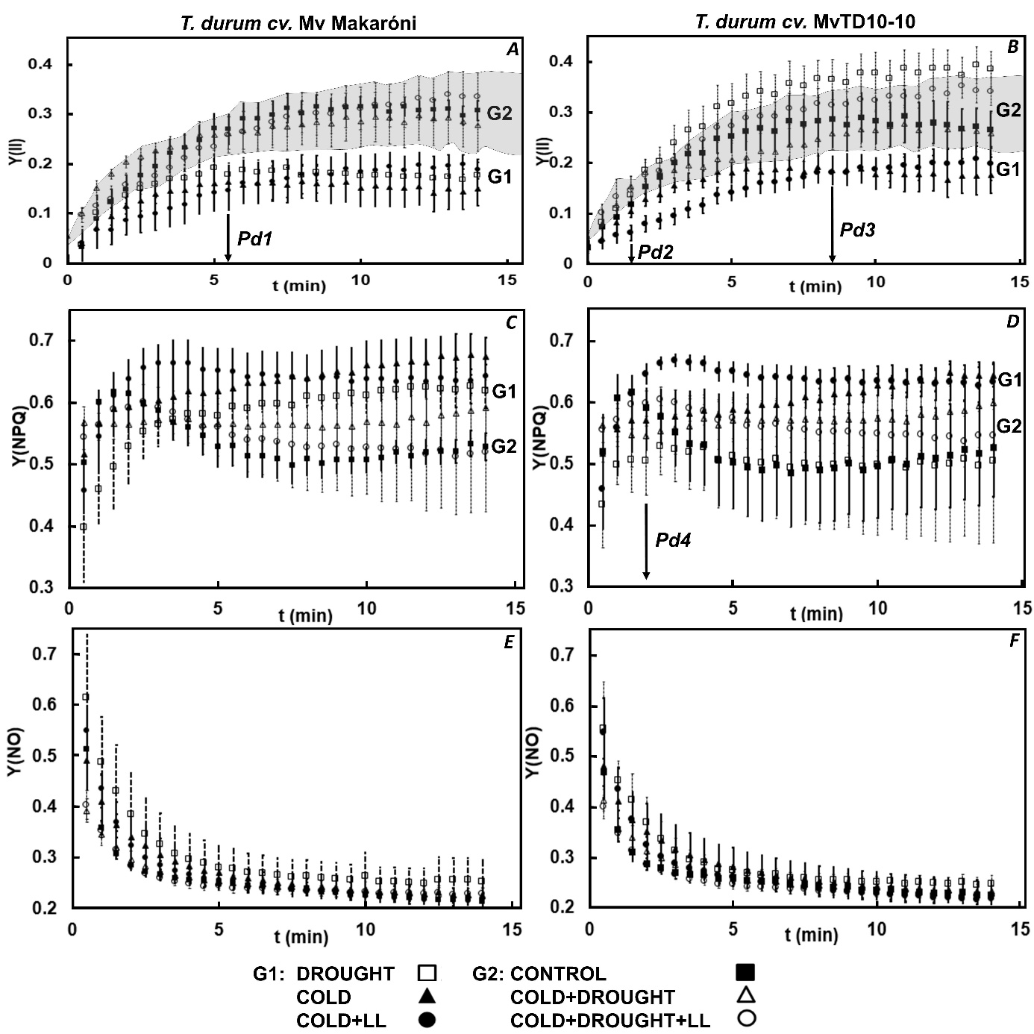

Fig. 3S. Kinetic changes in the actual quantum yield [Y_{(II)}] (A,B), quantum yield of regulated energy dissipation [Y_{(NPQ)}] (C,D), and quantum yield of nonregulated energy dissipation [Y_{(NO)}] (E,F) in the cold-tolerant Mv Makaróni and cold-sensitive MvTD10-10 durum wheat cultivars. Data were recorded at laboratory temperature (adapted state) and represent means ± SD calculated from the data of five plants per treatment [G1 – group of curves: DROUGHT (□), COLD (▲) and COLD+LL (●), G2 – group of curves: CONTROL (■), COLD+DROUGHT (△) and COLD+DROUGHT+LL (○), P_{d} – time on the x-axis indicating the divergence of the curves of quenching parameters, I – normal water supply, D – moderate water deficiency, NL – normal light, LL – low light)]. The G2 group of Y_{(II)} curves are highlighted by grey field (on panel A and B).

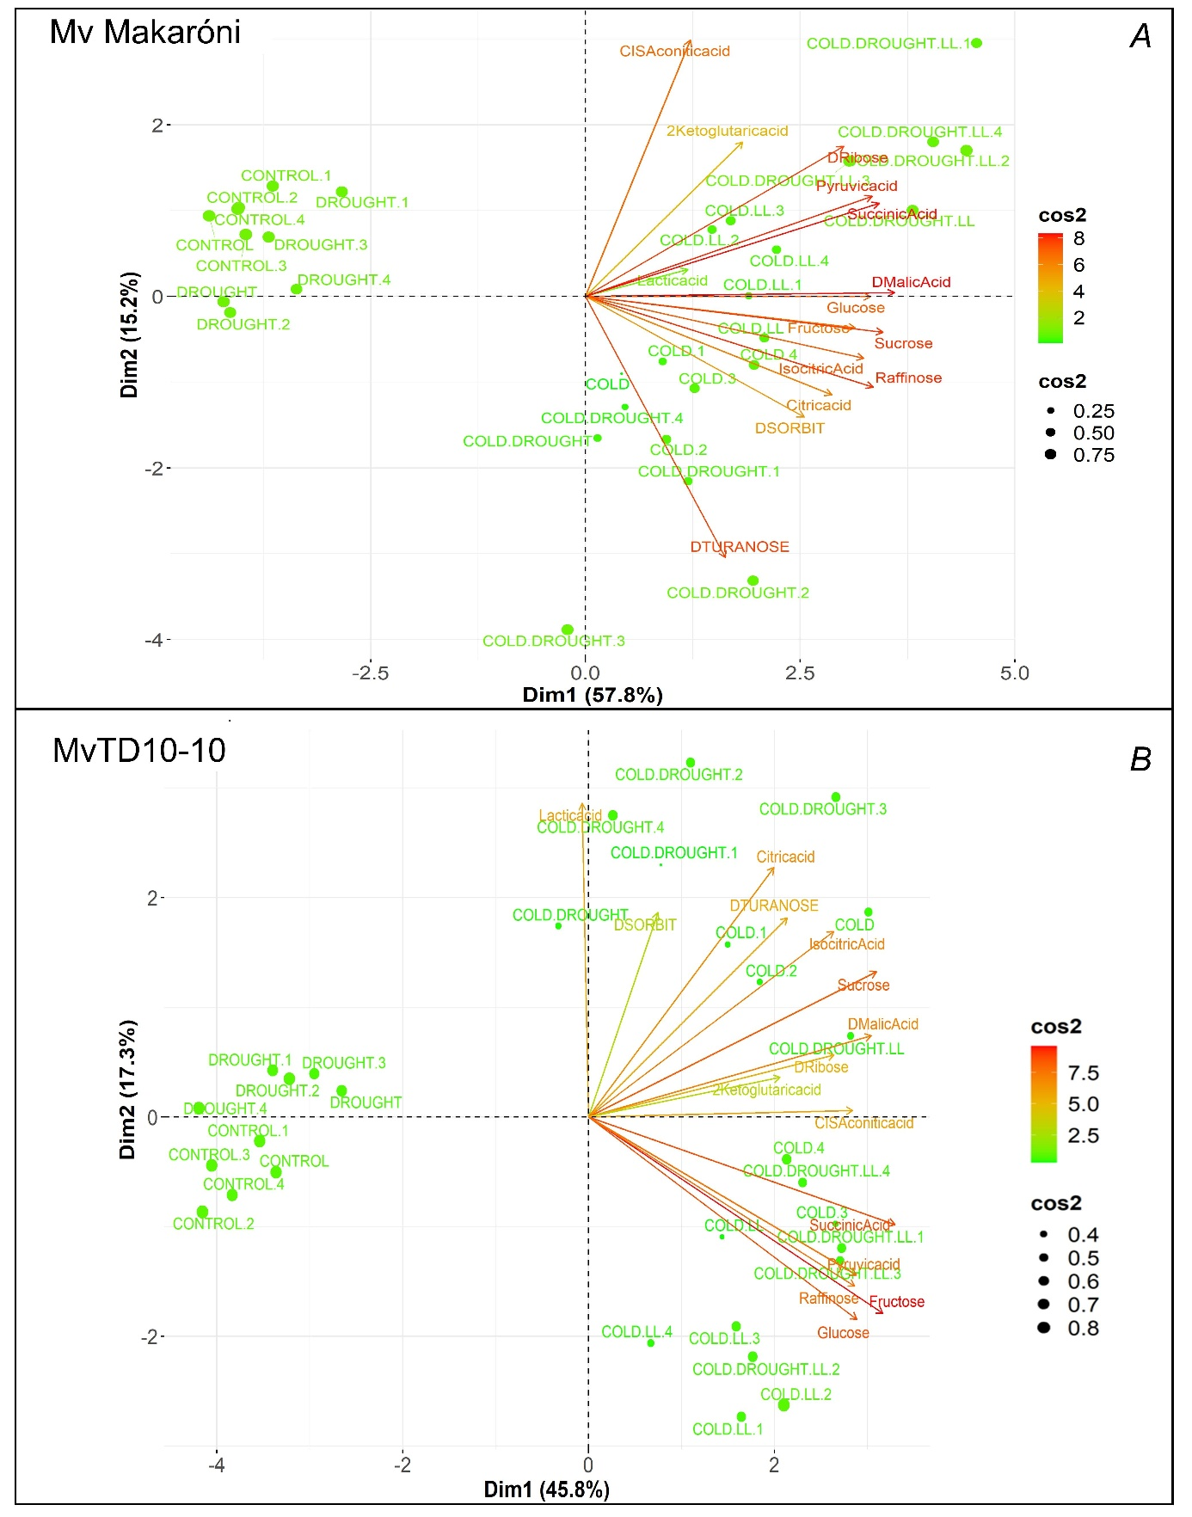

Fig. 4S. PCA biplot analysis for fifteen metabolic compounds determined under CONTROL, DROUGHT, COLD, COLD+LL, COLD+DROUGHT, COLD+DROUGHT+LL conditions in (A) Mv Makaróni and (B) MvTD10-10. Square cosine (cos²) shows the accuracy of representation of variables on the principal component (Dim) plane.

