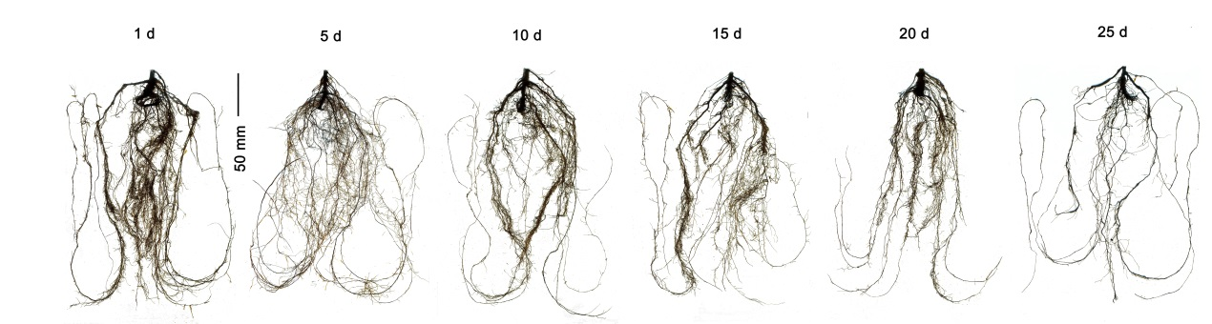

Fig. 1S. Morphological changes of the roots after 1, 5, 10, 15, 20, and 25 d of drought treatment. The bar is 50 mm.
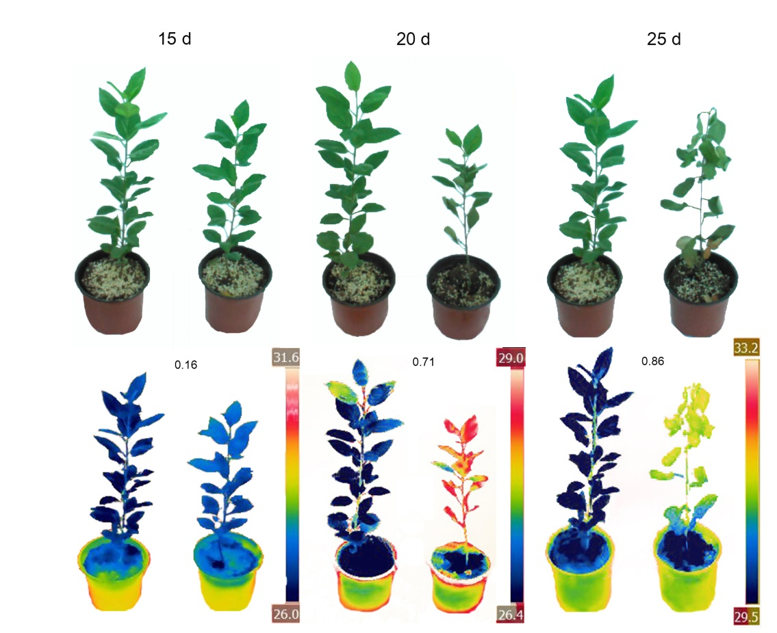

Fig. 2S. Changes in leaf temperature after rehydration under different durations of drought treatment. The data on the infrared image indicate the values of the crop water stress index.
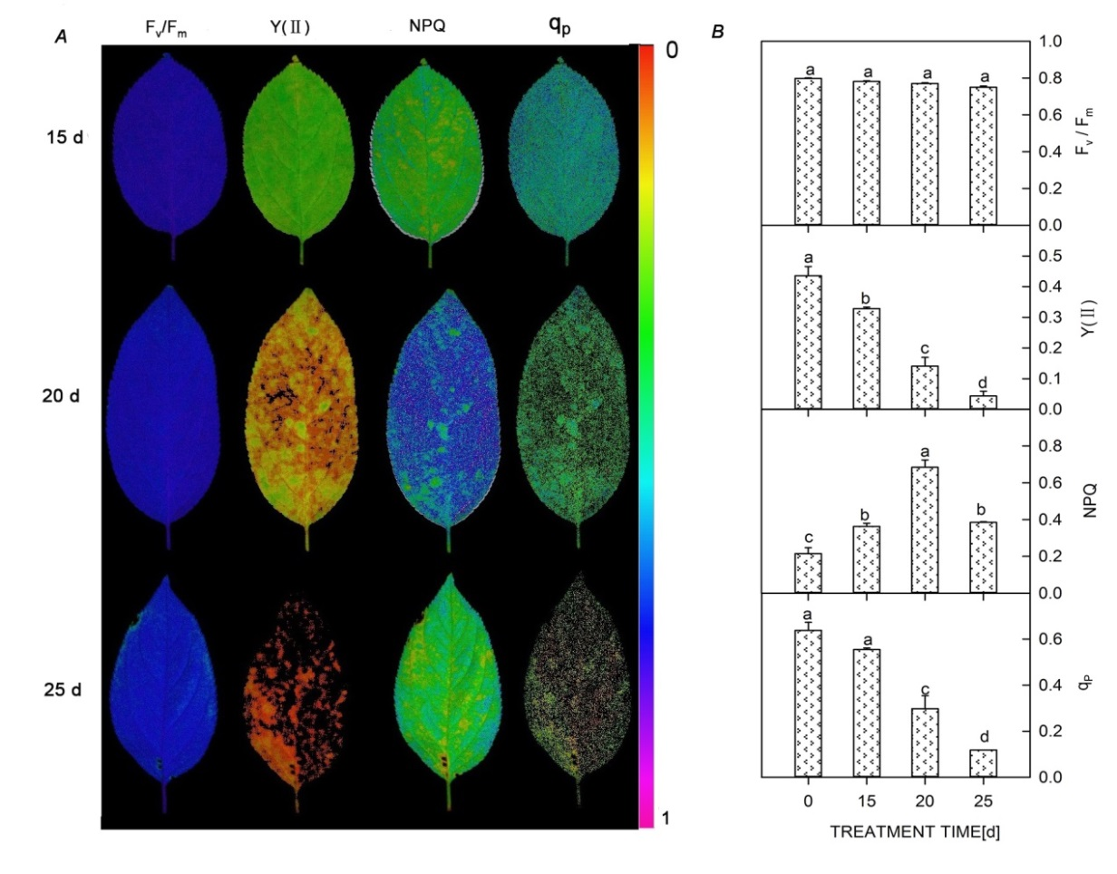

Fig. 3S. Changes in chlorophyll fluorescence parameters after rehydration across drought periods (15, 20, 25 d). F_{v}/F_{m} – maximum photochemical efficiency; Y_{(II)} – actual photochemical quantum yield;
NPQ – nonphotochemical fluorescence quenching; q_{P} – photochemical quenching coefficient. Different lowercase letters indicate significant differences at P<0.05.

Table 1S. Changes in plant roots with the extension of drought. Lowercase letters indicate the groups differentiated by Tukey's tests at P<0.05. Values are means ± SE (n = 6).

Days | Length [cm] | Surface area [cm²] | Volume [cm³] | Number of root tips | Number of forks
1 | 3,115.61 ± 103.79ª | 837.09 ± 32.45ª | 38.26 ± 1.20ª | 8,190.00 ± 66.02ª | 22,759.33 ± 289.64ª
5 | 3,265.58 ± 53.40ª | 862.44 ± 32.96ª | 43.21 ± 2.61^{b} | 8,235.67 ± 46.20ª | 23,420.00 ± 600.81ª
10 | 2,509.30 ± 127.89^{b} | 588.91 ± 1.39^{b} | 28.20 ± 2.23^{c} | 5,911.33 ± 99.50^{b} | 16,525.00 ± 691.34^{b}
15 | 2,223.63 ± 79.01^{c} | 510.89 ± 9.87^{c} | 20.60 ± 1.87^{d} | 5,764.00 ± 111.86^{b} | 13,728.67 ± 729.02^{c}
20 | 1,940.12 ± 74.71^{d} | 485.09 ± 13.89^{c} | 26.88 ± 1.33^{c} | 5,708.67 ± 424.48^{b} | 11,898.67 ± 624.51^{d}
25 | 1,417.98 ± 81.71e | 390.75 ± 6.78^{d} | 18.50 ± 1.69^{d} | 4,388.33 ± 103.00^{c} | 5,923.67 ± 90.01e

