The Moderating Role of Population Succession in the Adaptive Responses of Synechococcus Assemblages: Evidence from Light Intensity Simulation Experiment

T. WANG*,**,***,#,†, X. CHEN##,†, J. L. LI^{*,###,+} S. QIN*,###, Y. L. CUI*,###, F. XU**

Key Laboratory of Coastal Biology and Biological Resource Utilization, Yantai Institute of Coastal Zone Research, Chinese Academy of Sciences, Yantai 264000, China*
College of Environmental Science and Engineering, Ocean University of China, Qingdao 266100, China**
CAS Key Laboratory for Experimental Study under Deep-sea Extreme Conditions, Institute of Deep-sea Science and Engineering, Chinese Academy of Sciences, Sanya 572000, China***
University of Chinese Academy of Sciences, Beijing, China#
College of Marine Life Science, Ocean University of China, Qingdao 266005, China##
Center for Ocean Mega-Science, Chinese Academy of Sciences, Qingdao 266071, China###
⁺Corresponding author; e-mail: jlli@yic.ac.cn
†Co-first authors

SUPPLEMENTARY MATERIAL

Fig. 1S. Map of location information in the sampling site.
Fig. 2S. Histogram of each physiological parameter with significant difference marked. “*” represents the value below the detection line.
Fig. 3S. The linear relationship between physiological parameters and percentage of OTU based on rpoC1 gene. “*” indicates p < 0.05, “**” indicates p<0.01.
Fig. 4S. Spearman correlation heat map between physiological parameters and OTUs accounting for more than 1% abundance based on cpeBA operon. The color legend on the bottom represents the value of the Spearman correlation coefficient. The color of rounds under OTUs that correlated to the parameters represents their pigment type.
Fig. 5S. (A) Module gene topological overlap heat map. The rows and columns in the figure indicate a single gene. Dark yellow and green indicate a high degree of topological overlap. (B) Clustering tree based on the module eigengenes.

Table 1S. Reference sequences of rpoC1 gene.
Table 2 S. Reference sequences of cpeBA operon.
Table 3 S. Fitting methods and results of physiological parameters, “**” represents p<0.01.
Table 4S. Sequencing information and alpha diversity indexes of rpoC1 gene and cpeBA operon.
Table 5S. The topological feature of co-expression networks constructed based on each module.

Fig. 1S
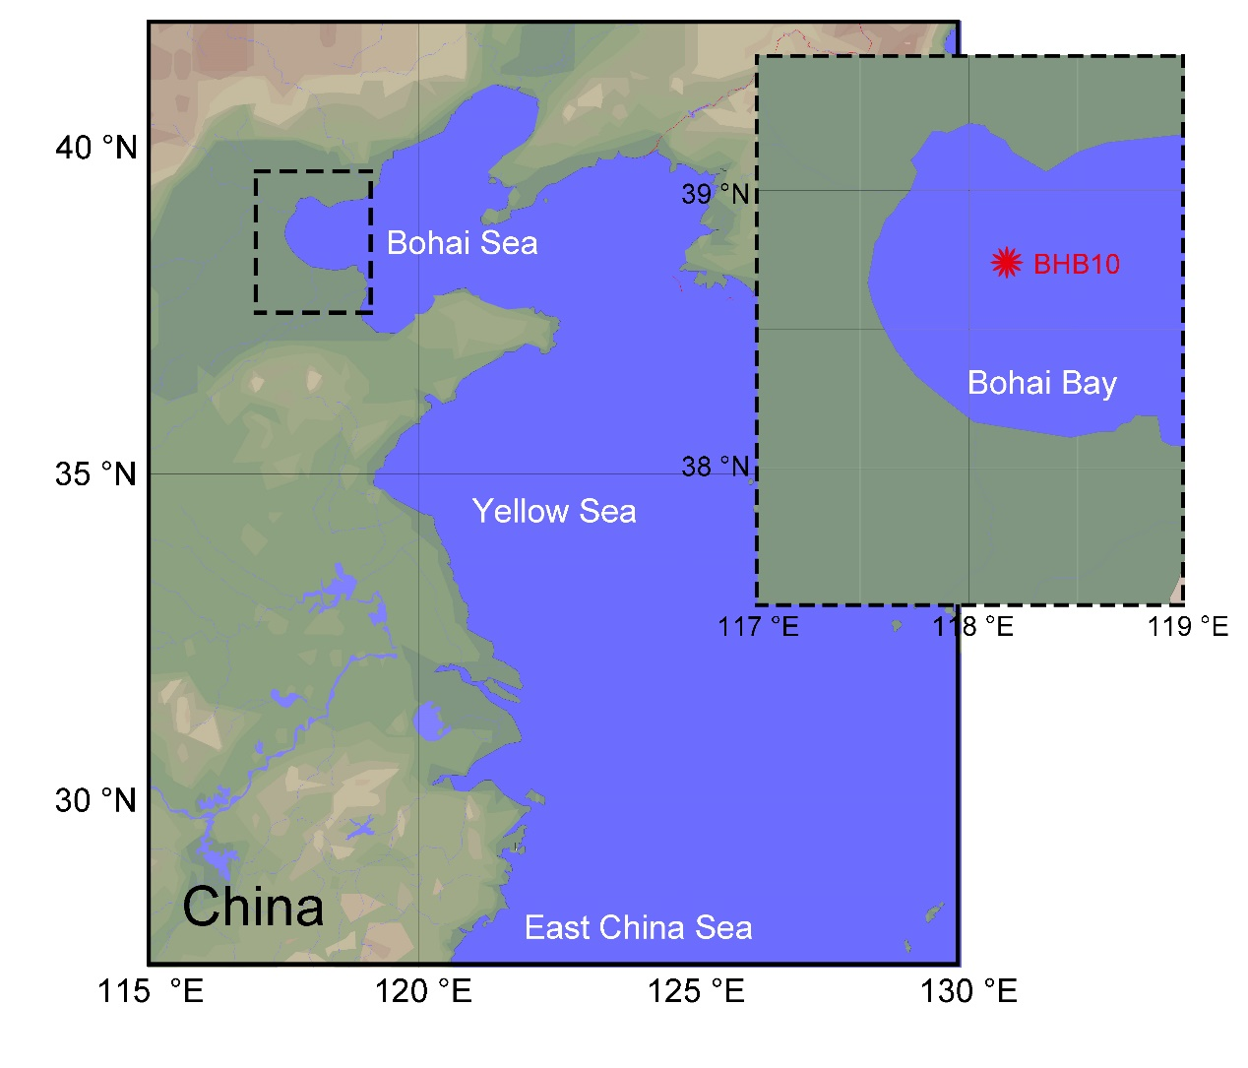
Fig. 2S
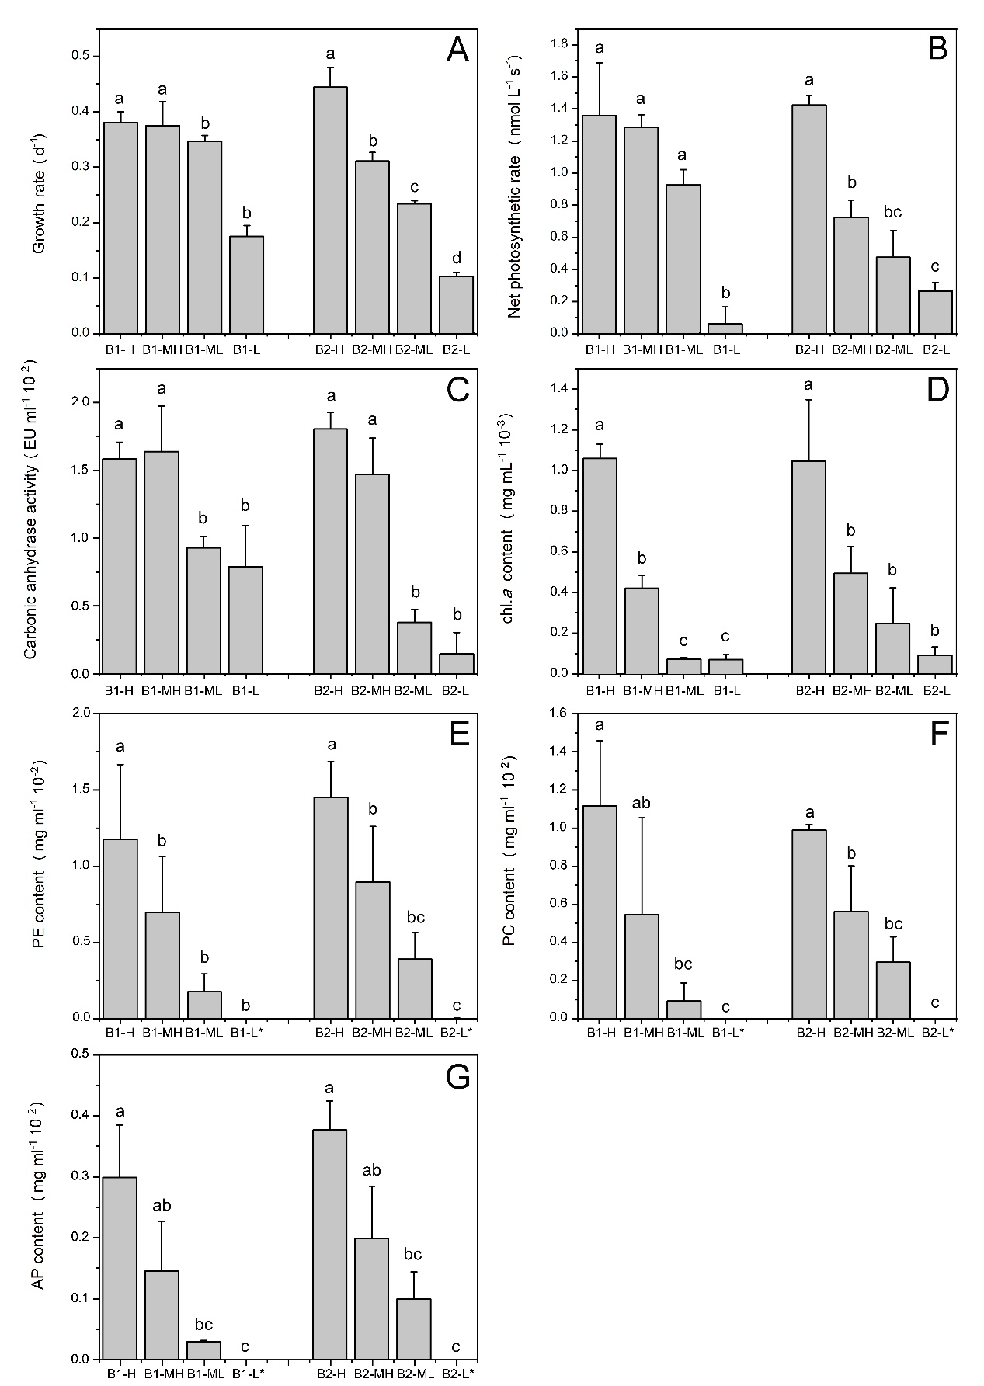

Fig. 3S
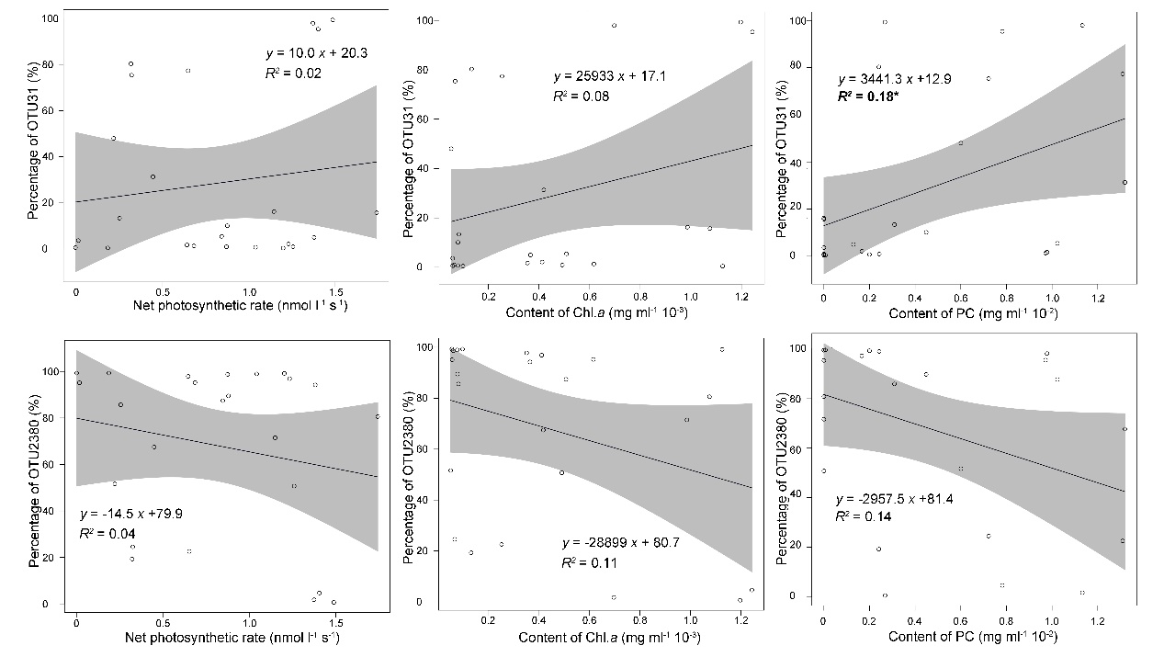

Fig. 4S
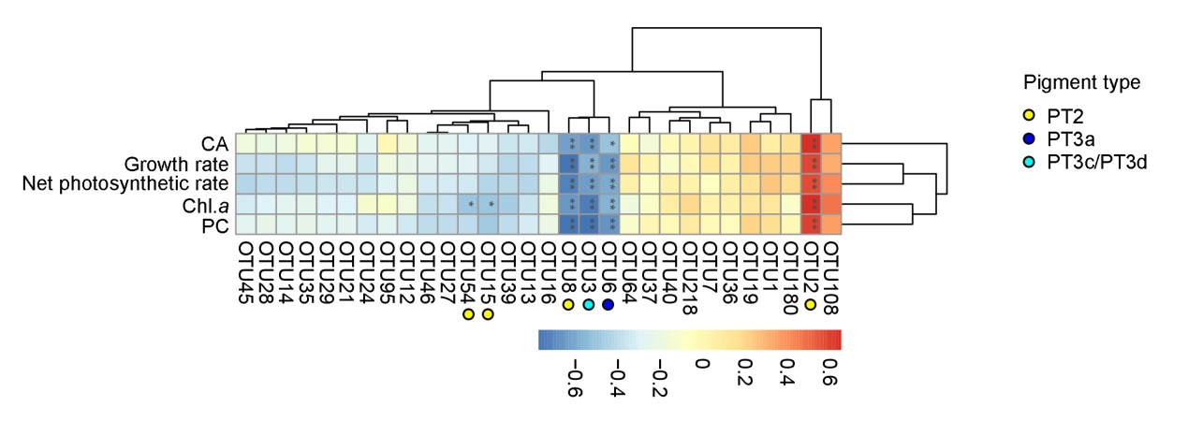

Fig. 5S
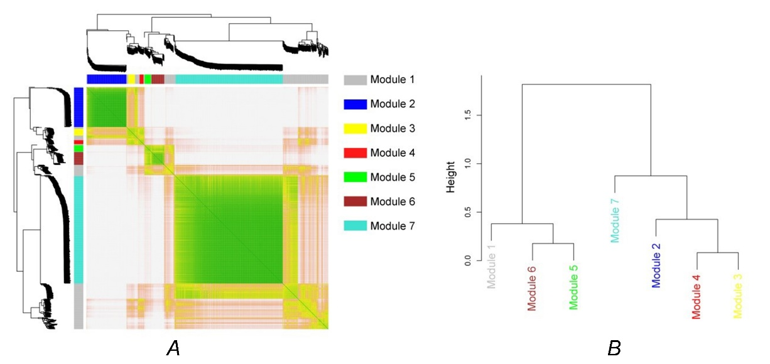

Table 1S

Representative strain | Cluster | Clade | Accession number
Synechococcus sp. Minos01 | S5.3 |  | AJ621022.1
Synechococcus sp. WH8007 | S5.2 | CB5 | AF448107.1
Synechococcus sp. RS9914 | S5.1 | VIII | AJ621011.1
Synechococcus sp. RS9906 | S5.1 | VIII | JQ421058.1
Synechococcus sp. RS9911 | S5.1 | II | AJ621009.1
Synechococcus sp. RS9907 | S5.1 | II | AJ621007.1
Synechococcus sp. RS9903 | S5.1 | IX | AJ621005.1
Synechococcus sp. RS9901 | S5.1 | IX | AJ621003.1

Table 2S

Representative strain | Cluster | Clade | Pigment type | Accession number
Synechococcus sp. A15-60 | S5.1 | VII | 3C | KF528780.1
Synechococcus sp. Minos11 | S5.3 |  | 3dB | KF528785.1
Synechococcus sp. MIT S99220 | S5.1 | CRD1 | 3dA | MG018774.1
Synechococcus sp. SYN20 | S5.1 | I | 3a | MG018776.1
Synechococcus sp. ROS8604 | S5.1 | I | 3a | KF528765.1
Synechococcus sp. WH7803 | S5.1 | V | 3a | X72961.1
Synechococcus sp. M16B.1 | S5.1 | II | 3a | JN566234.1
Synechococcus sp. KORDI-49 | S5.1 | WPC1 | 3a | CP006270.1
Synechococcus sp. BMK-MC | S5.1 | V | 2 | KF528784.1
Synechococcus sp. M12.1 | S5.1 | II | 2 | JN566232.1
Synechococcus sp. PROS-7 | S5.1 | VI | 2 | KF528783.1
Synechococcus sp. A15-44 | S5.1 | II | 2 | KF528782.1

Fitting method | Linear fitting | Nonlinear fitting
Fitting method | Linear fitting | Logarithmic curve | Power curve
Formula | y = a×x+b | y = a×ln(x)+ b | y = a×x^{b}+c
Growth rate | a = 0.00077, b = 0.22, R² = 0.54, ** | a = 0.77, b = 0.0015, R² = 0.78, ** | a = -0.99, b = -0.52, c = 0.46, R² = 0.83, **
Net photosynthetic rate | a = 0.0037, b = 0.46, R² = 0.61, ** | a = 0.35, b = -0.54, R² = 0.79, ** | a = -3.69, b = -0.22, c = 2.45, R² = 0.80, **
Carbonic anhydrase activity | a = 4.2×10⁻⁵, b = 0.0068, R² = 0.53, ** | a = 0.0040, b = -0.0047, R² = 0.71, ** | a = -0.067, b = -0.083, c = 0.060, R² = 0.71, **
Chl. a content | a = 3.62×10⁻⁶, b = 8.58×10⁻⁵,R² = 0.89, ** | a = 0.00029, b = -0.00067, R² = 0.8172, ** | a = 2.54×10⁻⁵,b = 0.67,c = -4.39*10⁻⁵, R² = 0.91, **
PE content | a = 4.49×10⁻⁵, b = 0.0016, R² = 0.71, ** | a = 0.0039, b = -0.0092, R² = 0.80, ** | a = 0.012, b = 0.17, c = -0.017, R² = 0.80, **
PC content | a = 3.69×10⁻⁵, b = 0.00093, R² = 0.73, ** | a = 0.0031, b = -0.0075, R² = 0.77, ** | a = 0.0026, b = 0.32, c = -0.0054, R² = 0.79, **
AP content | a = 0.00012, b = 0.0028, R² = 0.79, ** | a = 0.0099, b = -0.024, R² = 0.82, ** | a = 0.0069, b = 0.35, c = -0.015, R² = 0.84, **
Table 3S

Table 4S

Sample | rpoC1 |  |  |  | cpeBA
Sample | Sequence number | Chao index | Shannon index | Coverage | Sequence number | Chao index | Shannon index | Coverage
B1-H | 11754 | 7 | 0.33 | 0.99 | 42083 | 468 | 2.22 | 0.99
B1-MH | 13601 | 11 | 0.47 | 0.99 | 31740 | 419 | 2.88 | 0.99
B1-ML | 32801 | 6 | 0.05 | 0.99 | 43630 | 458 | 2.04 | 0.99
B1-L | 23543 | 5 | 0.08 | 0.99 | 38625 | 475 | 2.29 | 0.99
B1-I | 17772 | 65 | 2.10 | 0.99 | 56007 | 674 | 3.86 | 0.99
B2-H | 35390 | 8 | 0.11 | 0.99 | 44498 | 575 | 2.30 | 0.99
B2-MH | 5873 | 17 | 0.23 | 0.99 | 44532 | 529 | 2.26 | 0.99
B2-ML | 36566 | 8 | 0.58 | 0.99 | 41208 | 441 | 2.17 | 0.99
B2-L | 13176 | 8 | 0.54 | 0.99 | 33117 | 535 | 2.41 | 0.99
B2-I | 21264 | 59 | 2.00 | 0.99 | 32813 | 698 | 4.12 | 0.99

Table 5S

Module_ID | Average Degree | Average Weighted Degree | Density | Modularity | Number of Communities | Average Clustering Coefficient | Average Path length
Module 1 | 45.72 | 16.69 | 0.25 | 1.45 | 7.00 | 0.76 | 2.43
Module 2 | 46.00 | 90.00 | 0.42 | 0.21 | 7.00 | 1.00 | 1.00
Module 3 | 20.00 | 37.92 | 1.11 | 0.00 | 1.00 | 0.96 | 1.00
Module 4 | 12.00 | 21.95 | 1.20 | 0.00 | 1.00 | 0.91 | 1.00
Module 5 | 18.22 | 33.79 | 1.07 | 0.00 | 2.00 | 0.92 | 1.05
Module 6 | 6.72 | 11.44 | 0.19 | 0.71 | 9.00 | 0.95 | 1.00
Module 7 | 72.73 | 137.87 | 0.24 | 0.60 | 11.00 | 1.00 | 1.00

