Supplement
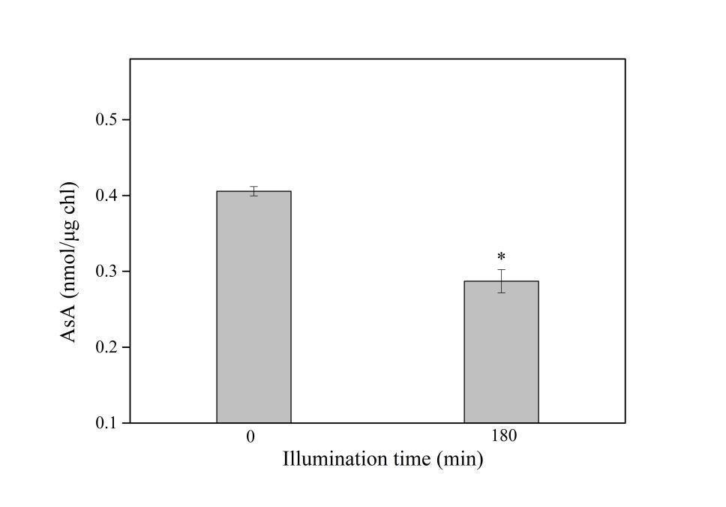
Fig. 1S. The effect of 50 µM rotenone on ascorbate synthesis following light exposure of 180 min. There was significant difference between 0 and 180 min (Tukey's test, P<0.05). Data are expressed as mean ± SD (n = 3).

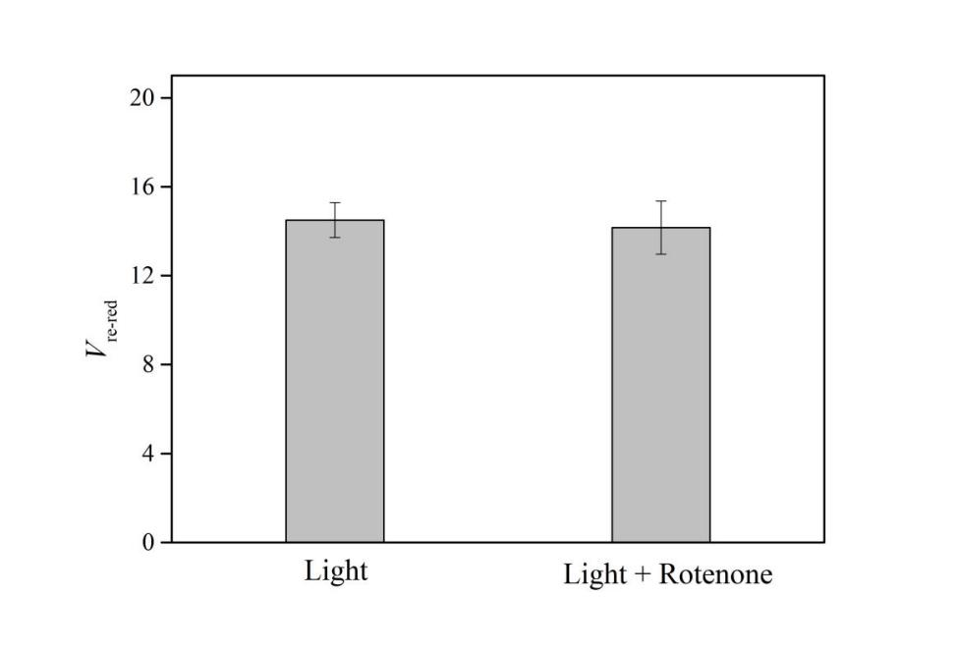
Fig. 2S. The effect of 50 µM rotenone on the initial rate of P700⁺ re-reduction (V_{re-red}) following light exposure of 180 min. There was no significant difference between Light and Light + Rotenone treatments (Tukey's test, P>0.05). Data are expressed as mean ± SD (n = 3).

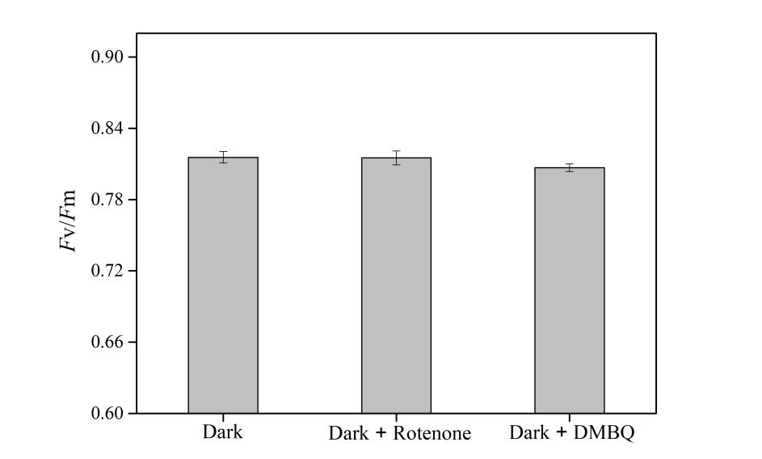

Fig. 3S. The effect of 50 µM rotenone and 125 µM DMBQ on F_{v}/F_{m} under darkness for 190 min. There was no significant difference of F_{v}/F_{m} between the three treatments (Tukey's test, all P values > 0.05). Data are expressed as mean ± SD (n = 3).

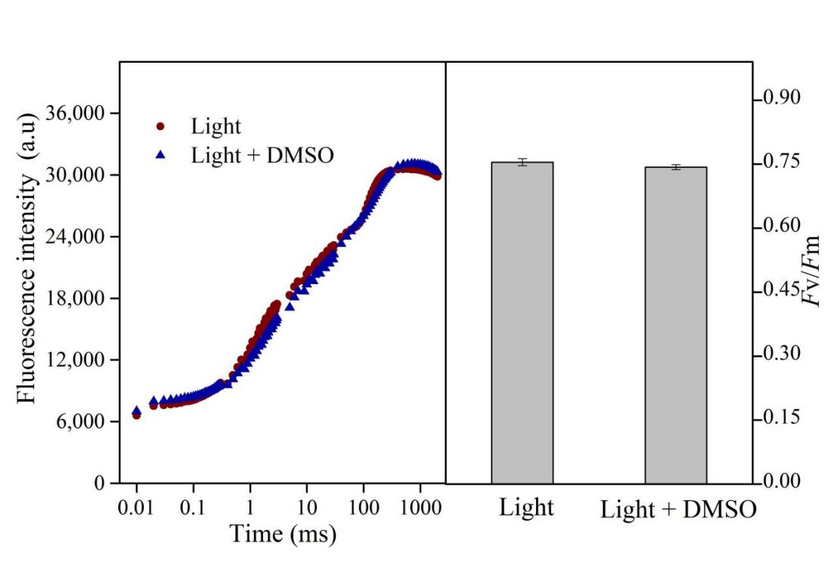

Fig. 4S. The effect of 1.45% (v/v) dimethyl sulfoxide (DMSO) on OJIP transients and F_{v}/F_{m} following light exposure of 3 h. There was no significant difference of F_{v}/F_{m} between Light and Light + DMSO treatments (Tukey's test, P>0.05). Data are expressed as mean ± SD (n = 3).

