Supplementary data
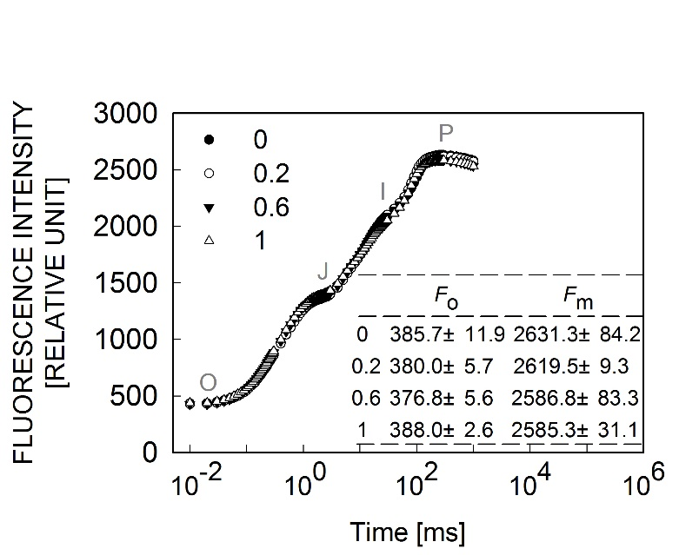
Fig. 1S. Chlorophyll a fluorescence (OJIP) transients in Rumex K-1 leaves in the presence of 0 (control), 0.2, 0.6, or 1 mM SHAM without light. Values are mean ± SE, n = 5.

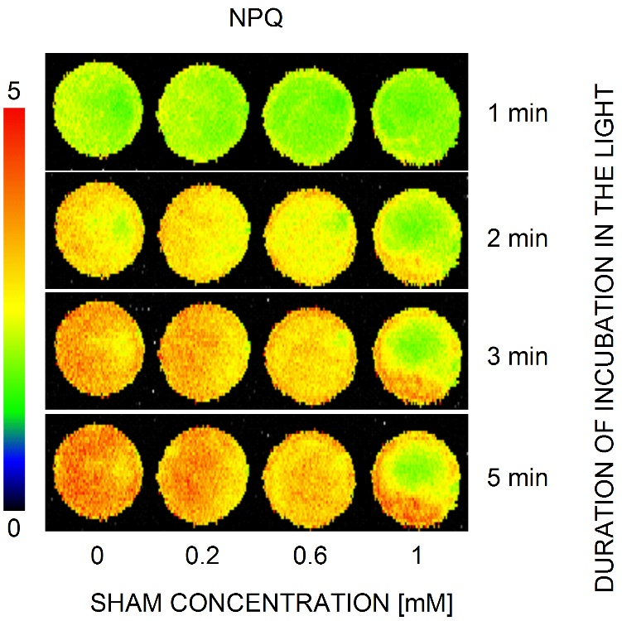

Fig. 2S. Images of NPQ in Rumex K-1 leaf discs (1.3 cm²) under 0 (control), 0.2, 0.6, or 1 mM SHAM treatments during photosynthetic induction.

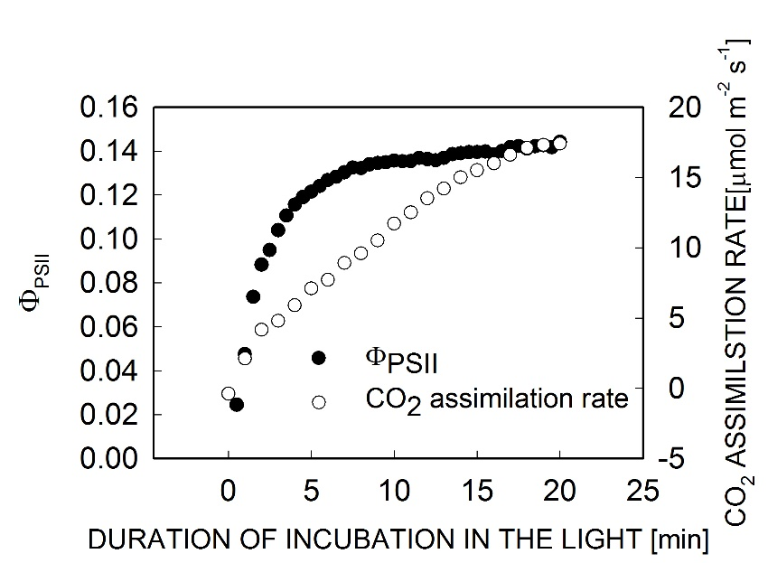

Fig. 3S. Photosystem II actual photochemical efficiency (Φ_{PSII}) and CO₂ assimilation rate in Rumex K-1 leaves during photosynthetic induction.

