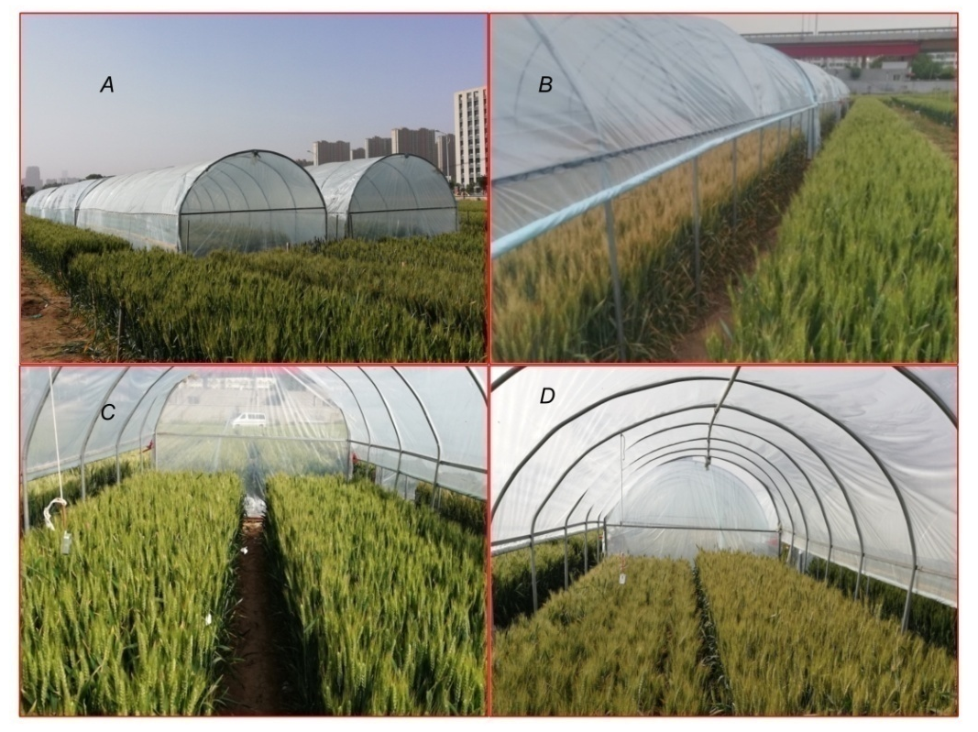

Fig. 1S. The heat tents placed over wheat plants to impose heat stress at 10 d after flowering outside (A and B) and inside the heat tents (C and D).

Fig. 2S. The crop canopy temperatures of control and heat stress in two seasons. CK – control treatment; H – heat stress treatment.

Fig. 3S. Time after anthesis to physiological maturity of four varieties in two seasons. CK – control treatment; GC8901 – Gaocheng8901; JM44 – Jimai44; JM23 – Jimai23; H – heat stress treatment; XM26 – Xinmai26.

Fig. 4S. Correlation between grain yield and other indicators. CK – control treatment; DM – dry mass. F_{v}/F_{m} – maximum quantum yield of PSⅡ photochemistry; GY – grain yield; GN – grain number; H – heat stress treatment;
P_{N} – net photosynthetic rate; TKM – thousand kernel mass; E – transpiration rate; Ф_{PSⅡ} – effective quantum yield of PSⅡ photochemistry.

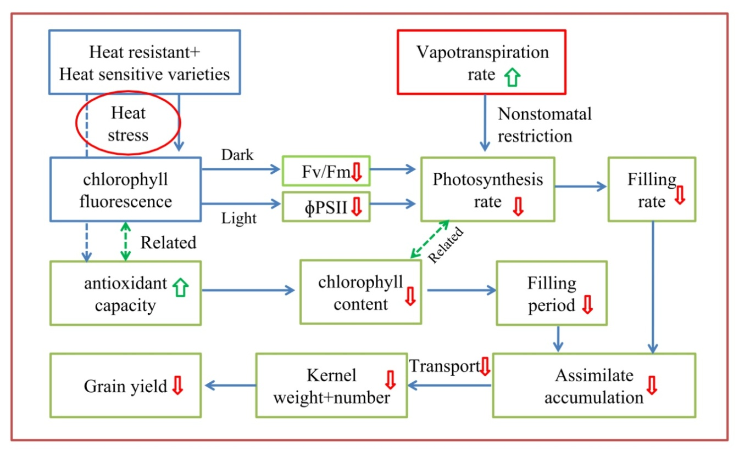
Fig. 5S. The flow chart of effect of heat stress on mechanism of yield reduce in four varieties. Red downward arrow indicates reduction under heat stress; Green up arrow indicates increase under heat stress; The green frame line means heat resistant varieties superior to heat sensitive varieties under heat stress; The red frame line means heat resistant varieties inferior to heat sensitive varieties under heat stress.

Table 1S. KMO and Bartlett's test.

Kaiser-Meyer-Olkin Measure of Sampling Adequacy | Bartlett's Test of Sphericity
Kaiser-Meyer-Olkin Measure of Sampling Adequacy | Approx. Chi-Square | df | Sig.
0.826 | 115.732 | 28 | 0.00

Table 2S. Analysis of variance of F values of SPAD values at different times after anthesis. ***represent significance at 0.01 level, *represent significance at 0.05 level. SPAD – chlorophyll content.

 | SPAD-7d | SPAD-14d | SPAD-21d | SPAD-28d | SPAD-35d
Year | 543.5*** | 477.3*** | 385.1*** | 5279.9*** | 708.7***
Variety | 620.6*** | 563.7*** | 73.8*** | 298.6*** | 176.1***
Heat | 132.2*** | 730.3*** | 182.0*** | 544.3*** | 673.2***
Year × Variety | 22.4*** | 14.9*** | 7.3*** | 8.3*** | 42.3***
Year × Heat | 1.3 | 24.5*** | 3.3 | 13.8*** | 3.2
Variety × Heat | 3.8* | 79.5*** | 47.1*** | 36.0*** | 26.5***
Year × Variety × Heat | 7.8*** | 15.5*** | 17.1*** | 16.3*** | 29.6***

Table 3S. Analysis of dry matter weight of different parts of wheat plant. ***represent significance at 0.01 level, *represent significance at 0.05 level.

 | Spike axis + glume | Grain | Leaf | Stem + sheath
Year | 62.14*** | 3.49 | 31.98*** | 0.98
Variety | 1.48 | 12.76*** | 10.51*** | 12.64***
Heat | 21.90*** | 643.34*** | 43.96*** | 49.35***
Year × Variety | 1.25 | 5.81*** | 12.54*** | 12.64***
Year × Heat | 1.26 | 42.54*** | 0.61 | 3.46
Variety × Heat | 0.46 | 2.60 | 3.48* | 0.78
Year × Variety × Heat | 0.25 | 3.02 | 1.12 | 4.63*

