SUPPLEMENTARY DATA
Journal: Photosynthetica

The melatonin receptor CAND2 is involved in the regulation of photosynthesis and chloroplast gene expression in Arabidopsis thaliana under photooxidative stress

Ivan Bychkov, Natalia Kudryakova, Elena Pojidaeva, Victor Kusnetsov

К.А. Timiryazev Institute of Plant Physiology RAS, 35 Botanicheskaya St., Moscow, 127276 Russia.
CORRESPONDENCE
Prof. Victor Kusnetsov
К.А. Timiryazev Institute of Plant
Physiology RAS, 35 Botanicheskaya St.
Moscow, 127276, Russia
Email: vkusnetsov2001@mail.ru
Tel: +7 499 6785400
FAX: +7 499 6785420

Fig. 1S.
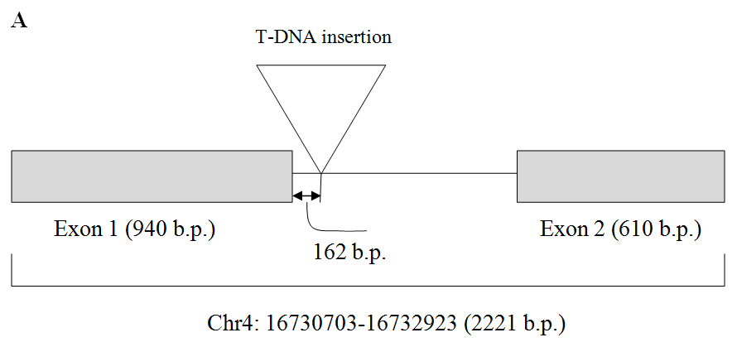
Structure of the ASMT gene (NASC680911 with indication of the position T-DNA insertion Vacuum infiltration of Arabidopsis thaliana plants (ecotype Columbia-0) with Agrobacterium tumefaciens vector pROK2. The insertion disrupts the first intron between the first and the second exons (chr4 16731822).

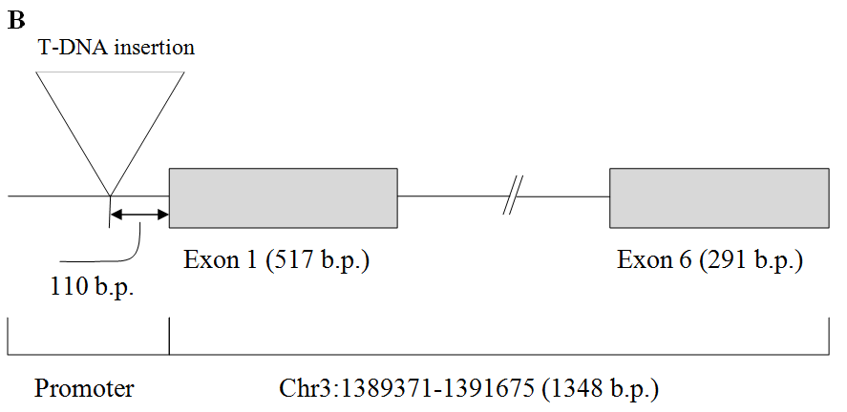
Structure of the CAND2 gene (NASC678658) with indication of the position T-DNA insertion Vacuum infiltration of Arabidopsis thaliana plants (ecotype Columbia-0) with Agrobacterium tumefaciens vector pROK2. The insertion disrupts the promoter before the first exon (chr3 1389261

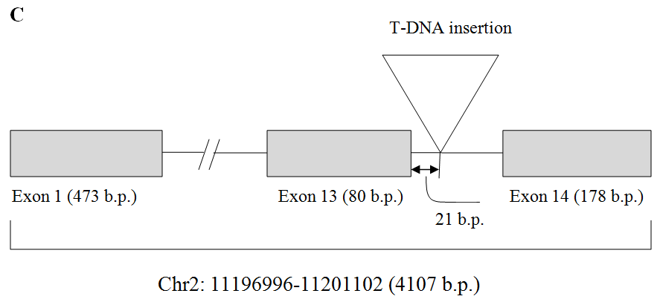
Structure of the GPA1 gene (NASC6534) with indication of the position T-DNA insertion. Vacuum infiltration of Arabidopsis thaliana plants (ecotype Columbia-0) with Agrobacterium tumefaciens vector pROK2. The insertion disrupts the 13 intron between the thirteenth and the fourteenth exons (chr2 11200588).

Table 1S. List of primers used for RT-qPCR.

Gene name | Locus | Forward primer (5′-3′) | Reverse primer (5′-3′)
SNAT1 | AT1G32070 | TAC GCA ACT TGT GGA ACC ACC T | ATC ATA AAC ATC AAT CTC ACC ACC A
ASMT | AT4G35160 | GCAAAGAAGCGGTCCCTCCAA | GTCCGTTCTTTGCCTGTGCTTGT
COMT | AT5G54160 | GGA GTG ACG AAC ATT GCG T | TCT CGG TTC GTT CTT TGC CT
ELIP1 | AT3G22840 | AAG GTG GGA CAC TCG TCT AAG | GTG TTT TTA ACC CGA AGT TTC
LHCB2 | AT3G27690 | CCA ACG ATC TCC TCC GCA AA | AGA CTT GAC GGT ACG ACG CA
rbcL | AtCg00490 | CGG GTA CAT GCG AAG AAA TGA | TCT CGG TCA AAG CAG GCA TA
psbA | Atcg00020 | CGG TGC CAT TAT TCC TAC TTC T | CTT GCC CGA ATC TGT AAC CT
psbD | AtCg00270 | GGA TGA CTG GTT ACG GAG GG | GGT TGT ACC TGT GAA CCA ACC
psaA | AtCg00350 | TAA CCA CGC CCG CTG AAT AG | GGC ACA AGC ATC TCA GGT AA
accD | ArthCp031 | GCT ACC AAT CAA TGT TTA CCT C | GAT TGA TAA TCA CAT AAA ACC G
atpB | AtCg00480 | CTA TGA GTG CGA CAG AGG GT | GAT AGG AGA TGT TGT GCG AG
trnE | ArthCt097 | CCCAGGGGAAGTCGAATCC | GCCCCCATCGTCTAGTGGTTC
rpoA | ArthCp055 | CGC CAA GTA AAG CTC TTC GC | AAG GCC AAG CCG ACA CAA TA
rpoB | ArthCp014 | ATG AGC AAC ACC AAA CCC CT | GGG TAG GCG AAA TGG AGG TT
RPOTp | At2g24120 | TTG CTG CTG CTT GCT ATT CTG C | GCA CAA TCA CCA AGC CAA CT
RPOTmp | At5g15700 | CGT TTC CTC ATT TAG ACT TTC CTC C | CCT TCT CTC TGT CTG CGT CTC TGT
UBQ10 | At4G05320 | GCG TCT TCG TGG TGG TTT CTA A | GAA AGA GAT AAC AGG AAC GGA AAC A

Sequence data from this article can be found in the National Center for Biotechnology Information https://www.ncbi.nlm.nih.gov/

Table 2S. Effect of melatonin treatment on the antioxidant system. Two-week-old plants were shifted for 72 h to paper filters moistened with a liquid MS medium supplemented or not with 50 µM of melatonin and exposed to HL stress (600 μmol m^{–2} s^{–1}) for 24 h. Control plant were grown under moderate light (60 μmol m^{–2} s^{–1}) and harvested at the same time. The data presented in the table are the mean values ± SE (n ≥ 3). Different letters denote statistically significant differences at p<0.05 (ANOVA with post hoc Tukey's multiple-comparison test).

Parameters | Moderate light MS | High light stress MS | Moderate light MS+melatonin | High light stress MS+melatonin | Genotype
TBARs content  [μM g^{–1}(FM)] | 2.751 ± 0.185ª | 6.709 ± 0.189^{b} | 2.771 ± 0.243ª | 4.598 ± 0.172^{c} | WT
TBARs content  [μM g^{–1}(FM)] | 2.611 ± 0.086ª | 7.598 ± 0.230^{b} | 2.531 ± 0.066ª | 4.710 ± 0.298^{c} | asmt
TBARs content  [μM g^{–1}(FM)] | 2.481 ± 0.116ª | 5.972 ± 0.406^{b} | 2.586 ± 0.187ª | 4.702 ± 0.077^{c} | cand2
TBARs content  [μM g^{–1}(FM)] | 2.186 ± 0.147ª | 6.977 ± 0.240^{b} | 2.001 ± 0.113ª | 5.294 ± 0.152^{c} | gpa1
Electrolyte exchange [%] | 20.4ª | 53.7^{b} | 21.1ª | 42.0^{c} | WT
Electrolyte exchange [%] | 18.1ª | 63.5^{b} | 19.0ª | 38.7^{c} | asmt
Electrolyte exchange [%] | 18.5ª | 45.9^{b} | 17.8ª | 44.9^{b} | cand2
Electrolyte exchange [%] | 18.9ª | 52.8^{b} | 20.8ª | 44.2^{c} | gpa1
H₂O₂ content  [mM g^{–1}(FM)] | 0.589 ± 0.021ª | 1.411 ± 0.077^{b} | 0.434 ± 0.017^{c} | 0.976 ±0.045^{d} | WT
H₂O₂ content  [mM g^{–1}(FM)] | 0.747 ± 0.033ª | 1.614 ± 0.060^{b} | 0.568 ± 0.025^{c} | 0.913 ± 0.044^{d} | asmt
H₂O₂ content  [mM g^{–1}(FM)] | 0.631 ± 0.019ª | 1.362 ± 0.047^{b} | 0.505 ± 0.043ª | 0.953 ± 0.047^{d} | cand2
H₂O₂ content  [mM g^{–1}(FM)] | 0.697 ± 0.012ª | 1.430 ± 0.047^{b} | 0.464 ± 0.046^{c} | 0.993 ± 0.051^{d} | gpa1
SOD activity [relative unit] | 0.153 ± 0.010ª | 0.263 ± 0.012^{b} | 0.147 ± 0.009ª | 0.214 ± 0.013^{c} | WT
SOD activity [relative unit] | 0.171 ± 0.010^{ac} | 0.232 ± 0.007^{b} | 0.156 ± 0.011ª | 0.185 ± 0.005^{c} | asmt
SOD activity [relative unit] | 0.188 ± 0.010^{ab} | 0.218 ± 0.009ª | 0.157 ± 0.008^{b} | 0.226 ± 0.012ª | cand2
SOD activity [relative unit] | 0.161 ± 0.020ª | 0.210 ± 0.014^{b} | 0.172 ± 0.011ª | 0. 204 ± 0.025^{b} | gpa1
Proline content,  [mM g^{–1}(FM)] | 0.732 ± 0.022ª | 1.229 ± 0.052^{b} | 0.642 ± 0.012ª | 0.959 ± 0.042^{c} | WT
Proline content,  [mM g^{–1}(FM)] | 0.588 ± 0.019ª | 1.574 ± 0.043^{b} | 0.597 ± 0.012ª | 0.776 ± 0.046^{c} | asmt
Proline content,  [mM g^{–1}(FM)] | 0.565 ± 0.014ª | 0.968 ± 0.021^{b} | 0.537 ± 0.043ª | 0.836 ± 0.035^{b} | cand2
Proline content,  [mM g^{–1}(FM)] | 0.581 ± 0.062ª | 1.137 ± 0.058^{b} | 0.448 ± 0.076ª | 1.001 ± 0.048^{c} | gpa1
P5CSI, relative normalized expression | 1.000 ± 0.095ª | 1.967 ± 0.241^{b} | 0.762 ± 0.100ª | 1.420 ± 0.165^{c} | WT
P5CSI, relative normalized expression | 1.000 ± 0.115ª | 1.052 ± 0.131ª | 0.777 ± 0.093ª | 0.475 ± 0.039^{b} | asmt
P5CSI, relative normalized expression | 1.000 ± 0.102ª | 0.908 ± 0.170ª | 0.794 ± 0.062ª | 1.042 ± 0.149ª | cand2
P5CSI, relative normalized expression | 1.000 ± 0.108ª | 1.317 ± 0.148 ª | 1.151 ± 0.12 ª | 1.356 ± 0.127 ª | gpa1
PRODH, relative normalized expression | 1.000 ± 0.120ª | 0.276 ± 0.031^{b} | 0.594 ± 0.071^{c} | 1.781 ± 0.230^{d} | WT
PRODH, relative normalized expression | 1.000 ± 0.124ª | 0.644 ± 0.084^{b} | 1.283 ± 0.130ª | 1.042 ± 0.121ª | asmt
PRODH, relative normalized expression | 1.000 ± 0.101ª | 0.558 ± 0.059^{bc} | 0.708 ± 0.075^{b} | 0.386 ± 0.041^{c} | cand2
PRODH, relative normalized expression | 1.000 ± 0.061ª | 0.797 ± 0.085^{ab} | 1.178 ± 0.095ª | 0.710 ± 0.074^{b} | gpa1

Table 3S. Effect of HL stress and melatonin treatment on the expression of plastid-encoded genes and LHCB2 (light harvesting antenna protein of PSII). Two-week-old plants were shifted for 72 h to paper filters moistened with a liquid MS medium supplemented or not with 50 µM of melatonin and exposed to HL stress (PPFD 600 μmol m^{–2} s^{–1}) for 24 h. Control plants were grown under moderate light (PPFD 60 μmol m^{–2} s^{–1}) and harvested at the same time. RNAs were analyzed by RT-qPCR using UBQ10 as internal standard. The data presented in the table are the mean values ± SE (n ≥ 3). Different letters denote statistically significant differences at p<0.05 (ANOVA with post hoc Tukey's multiple-comparison test).

Genotype | Moderate light MS | High light stress MS | Moderate light MS+melatonin | High light stress MS+melatonin
rbcL
Wild type | 1.000 ± 0.119ª | 0.378 ± 0.040^{b} | 0.951 ± 0.087ª | 0.653 ± 0.071^{c}
asmt | 1.000 ± 0.115ª | 0.157 ± 0.019^{b} | 1.003 ± 0.102ª | 0.638 ± 0.063^{c}
cand2 | 1.000 ± 0.095ª | 0.278 ± 0.029^{b} | 0.821 ± 0.092ª | 0.424 ± 0.054^{b}
gpa1 | 1.000 ± 0.102ª | 0.406 ± 0.050^{b} | 0.905 ± 0.099ª | 0.520 ± 0.059^{b}
psbA
Wild type | 1.000 ± 0.085ª | 0.233 ± 0.025^{b} | 0.899 ± 0.091ª | 0.551 ± 0.050^{c}
asmt | 1.000 ± 0.114ª | 0.334 ± 0.029^{b} | 1.111 ± 0.089ª | 0.630 ± 0.066^{c}
cand2 | 1.000 ± 0.107ª | 0.353 ± 0.033^{b} | 1.008 ± 0.082ª | 0.388 ± 0.034^{b}
gpa1 | 1.000 ± 0.103ª | 0.401 ± 0.043^{b} | 0.891 ± 0.094ª | 0.455 ± 0.067^{b}
psaA
Wild type | 1.000 ± 0.104ª | 0.156 ± 0.013^{b} | 0.894 ± 0.093ª | 0.447 ± 0.046^{c}
asmt | 1.000 ± 0.088ª | 0.154 ± 0.016^{b} | 0.940 ± 0.099ª | 0.452 ± 0.041^{c}
cand2 | 1.000 ± 0.103ª | 0.252 ± 0.033^{b} | 0.959 ± 0.094ª | 0.219 ± 0.027^{b}
gpa1 | 1.000 ± 0.100ª | 0.331 ± 0.035^{b} | 1.102 ± 0.101ª | 0.290 ± 0.026^{b}
accD
Wild type | 1.000 ± 0.120ª | 0.341 ± 0.033^{b} | 0.915 ± 0.083ª | 0.783 ± 0.079ª
asmt | 1.000 ± 0.098ª | 0.278 ± 0.030^{b} | 0.978 ± 0.098ª | 0.647 ± 0.081^{c}
cand2 | 1.000 ± 0.104ª | 0.521 ± 0.044^{b} | 1.081 ± 0.084ª | 0.508 ± 0.047^{b}
gpa1 | 1.000 ± 0.109ª | 0.552 ± 0.058^{b} | 0.973 ± 0.088ª | 0.464 ± 0.057^{b}
atpB
Wild type | 1.000 ± 0.099ª | 0.300 ± 0.031^{b} | 0.904 ± 0.095ª | 0.581 ± 0.061^{c}
asmt | 1.000 ± 0.102ª | 0.223 ± 0.025^{b} | 0.975 ± 0.099ª | 0.544 ± 0.055^{c}
cand2 | 1.000 ± 0.104ª | 0.349 ± 0.034^{b} | 0.947 ± 0.091ª | 0.396 ± 0.049^{b}
gpa1 | 1.000 ± 0.114ª | 0.377 ± 0.039^{b} | 0.909 ± 0.092ª | 0.353 ± 0.039^{b}

