Table 1S. Effects of different treatments on the light-saturation point (I_{sat}), light-compensation point (I_{c}), and dark respiration rate (R_{D}) of the different treatments. L1: ambient sunlight; L2: 40% shade; P0: phosphate fertilizer application of 0 kg(P₂O₅) ha^{–1}; P1: phosphate fertilizer application of 180 kg(P₂O₅) ha^{–1}. L: light factor, P: phosphate fertilizer factor, L × P: interaction between light and phosphate fertilizer. Different lowercase letters in the same column indicate significant differences (P<0.05). *P<0.05, **P<0.01, ns: not significant.

Treatment |  | I_{sat} [μmol m^{–2} s^{–1}] |  |  | I_{c} [μmol m^{–2} s^{–1}] |  |  | R_{D} [μmol m^{–2} s^{–1}]
Light (L) | Phosphorus (P) | R1 | R3 | R5 | R1 | R3 | R5 | R1 | R3 | R5
L1 | P0 | 1, 530.8 ± 20.3 | 1, 541.9 ± 33.4 | 1, 359.5 ± 9.4 | 170.4 ± 1.6 | 114.8 ± 1.4 | 169.3 ± 2.3 | 7.7 ± 0.2 | 4.4 ± 0.3 | 8.2 ± 0.3
L1 | P1 | 1, 544.2 ± 35.1 | 1, 682.4 ± 40.1 | 1, 492.7 ± 10.4 | 136.9 ± 2.1 | 38.3 ± 1.1 | 88.7 ± 1.0 | 5.8 ± 0.3 | 1.9 ± 0.2 | 4.7 ± 0.2
L2 | P0 | 1, 251.5 ± 18.6 | 1, 223 ± 11.3 | 1, 117.6 ± 9.8 | 264.3 ± 3.4 | 177 ± 2.5 | 200.6 ± 2.3 | 9.5 ± 0.2 | 9.2 ± 0.9 | 10.6 ± 0.9
L2 | P1 | 1, 479.7 ± 12.7 | 1, 497.2 ± 10.5 | 1, 295.9 ± 6.7 | 204.7 ± 4.1 | 99.5 ± 3.7 | 117.2 ± 1.6 | 9 ± 0.3 | 6.6 ± 0.7 | 7.6 ± 0.8
Mean for light (L)
L1 |  | 1, 537.5 ª | 1, 612.2 ª | 1, 426.1 ª | 153.7 ^{b} | 76.6 ^{b} | 129 | 6.8 ^{b} | 3.2 ^{b} | 6.5 ^{b}
L2 |  | 1, 365.6 ^{b} | 1, 360.1 ^{b} | 1, 206.8 ^{b} | 234.5 ª | 138.3 ª | 158.9 | 9.3 ª | 7.9 ª | 9.1 ª
Mean for phosphorus (P)
P0 |  | 1, 391.2 ^{b} | 1, 382.5 ^{b} | 1, 238.6 | 217.4 ª | 145.9 ª | 185 ^{b} | 8.6 | 6.8 | 9.4 ª
P1 |  | 1, 512 ª | 1, 589.8 ª | 1, 394.3 | 170.8 ^{b} | 68.9 ^{b} | 103 ª | 7.4 | 4.3 | 6.2 ^{b}
Significance
L |  | ns | ns | ns | ** | ** | * | ** | ** | **
P |  | ns | ns | ns | ** | ** | ** | ns | ** | **
L × P |  | ns | ns | ns | ns | ns | ns | ns | ns | ns

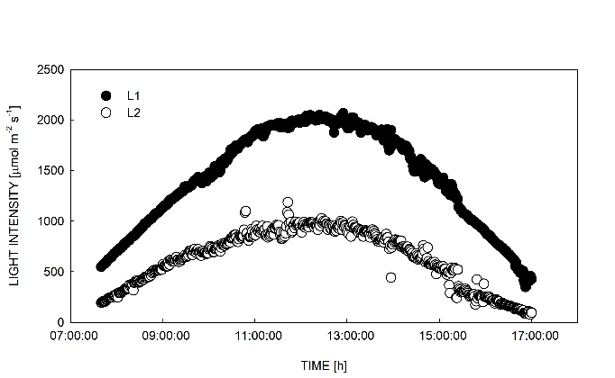

Fig. 1S. The light intensity on the upper of L1 and L2 treatment. L1: ambient sunlight; L2: 40% shade.

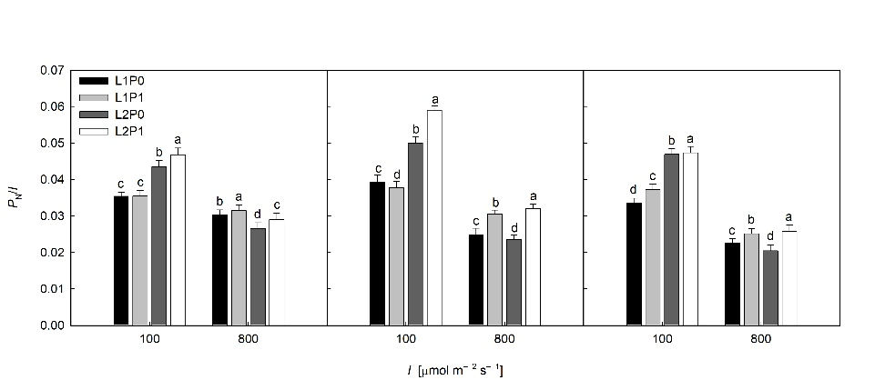

Fig. 2S. Changes in the plant's light energy utilization efficiency (P_{N}/I) of different treatments. L1: ambient sunlight; L2: 40% shade; P0: phosphate fertilizer application of 0 kg(P₂O₅) ha^{–1}; P1: phosphate fertilizer application of 180 kg(P₂O₅) ha^{–1}. Data are means of six replications. Lowercase letters above bars indicate significant differences at P<0.05 between the light intensity treatments (100 and 800 μmol m^{–2} s^{–1}).

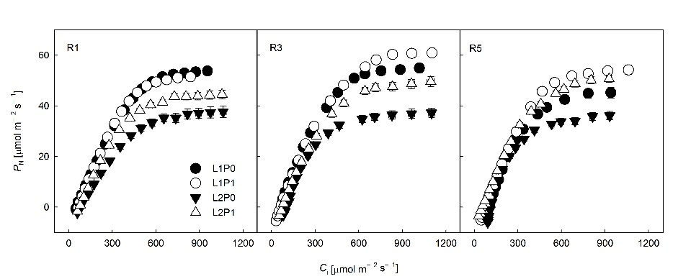

Fig. 3S. Changes in net photosynthetic rate–intercellular CO₂ concentration curve (P_{N}–C_{i}) of different treatments. L1: ambient sunlight; L2: 40% shade; P0: phosphate fertilizer application of 0 kg(P₂O₅)
ha^{–1}; P1: phosphate fertilizer application of 180 kg(P₂O₅) ha^{–1}. Data are means of six replications.

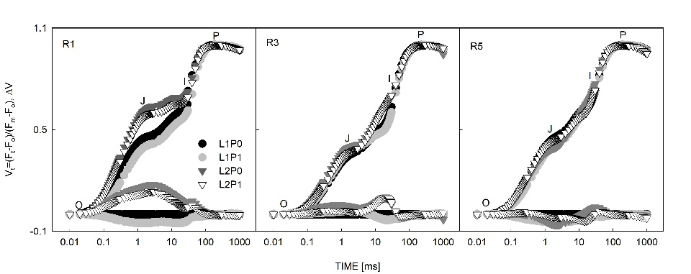

Fig. 4S. Changes in Chl a fluorescence transient curves (OJIP) of different treatments. The upper curves represent the rise in the relative variable fluorescence normalized between F_{o} and F_{m} and plotted as V_{t} changes on a logarithmic scale [V_{t} = (F_{t} − F_{o})/(F_{m} − F_{o})]. The ΔV_{t} values were derived (lower curves) from these OJIP curves (Strasser et al. 1992). L1: ambient sunlight; L2: 40% shade; P0: phosphate fertilizer application of 0 kg(P₂O₅) ha^{–1}; P1: phosphate fertilizer application of 180 kg (P₂O₅) ha^{–1}. Data are means of nine replications.

Reference:
Strasser R.J., Govindjee: The F0 and the O-J-I-P fluorescence rise in higher plants and algae. – In: Argyroudi-Akoyunoglou J.H. (ed.): Regulation of Chloroplast Biogenesis. Pp. 423-426. Springer, Boston 1992.

