Table 1S. Analysis of variance of the investigated parameters. C – cultivar; T – treatment; C × T – the interaction of C and T; * and ** represent significant differences at 0.05 and 0.01 levels, respectively. ^{ns} – nonsignificant at P<0.05 level. C_{i} – intercellular CO₂ concentration; DAS – days after spraying; DM – dry mass; E – transpiration rate; FM – fresh mass; g_{s} – stomatal conductance; P_{N} – net photosynthetic rate.

Index | C | T | C × T
Shoot FM | 55,167.50** | 20.24** | 0.19^{ns}
Shoot DM | 746.51** | 73.40** | 8.75**
Root FM | 197.85** | 68.20** | 24.34**
Root DM | 172.33** | 58.82** | 4.70*
Seedling height | 232.14** | 20.50** | 6.07**
Fe content in shoot | 23.12* | 78.33** | 0.40^{ns}
Root average diameter | 1.5E+31** | 35.17** | 41.83**
Root length | 29.54* | 51.17** | 30.37**
Root surface area | 1913.73** | 291.53** | 147.59**
Root volume | 259.57** | 25.11** | 0.23^{ns}
P_{N} at 1 DAS | 141.41** | 1.15^{ns} | 1.08^{ns}
P_{N} at 2 DAS | 8.73^{ns} | 170.10** | 11.34**
P_{N} at 3 DAS | 450.20** | 368.02** | 75.88**
P_{N} at 4 DAS | 178.67** | 57.33** | 5.90*
P_{N} at 5 DAS | 2.97^{ns} | 180.88** | 50.53**
g_{s} at 1 DAS | 1.03^{ns} | 10.76** | 0.19^{ns}
g_{s} at 2 DAS | 2.44^{ns} | 73.46** | 2.56^{ns}
g_{s} at 3 DAS | 1,482.25** | 63.76** | 0.39^{ns}
g_{s} at 4 DAS | 126.75** | 21.04** | 9.64**
g_{s} at 5 DAS | 29.71* | 10.32** | 7.42**
C_{i} at 1 DAS | 1.43^{ns} | 5.11* | 0.05^{ns}
C_{i} at 2 DAS | 10.13^{ns} | 3.56* | 1.00^{ns}
C_{i} at 3 DAS | 66.16* | 11.20** | 10.51**
C_{i} at 4 DAS | 17.84^{ns} | 6.22** | 4.23*
C_{i} at 5 DAS | 66.35* | 46.46** | 8.69**
E at 1 DAS | 1.26^{ns} | 5.98** | 0.19^{ns}
E at 2 DAS | 0.01^{ns} | 69.90** | 1.40^{ns}
E at 3 DAS | 693.3** | 124.19** | 3.19^{ns}
E at 4 DAS | 17.07^{ns} | 27.51** | 2.43^{ns}
E at 5 DAS | 6.88^{ns} | 30.09** | 6.95**

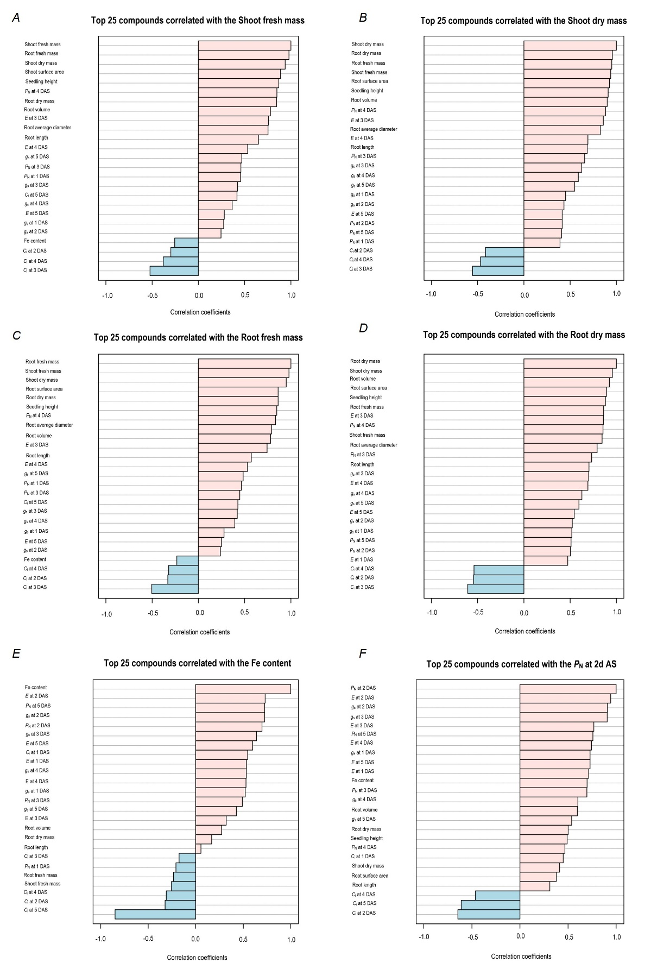
Fig. 1S. The top 25 parameters correlated with (A) shoot fresh mass, (B) shoot dry mass, (C) root fresh mass, (D) root dry mass, (E) Fe content, and (F) P_{N} at 2 DAS. C_{i} – intercellular CO₂ concentration; DAS – days after spraying; E – transpiration rate; g_{s} – stomatal conductance; P_{N} – net photosynthetic rate.

