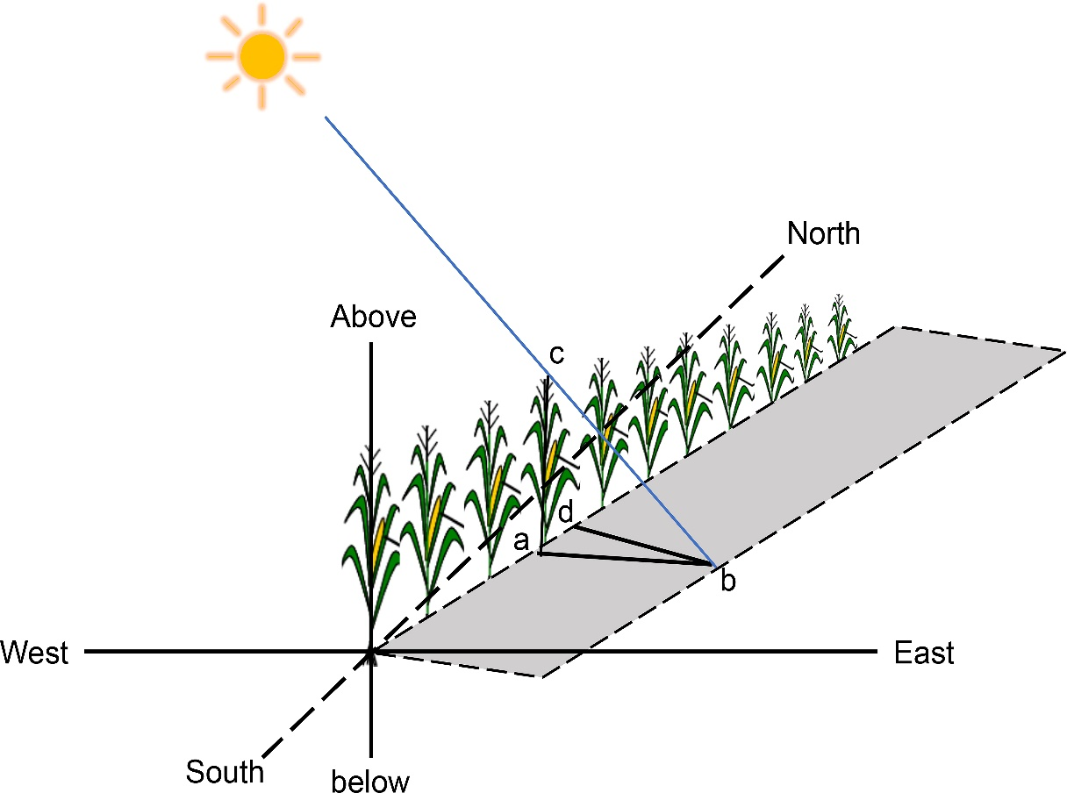

Fig. 1S. Projection diagram of crop plant in the field.
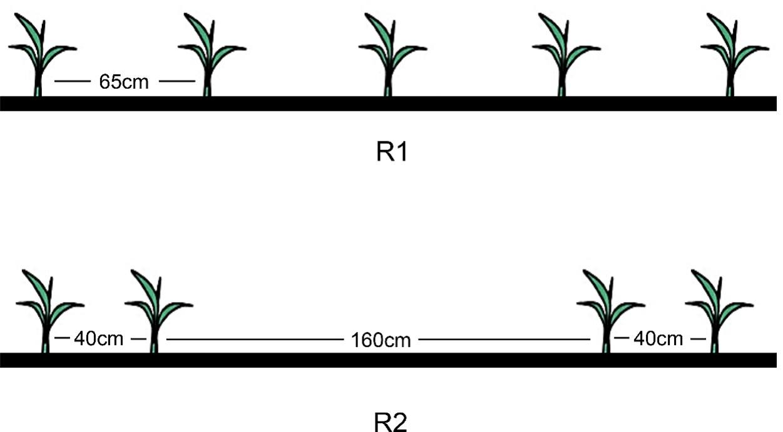

Fig. 2S. The sketch map of different planting patterns.

