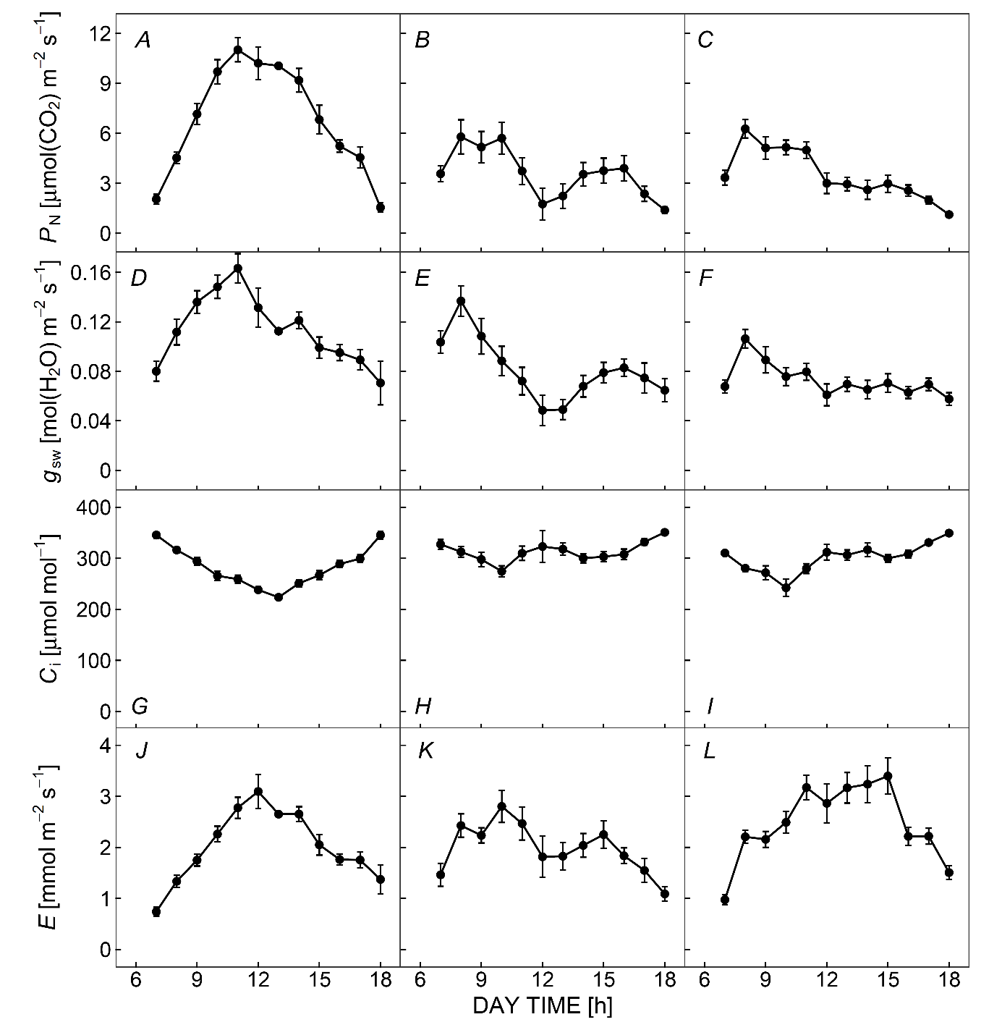
Fig. 1S. Diurnal changes in photosynthetic rate (P_{N}; A, B, C), stomatal conductance to H₂O (g_{sw}; D, E, F), intercellular CO₂ concentration (C_{i}; G, H, I), and transpiration rate (E; J, K, L). The respective rows indicate the day when the gas-exchange measurements were conducted (i.e., A, D, G, J: 22 May; B, E, H, K: 23 May; C, F, I, L: 30 May). The measurements were conducted from 6:30 to 18:00 h (Japan standard time) at intervals of about 5 min and plotted in figures as an hourly average (e.g., data point at 7 h represents the data average between 6:30 and 7:30 h). Means ± SE (n = about 15) are shown.

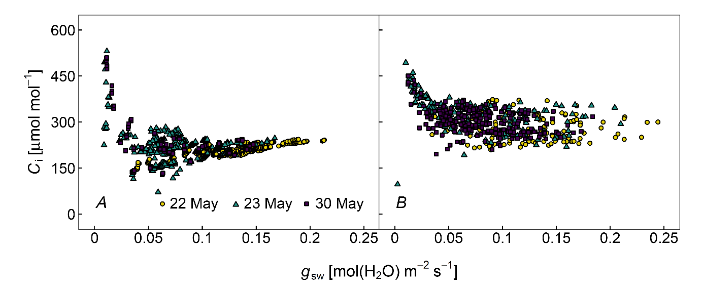

Fig. 2S. Relationships between stomatal conductance to water vapor (g_{sw}) and intercellular CO₂ concentration (C_{i}) measured by a portable gas-exchange system (LI-6400, LI-COR, Lincoln, NE, USA) equipped with a leaf chamber fluorometer (A) and clear top chamber (B) on the day when gas-exchange measurements were conducted (i.e., yellow circle: 22 May; blue triangle: 23 May; purple square: 30 May).

Fig. 3S. Relationships between leaf temperature (T_{leaf}) and maximum carboxylation rate based on the CO₂ concentration at the carboxylation site at T_{leaf} [V_{cmax}(C_{c},T_{leaf})]. The red lines were calculated from the fitting curve using the Arrhenius function.

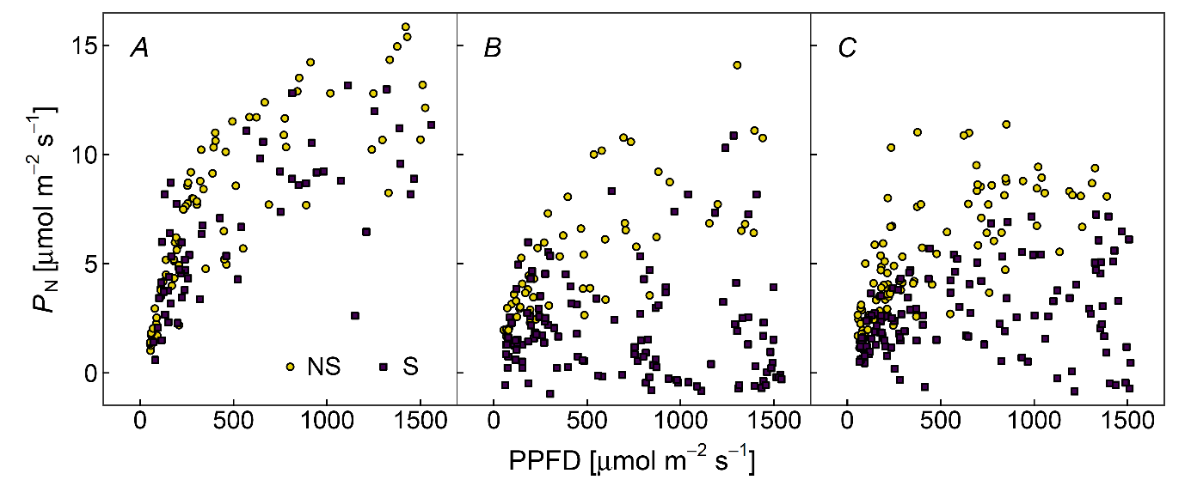
Fig. 4S. Relationships between PPFD and leaf photosynthetic rate (P_{N}) on the day when gas-exchange measurements were conducted (i.e., A: 22 May; B: 23 May; C: 30 May). NS and S indicate P_{N} before (yellow circle) and after (purple square) environmental stress-induced decreases, respectively.

