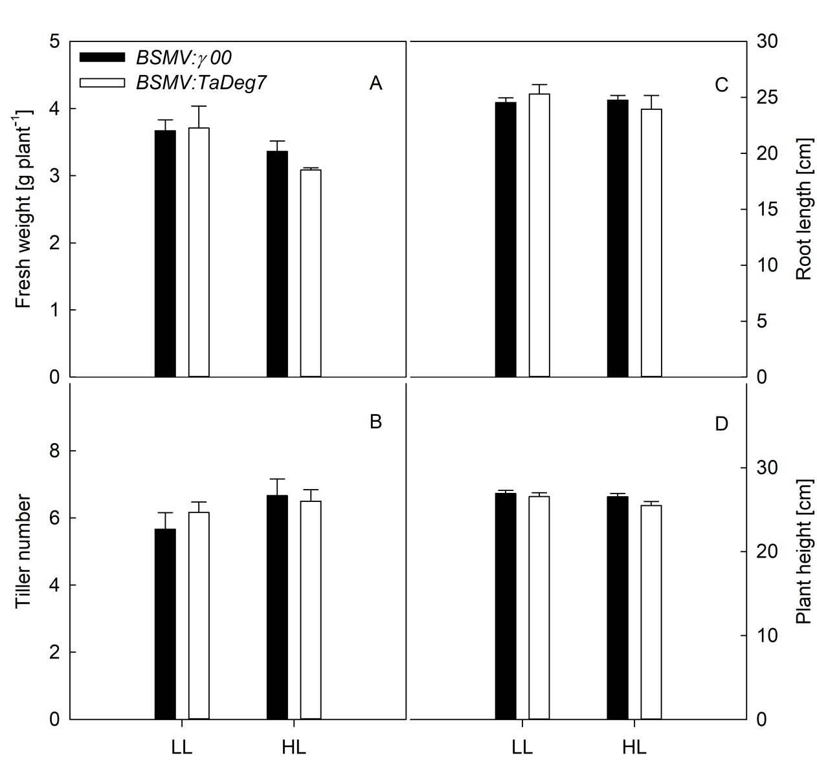

Fig. 1S. The fresh mass (A), tiller number (B), root length (C), and plant height (D) in the BSMV:TaDeg7 and BSMV:γ 00 plants grown in LL and HL. Data are represented as mean ± SE.

