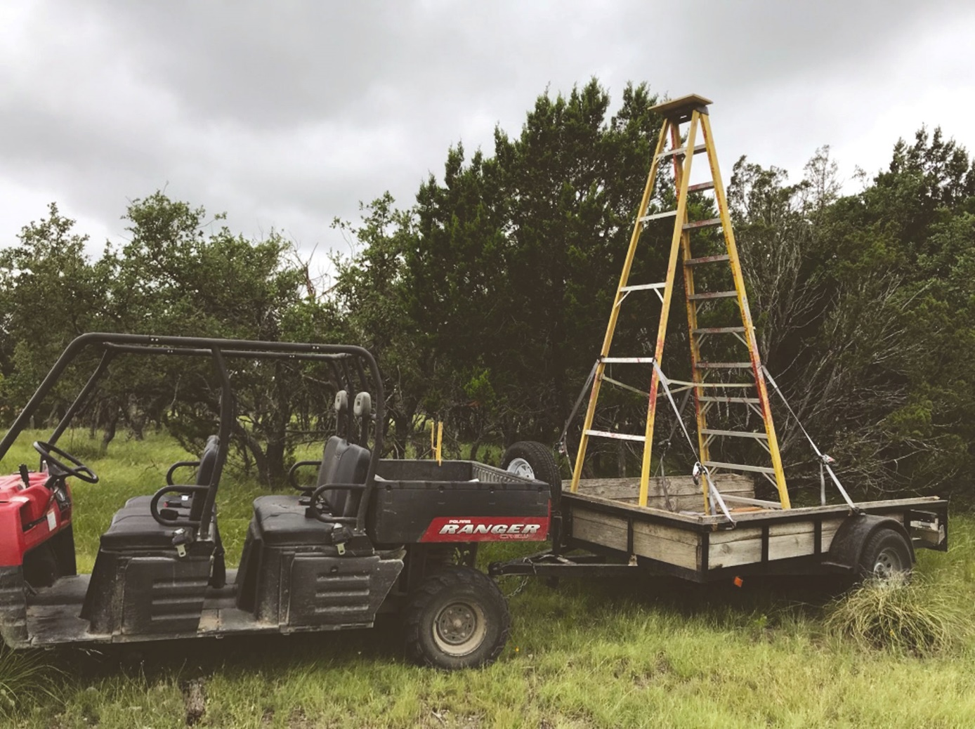

Fig. 1S. Mobile tree sampling platform utilized for leaf-level physiology measurements.

