Supplementary data
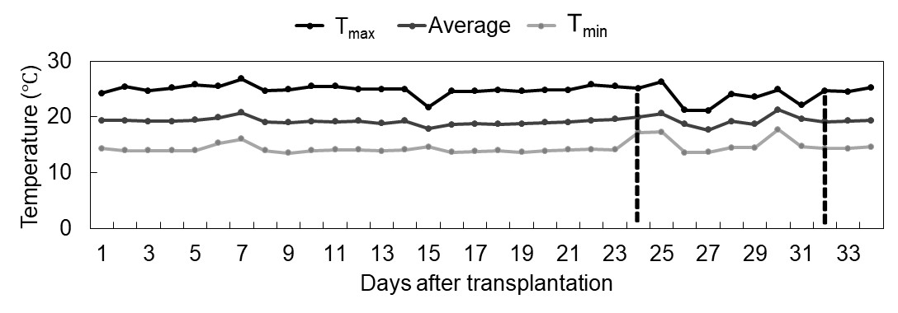

Fig. 1S. Maximum (T_{max}), minimum (T_{min}), and the average temperature in the greenhouse during the experiment. Dotted vertical lines indicate sampling days in the days after transplantation.

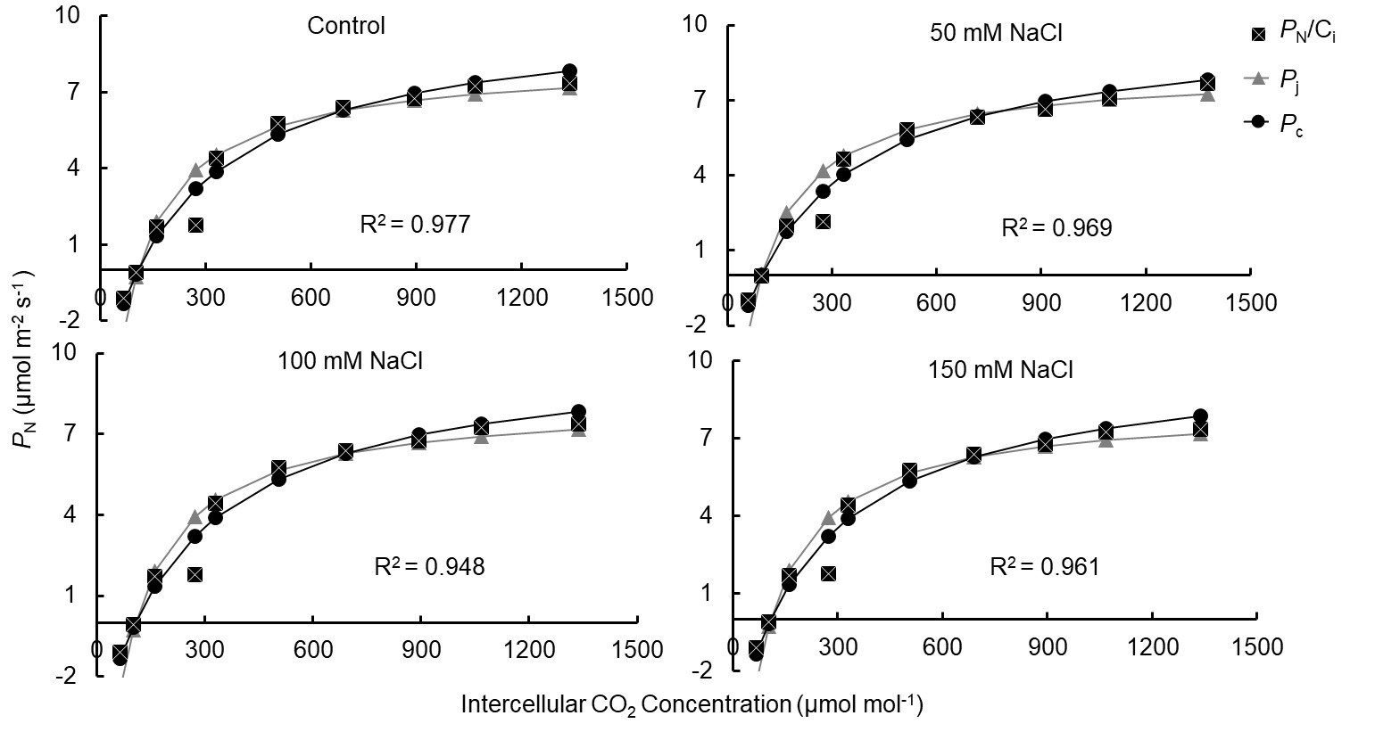

Fig. 2S. Response of the CO₂ assimilation rate (P_{N}) to increasing intercellular CO₂ concentration (C_{i}) (P_{N}/C_{i} curve) in the ‘Green Forest’ lettuce after 11 d (late rosette, GS1) of control and salt treatments. The vertical bars represent the standard error of the mean (n = 4).

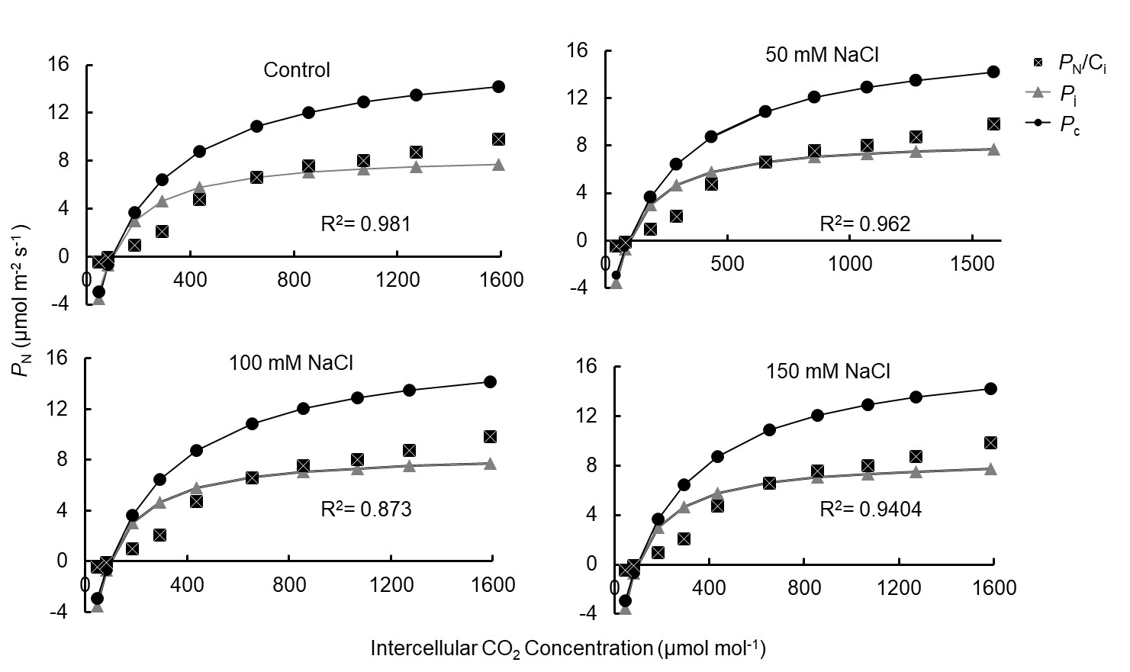
Fig. 3S. Response of the CO₂ assimilation rate (P_{N}) to increasing intercellular CO₂ concentration (C_{i}) (P_{N}/C_{i} curve) in the lettuce after 19 d (early head-formation, GS2) of control and salt treatments. The vertical bars represent the standard error of the mean (n = 4).

Table 1S. Environmental conditions in the greenhouse during transplantation (day 0), late-rosette stage (GS1), and early head-formation stage (GS2).

Environmental conditions | Day 0 | GS1 | GS2
Photosynthetic photon flux density [µmol m^{–2} s^{–1}] | 147.59 | 130.79 | 284.77
Relative humidity [%] | 65.33% | 68.21% | 71.45%
Temperature [℃] | 19.39 | 19.95 | 19.11

