Table 1S. Period of conduction of each stage of the recurrent water deficit in the two species expressed in days.

Events | CYCLE 1 | CYCLE 2 | CYCLE 3
Dry | 4 | 10 | 8
Recovery | 7 | 5 | 3

Table 2S. Abbreviations of the parameters, formulas, and description of the data derived from the chlorophyll a fluorescence transients. For review see Strasser et al. (2004).

Fluorescence parameter | Description
Extracted fluorescence parameters
ABS/RC = (M₀/V_{J})/φP₀ | absorption flux per RC
TR₀/RC = M₀/V_{J} | trapped energy flux per RC (at t = 0)
ET₀/RC = (M₀/V_{J}) × ψE₀ | electron transport flux per RC (at t = 0)
DI₀/RC = ABS/RC – TR₀/RC | dissipated energy flux per RC (at t = 0)
RC/CS_{x} = φP₀ (V_{J}/M₀) (ABS/CS_{x}) | density of RCs (Q_{A}– reducing PSII reaction centers)
φP₀ = TR₀/ABS = [1 − (F₀/F_{m})] = F_{V}/F_{m} | maximum quantum yield of primary photochemistry
φE₀= ET₀/ABS = [1 – (F₀/F_{m})] ψ₀ | quantum yield of electron transport (at t = 0)
PI_{(abs)} = (RC/ABS) × [φP₀/(1 – φP₀)] × [ψE₀/(1 – ψE₀)] | performance index on absorption basis

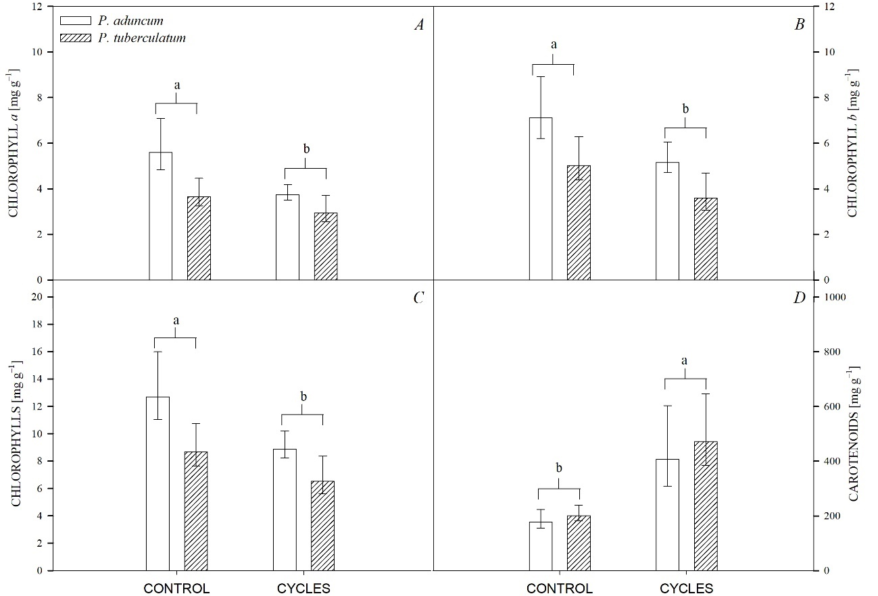

Fig. 1S. Content of photosynthetic pigments in Piper aduncum and Piper tuberculatum submitted to three cycles of drought and recovery, compared with the control (plants kept irrigated and evaluated throughout the experimental period) and with the values before the drought (T0). Means followed by the same letter do not differ from Tukey's test (p<0.05). A – chlorophyll a, B – chlorophyll b, C – total chlorophylls, D – total carotenoids.

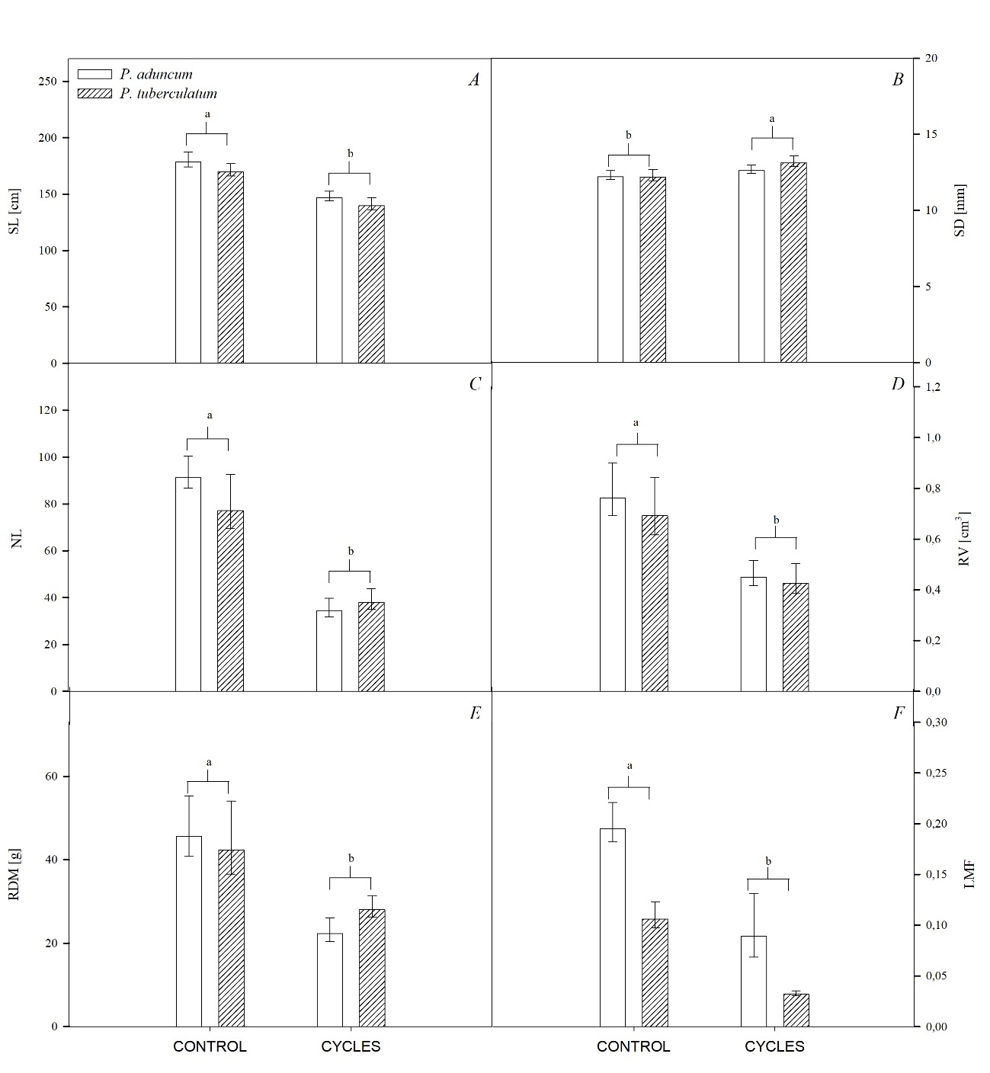

Fig. 2S. Characterization of growth parameters in Piper aduncum and Piper tuberculatum plants submitted to three cycles of drought and rehydration (recovery), compared with the control (plants kept irrigated and evaluated throughout the experimental period) and with the values before the dry (T0). Means followed by the same letter do not differ from Tukey's test (p<0.05). The bar corresponds to the standard error of the average of four replicates of a plant. A – stem length (SL), B – stem diameter (SD), C – number of leaves (NL), D – root volume (RV), E – root dry mass (RDM), F – fraction of leaf mass (LMF).

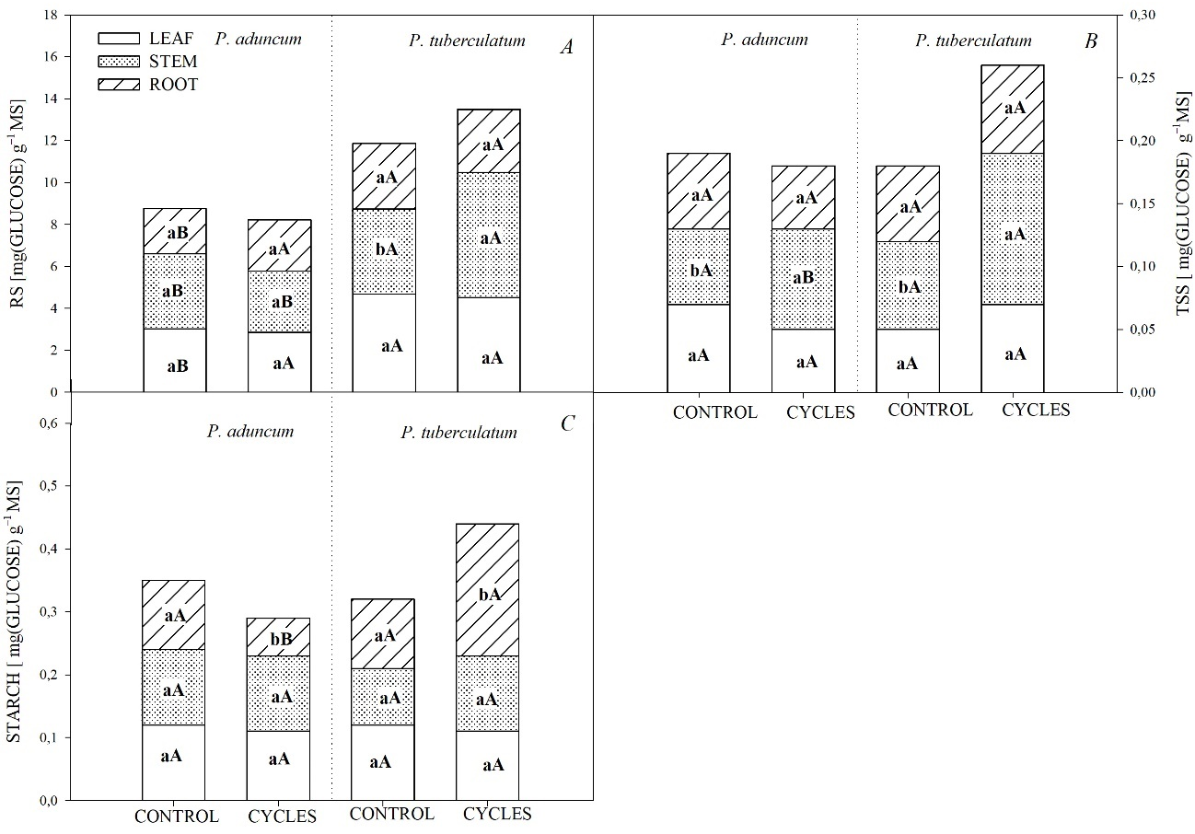

Fig. 3S. Allocation of carbohydrates in Piper aduncum and Piper tuberculatum plants submitted to three cycles of drought and rehydration (recovery), compared with the control (plants kept irrigated and evaluated throughout the experimental period) and with the values before the drought (T0). Means followed by the same letter do not differ from each other by Tukey's test (p<0.05), where capital letters are used to compare treatments (control and cycles) as a function of each species, while lowercase letters compare species with treatments. A – reducing sugar (RS), B – total soluble sugar (TSS), C – starch (starch).

