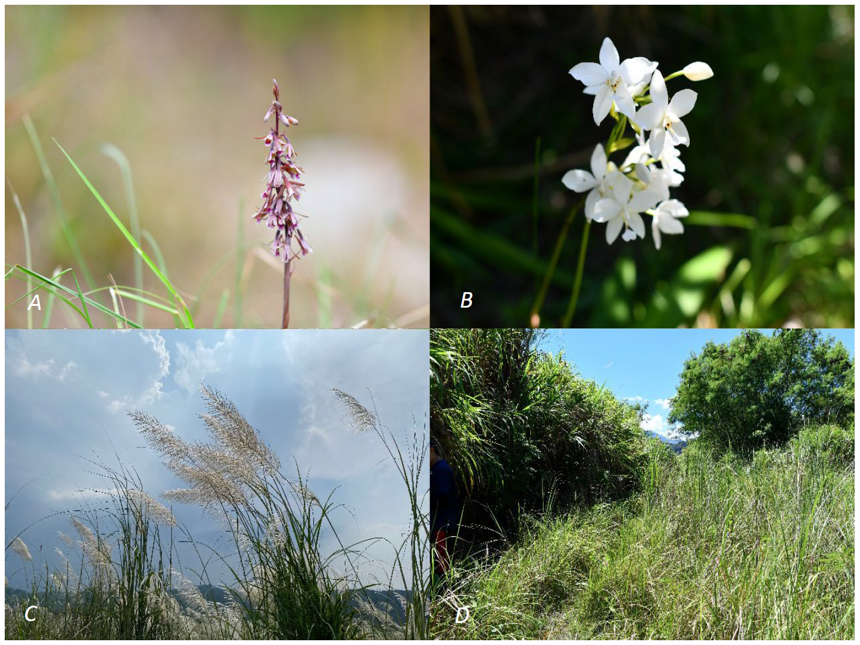

Fig. 1S. Selected Eulophia dentata (A), Bletilla formosana (B), and Saccharum spontaneum (C) plants that were grown at forested riparian land area (D) in Miaoli County, Miaoli, Taiwan (24°17'34.6"N, 120°50'02.1"E).
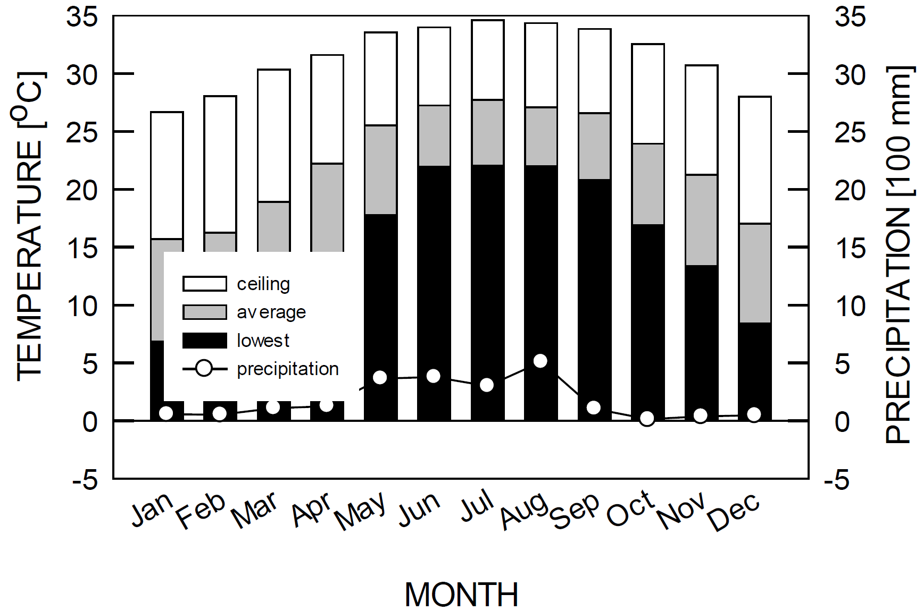

Fig. 2S. Average monthly air temperatures (bar) and precipitation (circle) during the study period from January–December 2012–2022 at Zhuolan City, Miaoli County, Miaoli, Taiwan.

