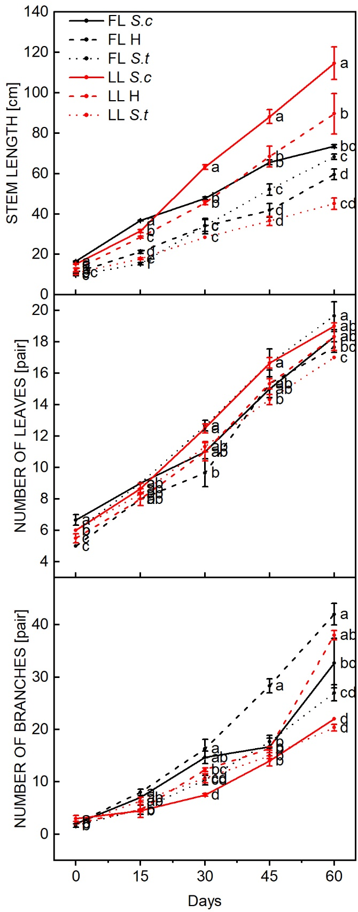
Fig.1S. Changes in the phenotypes of the three Sphagneticola species over time under low light. The main stem length (A), leaf pairs (B), and branch number (C) of the three Sphagneticola species under full and low light. The data are shown as the means ± SE of five biological replicates. Different letters (a, b, c, and d) above the bars represent significant differences at p<0.05. FL represents full light, and LL represents low light.

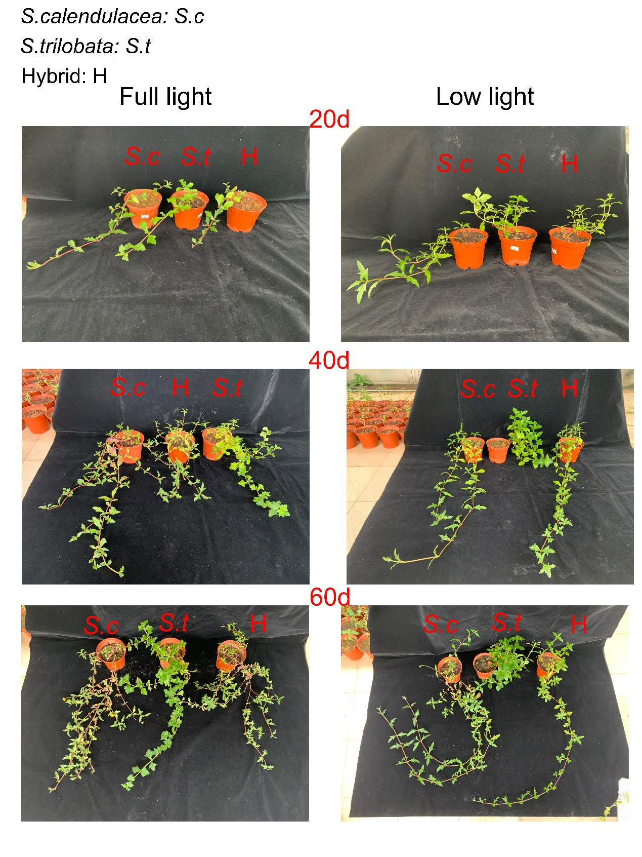
Fig. 2S. Phenotypic changes in the three Sphagneticola species at 20, 40 and 60 d of cultivation under full and low light.

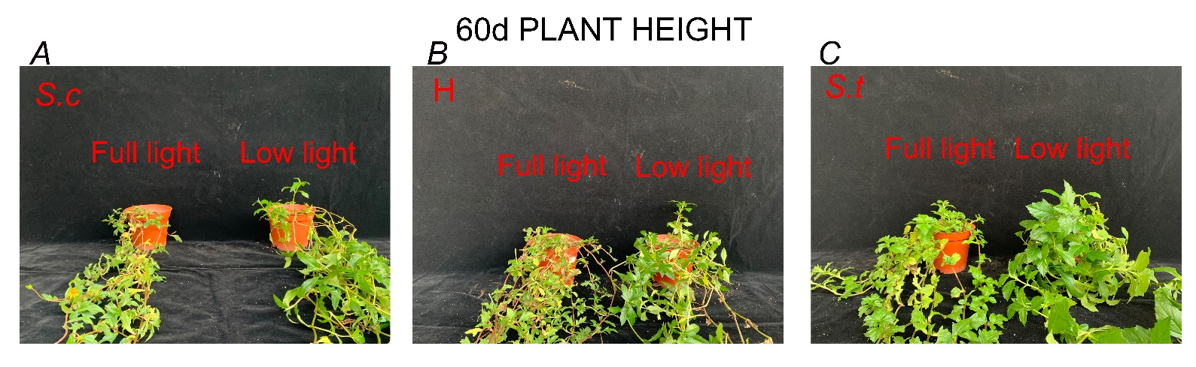
Fig. 3S. The plant height of three Sphagneticola species at 60 d of cultivation under low light. The plant heights of S. calendulacea (A), the hybrid (B), and S. trilobata (C) under full and low light.

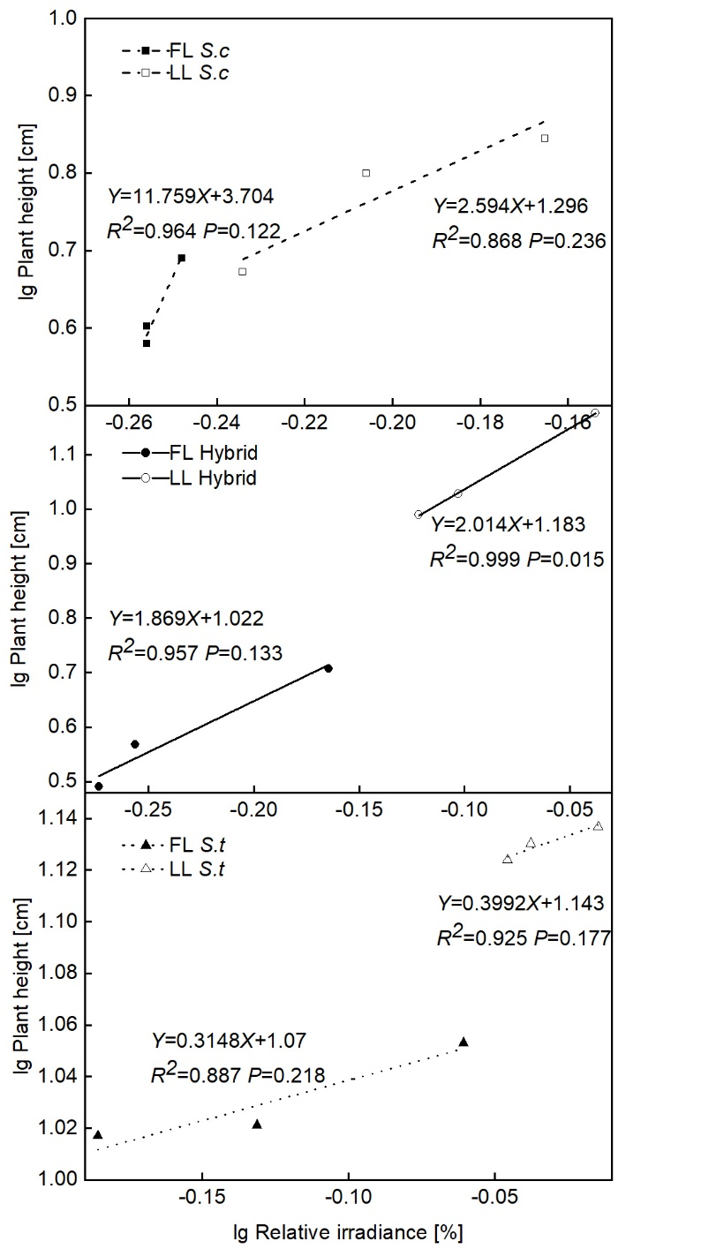
Fig. 4S. Standardized major axis (SMA) regression relationships between the relative irradiance above the leaf and plant height for three Sphagneticola species at 60 d of cultivation under low light. S. calendulacea (A), hybrid (B), and S. trilobata (C) under full and low light. FL represents full light, and LL represents low light. All data were log transformed.
Table 1S. Standardized major axis (SMA) regression analysis of the relationship between plant height and the relative irradiance above leaf of three Sphagneticola species at 60 d of cultivation under low light. Significant results (P<0.05) are shown in bold. All data were log transformed.

Table 2S. Standardized major axis (SMA) regression analysis of plant height and relative irradiance with other parameters. Significant results (P<0.05) are shown in bold. All data were log transformed.

