Supplementary materials

The equations used for the calculation of parameters used in this study (listed in the text table in “Materials and methods”):
F_{V}/F_{M} = (F_{M} – F₀)/F_{M}
Φ_{PSII} = (F_{M}ꞌ – F_{S})/F_{M}ꞌ
RFd = (F_{P} – F_{S})/F_{S}
q_{L} = [(1/F_{S}) – (1/F_{M}ꞌ)]/[(1/F₀) – 1/F_{M})]
NPQt = [4.88/((F_{M}ꞌ/F₀ꞌ) – 1)] –1
q_{It} = [4.88/((F_{M}ꞌꞌ/F₀ꞌꞌ) – 1)] –1
q_{Et} = NPQ_{t} – q_{It}

List of parameters derived from the OJIP analysis (Strasser et al. 2004, Bussotti et al. 2012):
Φ_{P0}: maximum quantum yield of primary photochemistry
Ψ₀: probability that a trapped exciton moves an electron into the electron transport chain further than Q_{A}–
Φ_{E0}: the maximum yield of electron transport
Φ_{Do}: fraction of dissipated energy
Φ_{Pav}: average efficiency of electron transport
PI_{ABS}: performance index on absorbed energy
F_{V}/F₀: maximum efficiency of water-splitting complex

Table 1S. ANOVA and post hoc results for radar parameters.

Parameter | F-statistics | p-value
F_{v}/F_{m} | 41.2691 | 1.2479E-09
F_{v}/F_{o} | 58.40236 | 3.5524E-11
Pi_Abs | 15.56999 | 7.8043E-06
Phi_P_{o} | 41.2691 | 1.2479E-09
Psi__{o} | 13.72141 | 2.0388E-05
Phi_E_{o} | 19.92344 | 1.0567E-06
Phi_D_{o} | 41.2691 | 1.2479E-09
Phi_P_{av} | 17.01474 | 3.8722E-06

group1 | group2 | meandiff | p-adj | lower | upper | reject | parameter
Cd0 | Cd1 | –0.0208 | 0.6643 | –0.0706 | 0.0291 | FALSE | Fv/Fm
Cd0 | Cd10 | –0.0201 | 0.685 | –0.07 | 0.0297 | FALSE | Fv/Fm
Cd0 | Cd50 | –0.2294 | 0 | –0.2904 | –0.1683 | TRUE | Fv/Fm
Cd1 | Cd10 | 0.0006 | 1 | –0.0492 | 0.0505 | FALSE | Fv/Fm
Cd1 | Cd50 | –0.2086 | 0 | –0.2697 | –0.1476 | TRUE | Fv/Fm
Cd10 | Cd50 | –0.2092 | 0 | –0.2703 | –0.1482 | TRUE | Fv/Fm
Cd0 | Cd1 | –0.4595 | 0.0439 | –0.9091 | –0.0099 | TRUE | Fv/Fo
Cd0 | Cd10 | –0.4504 | 0.0495 | –0.8999 | –0.0008 | TRUE | Fv/Fo
Cd0 | Cd50 | –2.5631 | 0 | –3.1137 | –2.0125 | TRUE | Fv/Fo
Cd1 | Cd10 | 0.0091 | 0.9999 | –0.4404 | 0.4587 | FALSE | Fv/Fo
Cd1 | Cd50 | –2.1036 | 0 | –2.6542 | –1.553 | TRUE | Fv/Fo
Cd10 | Cd50 | –2.1128 | 0 | –2.6634 | –1.5621 | TRUE | Fv/Fo
Cd0 | Cd1 | –0.5176 | 0.0196 | –0.9664 | –0.0688 | TRUE | Pi_Abs
Cd0 | Cd10 | –0.3399 | 0.1852 | –0.7887 | 0.1089 | FALSE | Pi_Abs
Cd0 | Cd50 | –1.3439 | 0 | –1.8935 | –0.7942 | TRUE | Pi_Abs
Cd1 | Cd10 | 0.1777 | 0.6973 | –0.271 | 0.6265 | FALSE | Pi_Abs
Cd1 | Cd50 | –0.8262 | 0.0019 | –1.3759 | –0.2766 | TRUE | Pi_Abs
Cd10 | Cd50 | –1.004 | 0.0002 | –1.5536 | –0.4544 | TRUE | Pi_Abs
Cd0 | Cd1 | –0.0208 | 0.6643 | –0.0706 | 0.0291 | FALSE | Phi_Po
Cd0 | Cd10 | –0.0201 | 0.685 | –0.07 | 0.0297 | FALSE | Phi_Po
Cd0 | Cd50 | –0.2294 | 0 | –0.2904 | –0.1683 | TRUE | Phi_Po
Cd1 | Cd10 | 0.0006 | 1 | –0.0492 | 0.0505 | FALSE | Phi_Po
Cd1 | Cd50 | –0.2086 | 0 | –0.2697 | –0.1476 | TRUE | Phi_Po
Cd10 | Cd50 | –0.2092 | 0 | –0.2703 | –0.1482 | TRUE | Phi_Po
Cd0 | Cd1 | –0.0689 | 0.2445 | –0.1676 | 0.0298 | FALSE | Psi_o
Cd0 | Cd10 | –0.024 | 0.9071 | –0.1227 | 0.0747 | FALSE | Psi_o
Cd0 | Cd50 | –0.2671 | 0 | –0.388 | –0.1462 | TRUE | Psi_o
Cd1 | Cd10 | 0.0449 | 0.5997 | –0.0538 | 0.1436 | FALSE | Psi_o
Cd1 | Cd50 | –0.1982 | 0.0008 | –0.3191 | –0.0774 | TRUE | Psi_o
Cd10 | Cd50 | –0.2431 | 0.0001 | –0.364 | –0.1222 | TRUE | Psi_o
Cd0 | Cd1 | –0.064 | 0.1395 | –0.1426 | 0.0146 | FALSE | Phi_Eo
Cd0 | Cd10 | –0.0294 | 0.7332 | –0.108 | 0.0492 | FALSE | Phi_Eo
Cd0 | Cd50 | –0.2588 | 0 | –0.355 | –0.1625 | TRUE | Phi_Eo
Cd1 | Cd10 | 0.0346 | 0.6234 | –0.044 | 0.1132 | FALSE | Phi_Eo
Cd1 | Cd50 | –0.1947 | 0.0001 | –0.291 | –0.0985 | TRUE | Phi_Eo
Cd10 | Cd50 | –0.2294 | 0 | –0.3256 | –0.1331 | TRUE | Phi_Eo
Cd0 | Cd1 | 0.0207 | 0.6643 | –0.0291 | 0.0706 | FALSE | Phi_Do
Cd0 | Cd10 | 0.0201 | 0.685 | –0.0297 | 0.07 | FALSE | Phi_Do
Cd0 | Cd50 | 0.2294 | 0 | 0.1683 | 0.2904 | TRUE | Phi_Do
Cd1 | Cd10 | –0.0006 | 1 | –0.0505 | 0.0492 | FALSE | Phi_Do
Cd1 | Cd50 | 0.2086 | 0 | 0.1476 | 0.2697 | TRUE | Phi_Do
Cd10 | Cd50 | 0.2092 | 0 | 0.1482 | 0.2703 | TRUE | Phi_Do
Cd0 | Cd1 | 4.9319 | 0.5818 | –5.6671 | 15.5308 | FALSE | Phi_Pav
Cd0 | Cd10 | –2.5135 | 0.913 | –13.1124 | 8.0854 | FALSE | Phi_Pav
Cd0 | Cd50 | 29.3044 | 0 | 16.3234 | 42.2854 | TRUE | Phi_Pav
Cd1 | Cd10 | –7.4454 | 0.2394 | –18.0443 | 3.1536 | FALSE | Phi_Pav
Cd1 | Cd50 | 24.3725 | 0.0001 | 11.3915 | 37.3535 | TRUE | Phi_Pav
Cd10 | Cd50 | 31.8179 | 0 | 18.8369 | 44.7989 | TRUE | Phi_Pav

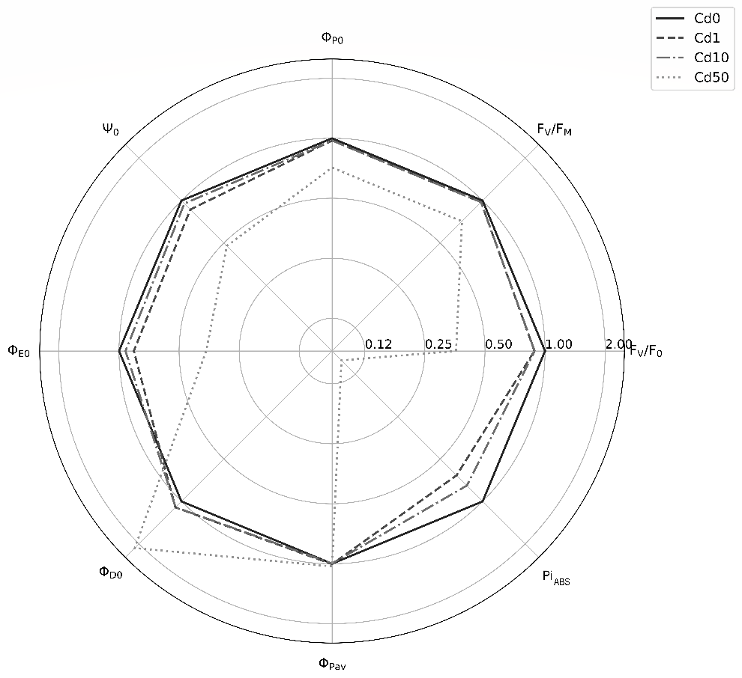

Fig. 1S. Radar plot showing parameters derived from the JIP-test. Values are normalized to the control values (Cd0) and the x-axis is in logaritmic scale (base 2). Each parameter is described in Supplementary material (Strasser et al. 2004, Bussotti et al. 2012), statistical analysis results are displayed in Supplementary material (Table 1S).

