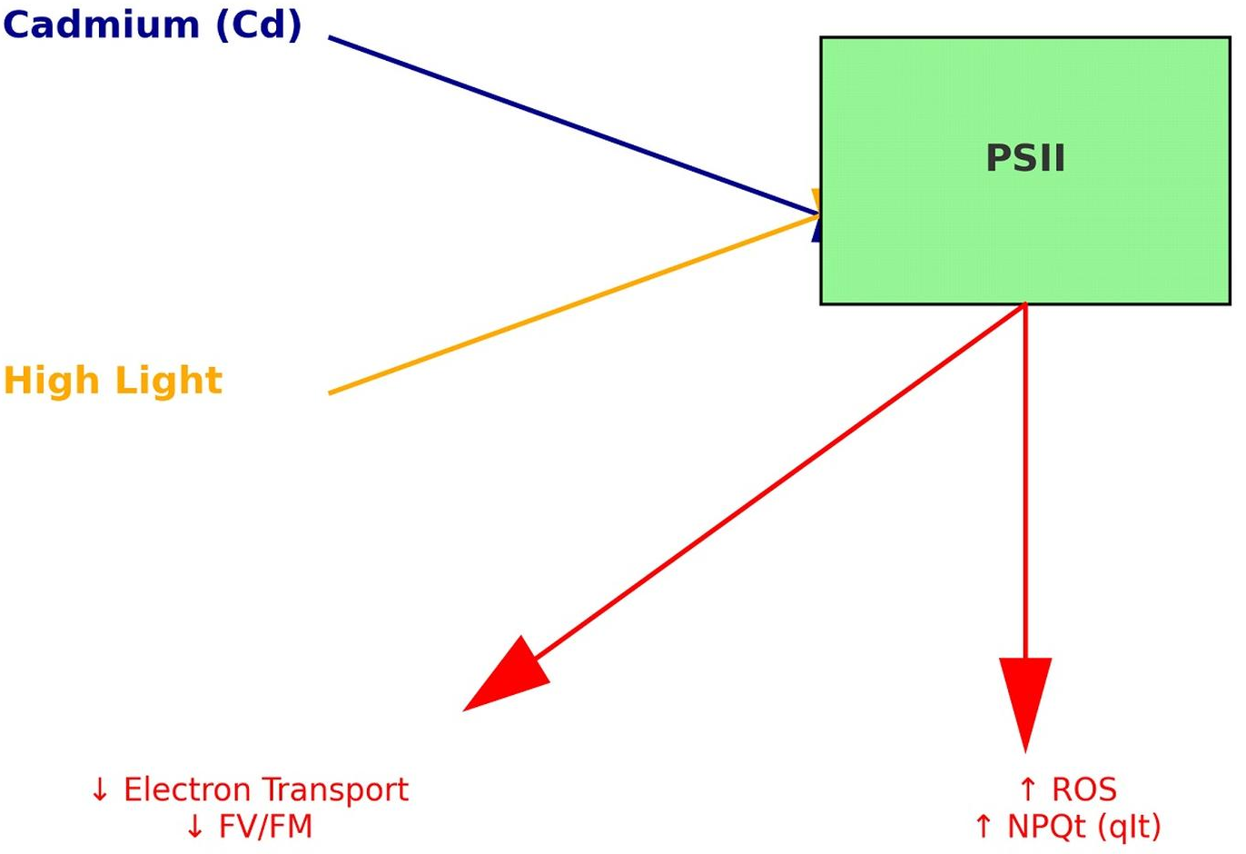

Fig. 1S. Coupling effect of cadmium (Cd) and high light on PSII in Arabidopsis thaliana. Cd and high light together reduce PSII efficiency (↓F_{V}/F_{M}), enhance photoprotective nonphotochemical quenching (NPQ), and increase ROS production.

