Table 1S. General Linear Models for three Onobrychis conferta populations, three timepoints (0, 3, 6 and 9 d) and osmotic treatments (0, 29% w/v PEG and 300 mM NaCl). Significant differences (P<0.05) are marked in bold.

Plant traits | Population |  |  | TRT |  |  | Population × TRT
 | F or χ2 | df | P | F or χ2 | df | P | F or χ2 | df | P
RL | χ2=11.402 | 4 | P<0.001 | χ2=6.086 | 2 | P<0.05 | χ2=2.00 | 4 | P<0.001
SL | χ2=13.00 | 2 | P<0.0001 | χ2=4.00 | 2 | P<0.001 | χ2=0.00 | 4 | P<0.001
SR ratio | χ2=12.00 | 2 | P<0.005 | χ2=8.00 | 2 | P<0.05 | χ2=4.00 | 4 | P<0.001
Leaflets | χ2=19.00 | 2 | P<0.001 | χ2=6.00 | 2 | P<0.05 | χ2=4.00 | 4 | P<0.001
Leaves | χ2=8.00 | 2 | P<0.05 | χ2=1.075 | 2 | P<0.001 | χ2=0.00 | 4 | P<0.001
Leaflets/Leaf | χ2=48.00 | 2 | P<0.001 | χ2=3.095 | 2 | P<0.001 | χ2=2.00 | 4 | P<0.001
Root FM | χ2=37.00 | 2 | P<0.001 | χ2=5.00 | 2 | P<0.05 | χ2=1.00 | 4 | P<0.001
Shoot FM | F=26.00 | 2 | P<0.001 | F=2.00 | 2 | P<0.001 | F=0.00 | 4 | P<0.001
Shoot/Root FM | χ2=29.00 | 2 | P<0.001 | χ2=0.065 | 2 | P<0.001 | χ2=2.00 | 4 | P<0.001
Root DM | F=17.00 | 2 | P<0.001 | F=0.00 | 2 | P<0.001 | F=0.00 | 4 | P<0.001
Shoot DM | χ2=84.00 | 2 | P<0.001 | χ2=0.00 | 2 | P<0.001 | χ2=0.00 | 4 | P<0.001
Shoot/Root DM | χ2=14.00 | 2 | P<0.001 | χ2=3.00 | 2 | P<0.001 | χ2=0.00 | 4 | P<0.001
Root WC | χ2=5.00 | 2 | P<0.001 | χ2=5.00 | 2 | P<0.001 | χ2=5.00 | 4 | P<0.001
Shoot WC | F=4.00 | 2 | P<0.05 | F=7.00 | 2 | P<0.0001 | F=0.00 | 4 | P<0.001
F₀ | χ2=24.00 | 2 | P<0.001 | χ2=31.00 | 2 | P<0.001 | χ2=1.00 | 4 | P<0.001
F_{m} | χ2=20.00 | 2 | P<0.001 | χ2=55.00 | 2 | P<0.001 | χ2=8.00 | 4 | P<0.001
F_{v} | χ2=19.00 | 2 | P<0.001 | χ2=110.00 | 2 | P<0.001 | χ2=9.00 | 4 | 0.051
F_{v}/F_{m} | χ2=26.00 | 2 | P<0.001 | χ2=197.00 | 2 | P<0.001 | χ2=11.00 | 4 | P<0.001
F_{v}/F₀ | χ2=29.00 | 2 | P<0.001 | χ2=189.00 | 2 | P<0.001 | χ2=1.00 | 4 | P<0.001
P_{N} | χ2=101.00 | 2 | P<0.001 | χ2=708.00 | 2 | P<0.001 | χ2=62.00 | 4 | P<0.001
C_{i} | χ2=30.00 | 2 | P<0.001 | χ2=0.00 | 2 | P<0.005 | χ2=3.00 | 4 | P<0.001
g_{s} | χ2=10.00 | 2 | P<0.01 | χ2=219.00 | 2 | P<0.001 | χ2=40.00 | 4 | P<0.001
_{i}WUE | χ2=121.00 | 2 | P<0.001 | χ2=413.00 | 2 | P<0.001 | χ2=24.00 | 4 | P<0.001
L_{s} | χ2=31.00 | 2 | P<0.001 | χ2=1.00 | 2 | P<0.001 | χ2=4.00 | 4 | P<0.001
Chl a | χ2=63.008 | 2 | P<0.0001 | χ2=187.203 | 2 | P<0.0001 | χ2=2.562 | 4 | 0.634
Chl b | χ2=27.933 | 2 | P<0.0001 | χ2=34.759 | 2 | P<0.0001 | χ2=1.636 | 4 | 0.802
Car | χ2=41.295 | 2 | P<0.0001 | χ2=104.633 | 2 | P<0.0001 | χ2=3.078 | 4 | 0.545
Chl (a+b)/Car | F=0.322 | 2 | 0.726 | F=11.356 | 2 | P<0.0001 | F=0.223 | 4 | 0.925
Chl a/b | F=0.852 | 2 | 0.431 | F=1.368 | 2 | 0.261 | F=0.289 | 4 | 0.884
Proline | χ2=1.376 | 2 | 0.503 | χ2=259.86 | 2 | P<0.0001 | χ2=2.494 | 4 | 0.646
MDA | χ2=12.78 | 2 | P<0.05 | χ2=325.514 | 2 | P<0.0001 | χ2=1.065 | 4 | 0.9

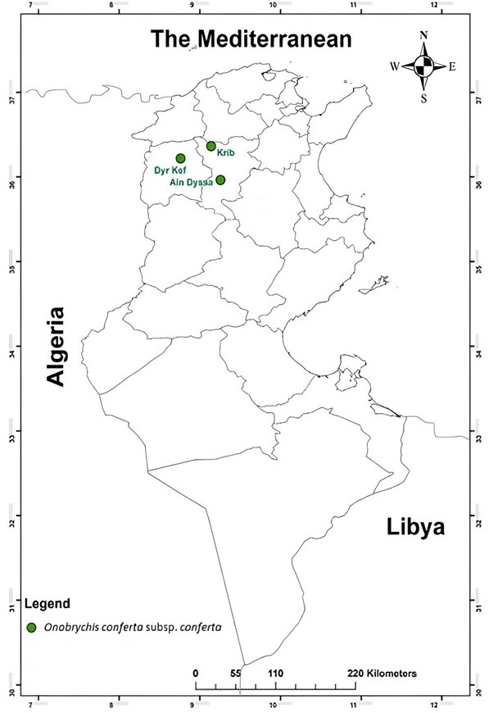

Fig. 1S. Distribution map of Onobrychis conferta in Tunisia.
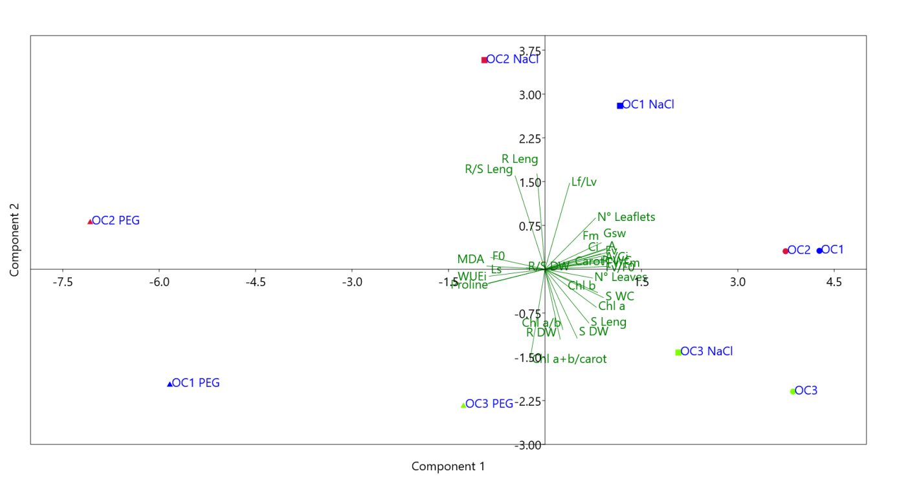
Fig. 2S. Loading and scatterplot of the principal component analysis (PCA), for three Onobrychis conferta populations (OC1, OC2, and OC3), three timepoints (0, 3, 6 and 9 d) and osmotic treatments (0, 29 w/v PEG and 300 mM NaCl). Abbreviations: R leng: Root length; S leng: Shoot length; R/S leng: Root/Shoot length ratio; N° Leaflets: Total number of leaflets; N° Leaves: Total number of leaves; R FW: Root fresh weight; S FW: Shoot fresh weight; S/R FW: Shoot/Root fresh weight ratio; R DW: Root dry weight; S DW: Shoot dry weight; S/R DW: Shoot/Root dry weight ration; F₀: basal fluorescence; F_{m}: maximum fluorescence; F_{v}: variable fluorescence; F_{v}/F₀: efficiency of the water-splitting complex; F_{v}/F_{m}: maximum photochemical efficiency of PSII; A: atmospheric CO₂ concentration; C_{i}: intracellular CO₂ concentration; gs: stomatal conductance; WUE_{i}: Intrinsic water use efficiency; L_{s}: Stomatal limitation; Chl a: Chlorophyll a; Chl b: Chlorophyll b; Carot: carotenoids; a+b/carot: Chlorophyll (a+b)/Carotenoids ratio; Chl a/b: Chlorophyll a/b ratio; Proline: Free proline content; MDA: malondialdehyde content.

