Table 1S. Effects of changes in the red/far-red light on the fluorescence parameters calculated based on the chlorophyll fluorescence parameters of Y_{(II)} and NPQ. Here, HIL is high-intensity light (4 h, 1,000 μmol(photon) m^{–2} s^{–1}).
The data are presented as the means ± SE. Different letters indicate statistically significant differences (p<0.05),
n = 5. Here, Y_{(II)} represents the effective photochemical quantum yield of PSII, and NPQ represents nonphotochemical quenching.

Parameter/Ratio | Y_{(II)} | NPQ
No FRL | 0.54 ± 0.03ª | 0.80 ± 0.16ª
1.67 | 0.52 ± 0.02ª | 0.48 ± 0.05^{b}
0.89 | 0.44 ± 0.01^{b} | 0.99 ± 0.12ª
0.29 | 0.45 ± 0.01^{b} | 1.03 ± 0.10ª
No FRL+HIL | 0.50 ± 0.02^{ab} | 0.70 ± 0.11^{ab}
1.67+HIL | 0.49 ± 0.03^{ab} | 0.89 ± 018ª
0.89+HIL | 0.46 ± 0.02^{ab} | 1.06 ± 0.15ª
0.29+HIL | 0.40 ± 0.01^{c} | 1.13 ± 0.14ª

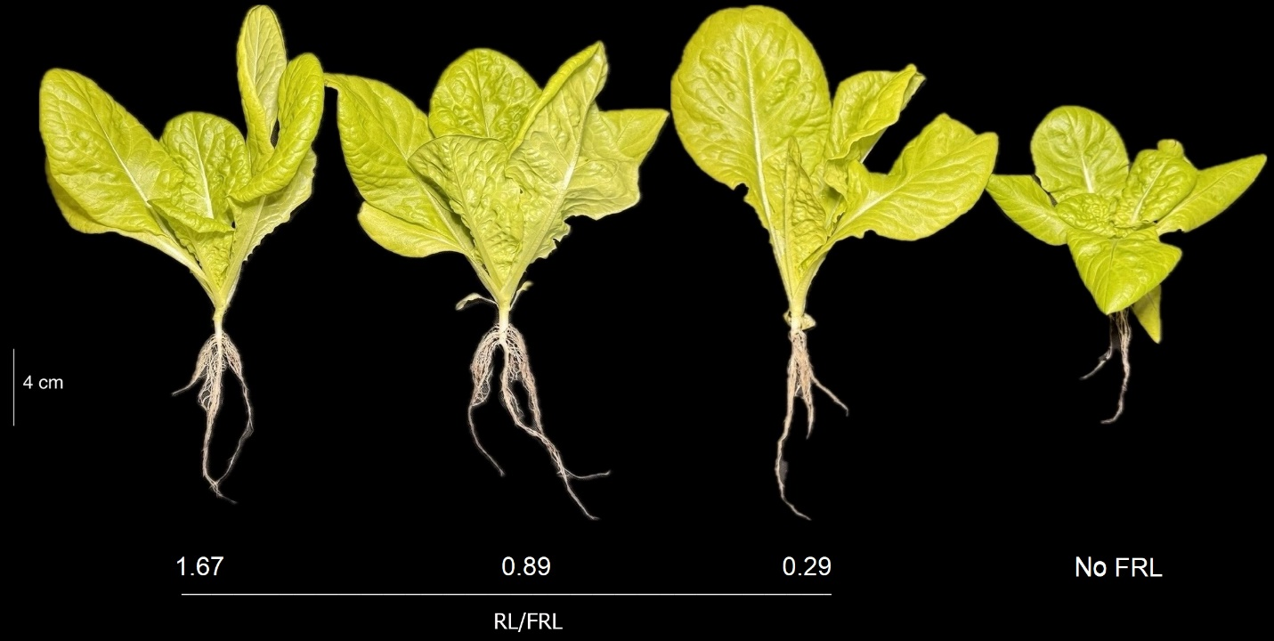

Fig. 1S. Lettuce plants at different red/far-red light ratios.

