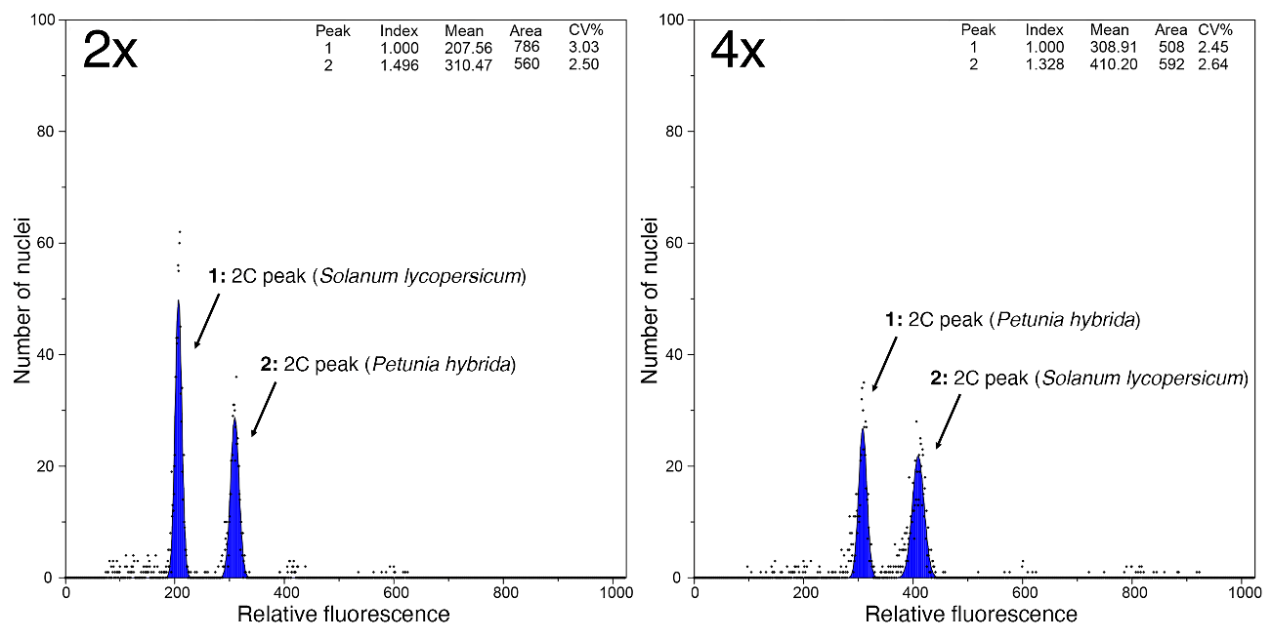
Fig. 1S. Representative flow cytometry histograms of diploid (2x) and tetraploid (4x) tomato plants. In the 2x histogram, peaks correspond to G1-phase S. lycopersicum nuclei (2C), P. hybrida standard (2C), and G2-phase S. lycopersicum nuclei (4C). In the 4x histogram, peaks correspond to P. hybrida (2C) and G1-phase tetraploid S. lycopersicum nuclei (2C).

