Supplementary figure
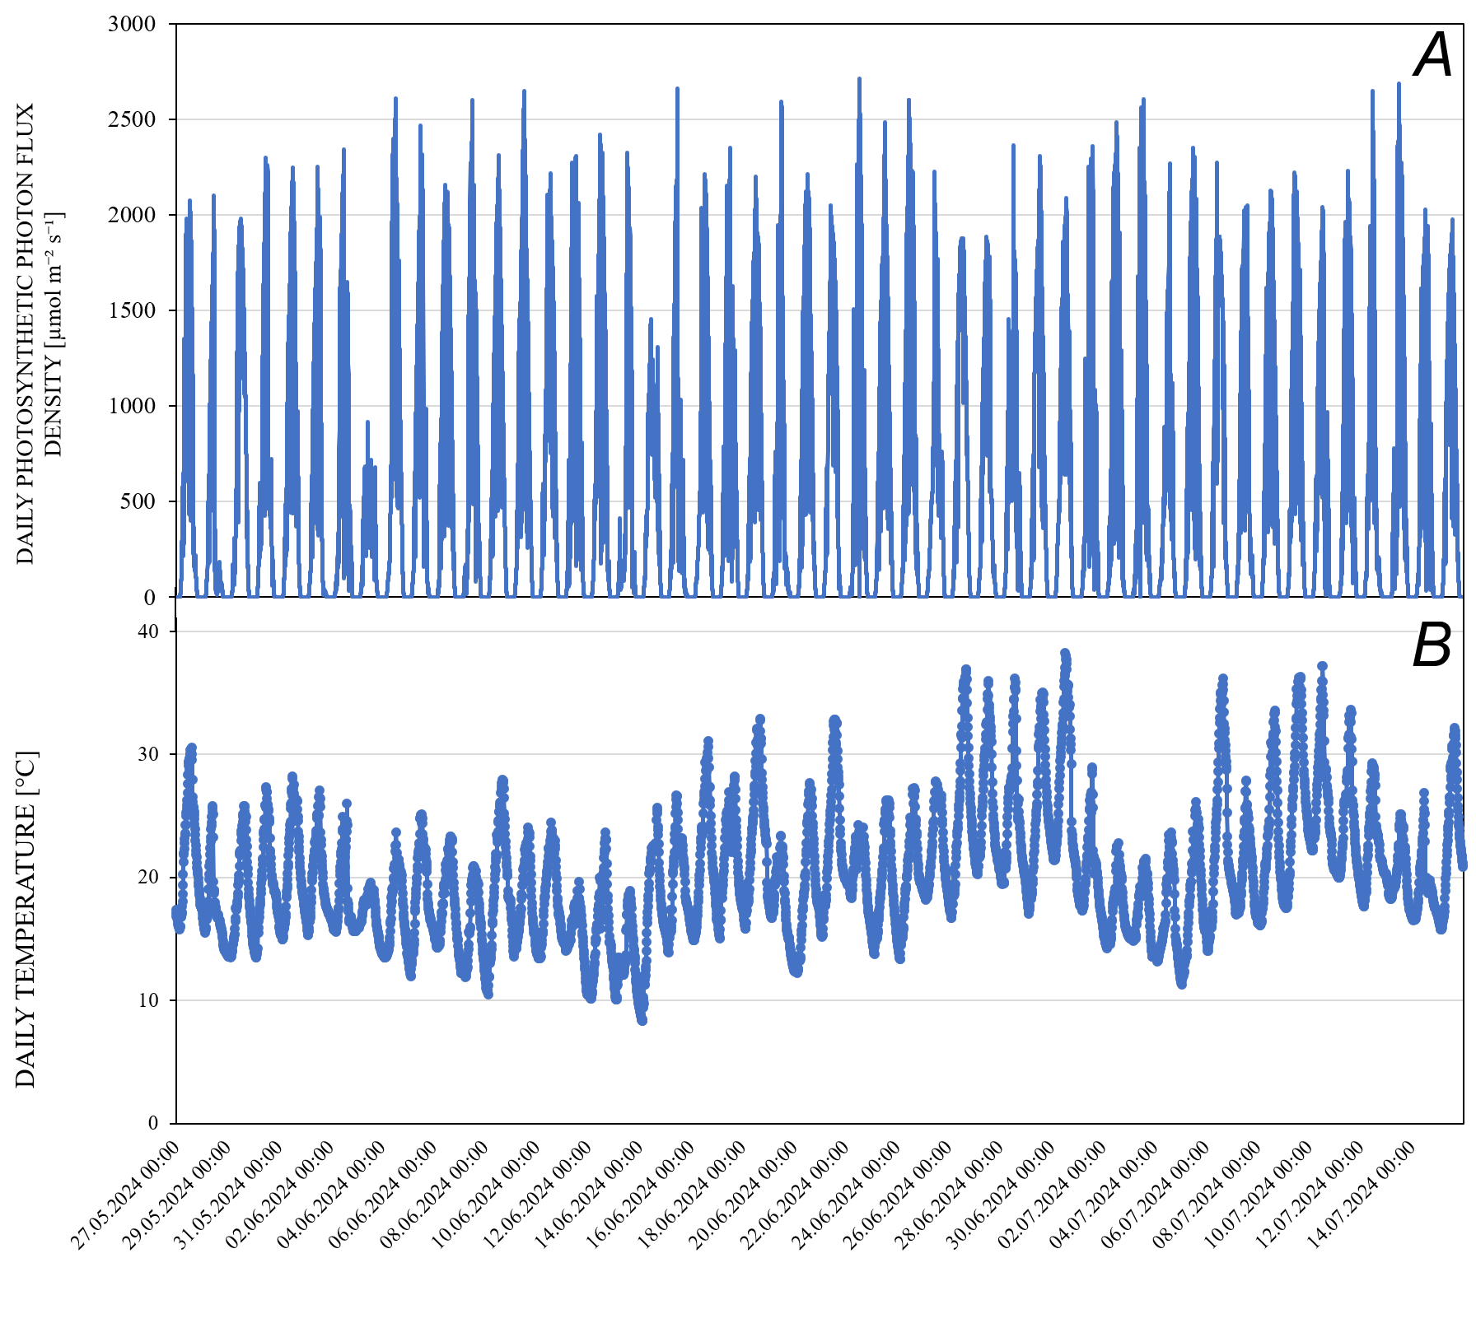
Fig. 1S. (A) Daily photosynthetic photon flux density and (B) temperature recorded throughout the experimental period (27.05.2024–15.07.2024).

