Supplementary Material

Interactions of PsbT with Val247 and Ser254 in the DE-loop of the D2 protein stabilize the quinone-iron electron acceptor complex of Photosystem II

V. ZHONG*, I. VASS**, AND J. J. EATON-RYE^{*,+}
Department of Biochemistry, University of Otago, P.O. Box 56, Dunedin 9054, New Zealand*
Institute of Plant Biology, HUN-REN, Biological Research Center, Szeged, Hungary**

⁺Corresponding author
e-mail: julian.eaton-rye@otago.ac.nz

Table of Contents

Page 3. Supplementary Fig. 1S. Multiple protein sequence alignment of the DE loop of the D2 protein in representative cyanobacteria, algae and plants.
Page 4. Supplementary Fig. 2S. Resolution of representative thermoluminescence curves into individual components for the strains with substitutions at the D2-Val247 position.
Page 5. Supplementary Fig. 3S. Resolution of representative thermoluminescence curves into individual components for the strains with substitutions at the D2-Ser254 position.
Page 6. Supplementary Table 1S. Primers used for the introduction of targeted mutations into the psbD1 gene using the QuikChange II site-directed mutagenesis kit.
Page 7. Supplementary Table 2S. Oxygen evolution rates in strains with mutations at D2-Val247.
Page 8. Supplementary Table 3S. Oxygen evolution rates in strains with mutations at D2-Ser254.
Page 9. Supplementary Table 4S. Kinetic analysis of chlorophyll a fluorescence decay following a single saturating actinic flash in strains with mutations at D2-Val247.
Page 10. Supplementary Table 5S. Thermoluminescence temperature maxima for the Q-bands, B-bands and C-bands in Synechocystis sp. PCC 6803 mutants with substitutions at Val247 and Ser254 of the D2 protein.
Page 11. Supplementary Table 6S. Kinetic analysis of chlorophyll a fluorescence decay following a single saturating actinic flash in strains with mutations at D2-Ser254.
Page 12. References

 | 222 232 242 252 262
Consensus | LFEDGEGANTFRAFNPTQAEETYSMVTANRFWSQIFGIAFS
Synechocystis sp. PCC 6803 | LFEDGEDSNTFRAFEPTQAEETYSMVTANRFWSQIFGIAFS
Anabaena cylindrica PCC 7122 | LFDDGEGSNTFPAFNPTQAEETYSMVTANRFWSQIFGIAFS
Calothrix sp. PCC 7507 | LFKDTTGFNTFSGFTPTQAEETYSMVTANRYWSQIFGIAFS
Cyanothece sp. ATCC 51142 | LFEDGEQANTFRAFEPTQAEETYSMVTANRFWSQIFGIAFS
Gloeobacter kilaueensis JS1 | LFEDGEAPNTFKAFDPAQEEETYSMVLANRFWSQIFGIAFS
Nostoc sp. NIES-7120 | LFEDGEGANTFRAFNPTQSEETYSMVTANRFWSQIFGIAFS
Synechocystis sp. PCC 6714 | LFEDGEDSNTFRAFEPTQAEETYSMVTANRFWSQIFGIAFS
Synechococcus sp. PCC 7002 | LFEDSDQANTFRAFEPTQAEETYSMVTANRFWSQIFGIAFS
Thermosynechococcus elongatus BP-1 | LFQDGEGASTFRAFNPTQAEETYSMVTANRFWSQIFGIAFS
Thermosynechococcus vulcanus | LFQDGEGASTFRAFNPTQAEETYSMVTANRFWSQIFGIAFS
Tolypothrix tenuis PCC 7101 | LFEDGEAANTFRAFNPTQSEETYSMVTANRFWSQIFGIAFS
Arabidopsis thaliana | LFEDGDGANTFRAFNPTQAEETYSMVTANRFWSQIFGVAFS
Chlamydomonas reinhardtii | LFEDGDGANTFRAFNPTQAEETYSMVTANRFWSQIFGVAFS
Nicotiana tabacum | LFEDGDGANTFRAFNPTQAEETYSMVTANRFWSQIFGVAFS
Pisum sativum | LFEDGDGANTFRAFNPTQAEETYSMVTANRFWSQIFGVAFS
Spinacia oleracea | LFEDGDGANTFRAFNPTQAEETYSMVTANRFWSQIFGVAFS

Supplementary Fig. 1S. Multiple protein sequence alignment of the DE loop of the D2 protein in representative cyanobacteria, algae and plants. The location of the conserved Val247 and Ser254 residues within a conserved motif associated with bicarbonate binding is shown in red. The bicarbonate-binding motif is shown in blue. The consensus sequence shows the most common amino acid at each position. The alignment was constructed using the Geneious platform.

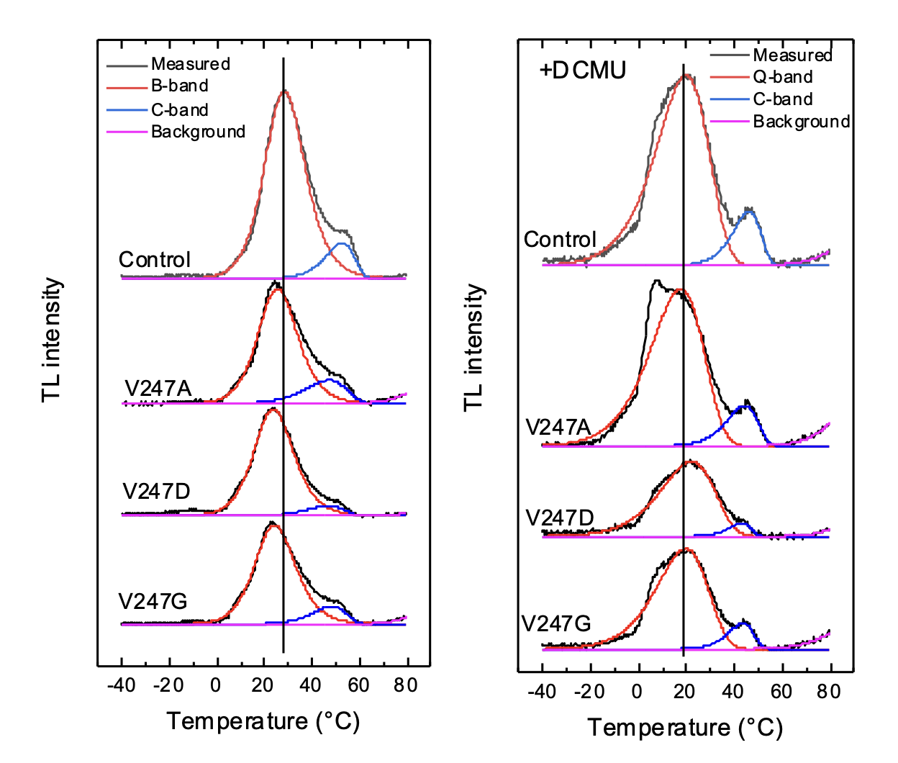

Supplementary Fig. 2S. Resolution of representative thermoluminescence curves into individual components for the strains with substitutions at the D2-Val247 position. The data in the absence of DCMU for detection of the B-band are in the left panel and the data in the presence of DCMU for detection of the Q-band are in the right panel. Fitting was performed according to Vass et al. (1981). The high temperature rise (pink background trace) is unrelated to photosynthetic activity but is required for fitting (Hideg and Vass 1993).

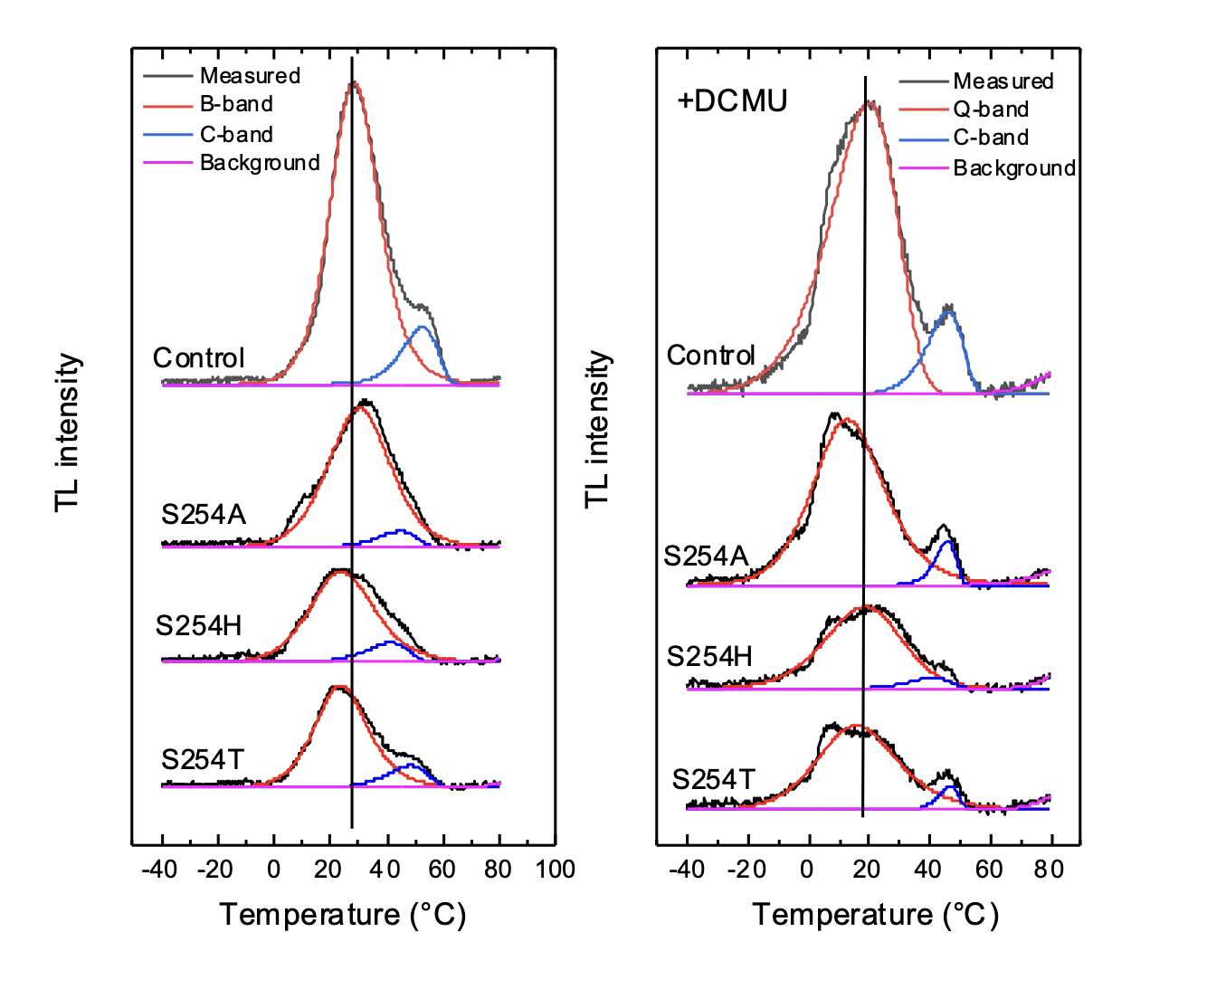

Supplementary Fig. 3S. Resolution of representative thermoluminescence curves into individual components for the strains with substitutions at the D2-Ser254 position. The data in the absence of DCMU for detection of the B-band are in the left panel and the data in the presence of DCMU for detection of the Q-band are in the right panel. Fitting was performed according to Vass et al. (1981). The high temperature rise (pink background trace) is unrelated to photosynthetic activity but is required for fitting (Hideg and Vass 1993).

Supplementary Table 1S. Primers used for the introduction of targeted mutations into the psbD1 gene using the QuikChange II site-directed mutagenesis kit.
Primers used in QuikChange Site-Directed Mutagenesis
D2-V247A-DS | AGAAACCTATTCCATGGCGACCGCTAACCGTTTCT
D2-V247A-US | AGAAACGGTTAGCGGTCGCCATGGAATAGGTTTCT
D2-V247D-DS | GAAGAAACCTATTCCATGGATACCGCTAACCGTTTCTGGT
D2-V247D-US | ACCAGAAACGGTTAGCGGTATCCATGGAATAGGTTTCTTC
D2-V247G-DS | AGAAACCTATTCCATGGGGACCGCTAACCGTTTCT
D2-V247G-US | AGAAACGGTTAGCGGTCCCCATGGAATAGGTTTCT
D2-S254A-DS | CCGCTAACCGTTTCTGGGCTCAGATTTTCGGTATTG
D2-S254A-US | CAATACCGAAAATCTGAGCCCAGAAACGGTTAGCGG
D2-S254H-DS | GACCGCTAACCGTTTCTGGCATCAGATTTTCGGTATTGCT
D2-S254H-US | AGCAATACCGAAAATCTGATGCCAGAAACGGTTAGCGGTC
D2-S254T-DS | CCGCTAACCGTTTCTGGACTCAGATTTTCGGTATTG
D2-S254T-US | CAATACCGAAAATCTGAGTCCAGAAACGGTTAGCGG

Supplementary Table 2S. Oxygen evolution rates in strains with mutations at D2-Val247.
Oxygen evolution rate (µmoles O₂ (mg of Chl)⁻¹ h⁻¹)
Electron acceptor
Strain | DMBQ | Bicarbonate | DMBQ + Bicarb. | DMBQ + Formate | DMBQ + Bicarb. + Formate
Control | 498 ± 7ª | 538 ± 25 | 488 ± 49 | 204 ± 36 | 382 ± 26
V247A | 405 ± 44 | 614 ± 81 | 566 ± 14 | 142 ± 24 | 508 ± 61
V247D | 298 ± 33 | 617 ± 68 | 515 ± 36 | - | 504 ± 58
V247G | 373 ± 21 | 655 ± 17 | 480 ± 23 | 43 ± 16 | 347 ± 97

ªThe standard error shown was calculated from the average of three independent experiments.

Supplementary Table 3S. Oxygen evolution rates in strains with mutations at D2-Ser254.
Oxygen evolution rate (µmoles O₂ (mg of Chl)⁻¹ h⁻¹)
Electron acceptor
Strain | DMBQ | Bicarbonate | DMBQ + Bicarb. | DMBQ + Formate | DMBQ + Bicarb. + Formate
Control | 498 ± 7ª | 538 ± 25 | 488 ± 49 | 204 ± 36 | 382 ± 26
S254A | 369 ± 23 | 471 ± 20 | 497 ± 20 | 219 ± 43 | 402 ± 100
S254H | 252 ± 5 | 480 ± 16 | 325 ± 35 | - | 231 ± 51
S254T | 344 ± 37 | 620 ± 8 | 442 ± 9 | 158 ± 29 | 412 ± 74

ªThe standard error shown was calculated from the average of three independent experiments

Supplementary Table 4S. Kinetic analysis of chlorophyll a fluorescence decay following a single saturating actinic flash in strains with mutations at D2-Val247.
 |  | Fast Phase |  | Intermediate Phase |  | Slow Phase
Strain | Treatment | Rate t_{1/2} (µs) | Amplitude (%) | Rate t_{1/2} (ms) | Amplitude (%) | Rate  t_{1/2} (s) | Amplitude (%)
Control | No treatment | 289 ± 28 | 67.3 ± 1.7 | 3.0 ± 0.3 | 25.0 ± 1.0 | 9.8 ± 1.6 | 7.7 ± 0.8
Control | Bicarbonate | 306 ± 21 | 68.8 ± 0.1 | 3.4 ± 0.2 | 24.3 ± 0.4 | 7.2 ± 1.0 | 6.9 ± 0.3
Control | Formate | 408 ± 24 | 66.2 ± 2.6 | 9.1 ± 0.5 | 22.7 ± 1.1 | 6.6 ± 0.5 | 11.1 ± 1.5
Control | Bicarbonate + Formate | 314 ± 34 | 67.4 ± 2.2 | 3.9 ± 0.3 | 25.1 ± 2.6 | 10.3 ± 2.4 | 7.5 ± 0.4
Control | DCMU |  |  | 2.0 ± 0.1 | 9.8 ± 0.1 | 0.7 ± 0.1 | 90.2 ± 0.1
D2-V247A | No treatment | 318 ± 5 | 67.5 ± 1.8 | 3.7 ± 0.7 | 23.6 ± 2.0 | 9.6 ± 2.6 | 8.8 ± 0.2
 | Bicarbonate | 278 ± 41 | 66.0 ± 2.3 | 3.3 ± 0.7 | 25.8 ± 2.5 | 7.6 ± 1.5 | 8.2 ± 0.3
 | Formate | 477 ± 30 | 56.1 ± 1.0 | 10.9 ± 2.3 | 26.9 ± 0.3 | 2.6 ± 1.2 | 17.0 ± 1.0
 | Bicarbonate + Formate | 324 ± 25 | 63.4 ± 0.6 | 3.5 ± 0.1 | 28.2 ± 0.6 | 5.3 ± 1.1 | 8..4 ± 0.1
 | DCMU |  |  | 2.2 ± 0.2 | 8.4 ± 1.2 | 0.5 ± 0.1 | 91.6 ± 1.2
D2-V247D | No treatment | 446 ± 31 | 57.8 ± 2.4 | 4.9 ± 0.4 | 24.1 ± 1.8 | 3.4 ± 1.4 | 18.1 ± 1.6
 | Bicarbonate | 404 ± 22 | 61.2 ± 3.5 | 5.3 ± 0.8 | 27.2 ± 3.2 | 4.5 ± 1.2 | 11.6 ± 0.5
 | Formate | 566 ± 61 | 47.6 ± 2.1 | 8.7 ± 1.1 | 24.4 ± 0.8 | 1.3 ± 0.3 | 28.0 ± 1.3
 | Bicarbonate + Formate | 411 ± 21 | 56.6 ± 1.6 | 4.1 ± 0.4 | 30.0 ± 2.5 | 3.5 ± 0.8 | 13.4 ± 0.9
 | DCMU |  |  | 2.1 ± 0.7 | 11.9 ± 0.1 | 1.0 ± 0.1 | 88.1 ± 0.1
D2-V247G | No treatment | 326 ± 37 | 59.6 ± 1.2 | 3.0 ± 0.2 | 30.4 ± 0.3 | 3.6 ± 0.1 | 10.1 ± 0.8
 | Bicarbonate | 366 ± 2 | 61.9 ± 2.8 | 3.6 ± 0.1 | 26.7 ± 0.6 | 3.7 ± 1.3 | 11.4 ± 2.2
 | Formate | 526 ± 46 | 53.1 ± 2.3 | 9.4 ± 1.5 | 26.7 ± 1.2 | 1.9 ± 0.1 | 20.2 ± 3.5
 | Bicarbonate + Formate | 373 ± 20 | 62.9 ± 1.6 | 4.2 ± 0.2 | 26.9 ± 0.1 | 4.9 ± 0.1 | 10.2 ± 1.7
 | DCMU |  |  | 2.3 ± 0.2 | 11.9 ± 0.9 | 0.8 ± 0.1 | 88.1 ± 0.9

ªThe fast (μs) component represents forward electron transfer from Q_{A}– to Q_{B} or, if present, Q_{B}–. The intermediate (ms) component represents electron transfer from Q_{A}– when the Q_{B}-binding site is empty and a Q_{B} from the plastoquinone pool must first bind to the vacant site before the electron is transferred. The slow (s) component represents the back reaction from Q_{A}– to the Mn₄CaO₅ cluster in the S₂ state (the Mn₄CaO₅ cluster or oxygen-evolving complex cycles through five (S₀₋₄) oxidation states). The kinetics of the first two phases are exponential functions, whereas the slow phase is described by a hyperbolic function. Following Vass et al. (1999) the decay curve was therefore deconvoluted using the equation F_{(t)} – F_{o} = A₁exp^{(-t/T1)} + A₂exp^{(-t/T2)} + A₃/(1 + t/T3); where, F_{(t)} is the yield of variable fluorescence, F_{o} is the initial fluorescence from dark-adapted cells, A₁, A₂, A₃ are the amplitudes and T₁, T₂, T₃ are the time constants. The T₁ and T₂ values are used to calculate the half-time of the fast and intermediate phases by using the equation t_{1/2} = ln 2 T, whereas the half-time for hyperbolic phase is equal to T₃.
^{b} In the presence of DCMU, the ms exponential component likely reflects recombination with TyrZ• (or P680⁺ if the Mn₄CaO₅ cluster is impaired) and the slow (s) hyperbolic component reflects recombination with the S₂ state of the Mn₄CaO₅ cluster (Vass et al. 1999).
The standard error is calculated from three biological repeats.

Supplementary Table 5S. Thermoluminescence temperature maxima for the Q-bands, B-bands and C-bands in Synechocystis sp. PCC 6803 mutants with substitutions at Val247 and Ser254 of the D2 protein.
Strain | B-band (°C) | Q-band (°C) | C-band (°C)
Control | 28.5 ± 0.9ª | 18.7 ± 0.2 | 51.8 ± 1.1/48.2 ± 1.0^{c}
V247A | 26.2 ± 0.5 | 16.1 ± 1.0 | 49.0 ± 1.2/47.1 ± 0.4
V247D | 24.3 ± 1.6 | 20.9 ± 0.8 | 47.5 ± 3.0/44.5 ± 0.0
V247G | 24.8 ± 0.3 | 18.7 ± 0.6 | 48.0 ± 1.2/44.9 ± 1.6
S254A | 31.4 ± 1.8 | 14.2 ± 0.8 | 45.3 ± 0.5/45.5 ± 0.8
S254H | 25.1 ± 0.1 | 20.1^{b} | 44.3 ± 0.5/41.3^{b}
S254T | 24.3 ± 1.1 | 17.2^{b} | 48.2 ± 3.0/46.9^{b}
ªThe experiment was repeated three times, and the standard error is shown.
^{b}The three independent replicates were averaged and a single fit performed.
^{c}The C-band is given in the absence and presence of DCMU (-DCMU/+DCMU).

Supplementary Table 6S. Kinetic analysis of chlorophyll a fluorescence decay following a single saturating actinic flash in strains with mutations at D2-Ser254.
 |  | Fast Phaseª |  | Intermediate Phase |  | Slow Phase
Strain | Treatment | Rate t_{1/2} (µs) | Amplitude (%) | Rate t_{1/2} (ms) | Amplitude (%) | Rate  t_{1/2} (s) | Amplitude (%)
Control | No treatment | 289 ± 28^{b} | 67.3 ± 1.7 | 3.0 ± 0.3 | 25.0 ± 1.0 | 9.8 ± 1.6 | 7.7 ± 0.8
Control | Bicarbonate | 306 ± 21 | 68.8 ± 0.1 | 3.4 ± 0.2 | 24.3 ± 0.4 | 7.2 ± 1.0 | 6.9 ± 0.3
Control | Formate | 408 ± 24 | 66.2 ± 2.6 | 9.1 ± 0.5 | 22.7 ± 1.1 | 6.6 ± 0.5 | 11.1 ± 1.5
Control | Bicarbonate + Formate | 314 ± 34 | 67.4 ± 2.2 | 3.9 ± 0.3 | 25.1 ± 2.6 | 10.3 ± 2.4 | 7.5 ± 0.4
Control | DCMU |  |  | 2.0 ± 0.1 | 9.8 ± 0.1 | 0.7 ± 0.1 | 90.2 ± 0.1
D2-S254A | No treatment | 351 ± 10 | 68.3 ± 0.3 | 4.1 ± 0.5 | 22.3 ± 1.1 | 9.0 ± 3.2 | 9.4 ± 1.0
 | Bicarbonate | 309 ± 13 | 69.7 ± 1.8 | 3.2 ± 0.2 | 20.9 ± 2.5 | 11.7 ± 2.0 | 9.4 ± 0.8
 | Formate | 468 ± 33 | 65.8 ± 1.0 | 14.8 ± 4.0 | 21.2 ± 0.6 | 6.8 ± 0.9 | 13.0 ± 0.4
 | Bicarbonate + Formate | 349 ± 11 | 68.4 ± 3.5 | 4.6 ± 1.0 | 23.6 ± 2.9 | 11.9 ± 2.4 | 8.0 ± 0.6
 | DCMU |  |  | 1.3 ± 0.2 | 11.4 ± 0.2 | 0.5 ± 0.1 | 88.6 ± 0.2
D2-S254H | No treatment | 337 ± 42 | 58.8 ± 2.4 | 5.7 ± 2.2 | 27.0 ± 2.6 | 8.1 ± 2.6 | 14.2 ± 1.3
 | Bicarbonate | 263 ± 7 | 63.3 ± 1.3 | 3.9 ± 0.1 | 25.2 ± 0.7 | 10.3 ± 1.9 | 11.5 ± 0.6
 | Formate | 429 ± 99 | 47.7 ± 2.4 | 14.8 ± 1.7 | 27.4 ± 2.1 | 2.1 ± 0.9 | 24.9 ± 0.4
 | Bicarbonate + Formate | 318 ± 38 | 59.6 ± 1.4 | 4.7 ± 0.8 | 27.0 ± 1.6 | 0.8 ± 0.3 | 13.4 ± 1.3
 | DCMU |  |  | 1.1 ± 0.3 | 26.4 ± 0.4 | 1.2 ± 0.1 | 73.6 ± 0.4
D2-S254T | No treatment | 360 ± 45 | 58.8 ± 4.3 | 3.3 ± 0.5 | 33.9 ± 3.7 | 3.4 ± 0.9 | 7.3 ± 0.6
 | Bicarbonate | 342 ± 47 | 58.4 ± 3.1 | 3.5 ± 0.5 | 34.3 ± 2.9 | 5.6 ± 1.8 | 7.3 ± 0.7
 | Formate | 430 ± 61 | 50.3 ± 2.8 | 5.0 ± 0.7 | 34.9 ± 3.3 | 1.1 ± 0.2 | 14.8 ± 0.8
 | Bicarbonate + Formate | 378 ± 66 | 57.5 ± 6.5 | 4.0 ± 1.0 | 34.9 ± 5.9 | 4.8 ± 1.9 | 7.6 ± 0.9
 | DCMU |  |  | 1.7 ± 0.1 | 22.9 ± 1.0 | 0.7 ± 0.1 | 77.1 ± 1.0
ªThe rates and amplitudes were calculated as described in Supplemental Table 4S.
^{b}The standard error is calculated from three biological repeats.

References

Hideg É., Vass I.: The 75℃ thermoluminescence band of green tissues: chemiluminescence from membrane-chlorophyll interaction. – Photochem. Photobiol. 58: 280-283, 1993.
Vass I., Horváth T., Herczeg T., Demeter S.: Photosynthetic energy conversion investigated by thermoluminescence. Activation energies and half lives of thermoluminescence bands of chloroplasts determined by mathematical resolution of glow curves. – BBA– Bioenergetics 634: 140-153, 1981.
Vass I., Kirilovsky D., Etienne A.-L.: UV-B radiation-induced donor-and acceptor-side modifications of Photosystem II in the cyanobacterium Synechocystis sp. PCC 6803. – Biochemistry 38: 12786-12794, 1999.

