Supplement

Table 1S. Summary of strain, growth temperature, and light levels.

Strain | Media | Temperature [°C] | Light intensity [µE]
Anabaena cylindrica PCC 7122 | BG-11 | 24 | 24
Anabaena flos-aquae UTEX B 1444 | BG-11 | 24 | 24
Anabaena flos-aquae UTEX LB 2558 | BG-11 | 24 | 24
Calothrix parietina UTEX LB 1952 | BG-11 | 24 | 24
Fischerella ambigua UTEX 1903 | BG-11 | 37 | 37
Fischerella sp. PCC 7414 | BG-11 | 37 | 37
Chroococcidiopsis thermalis PCC 7203 | BG-11 | 25 | 25

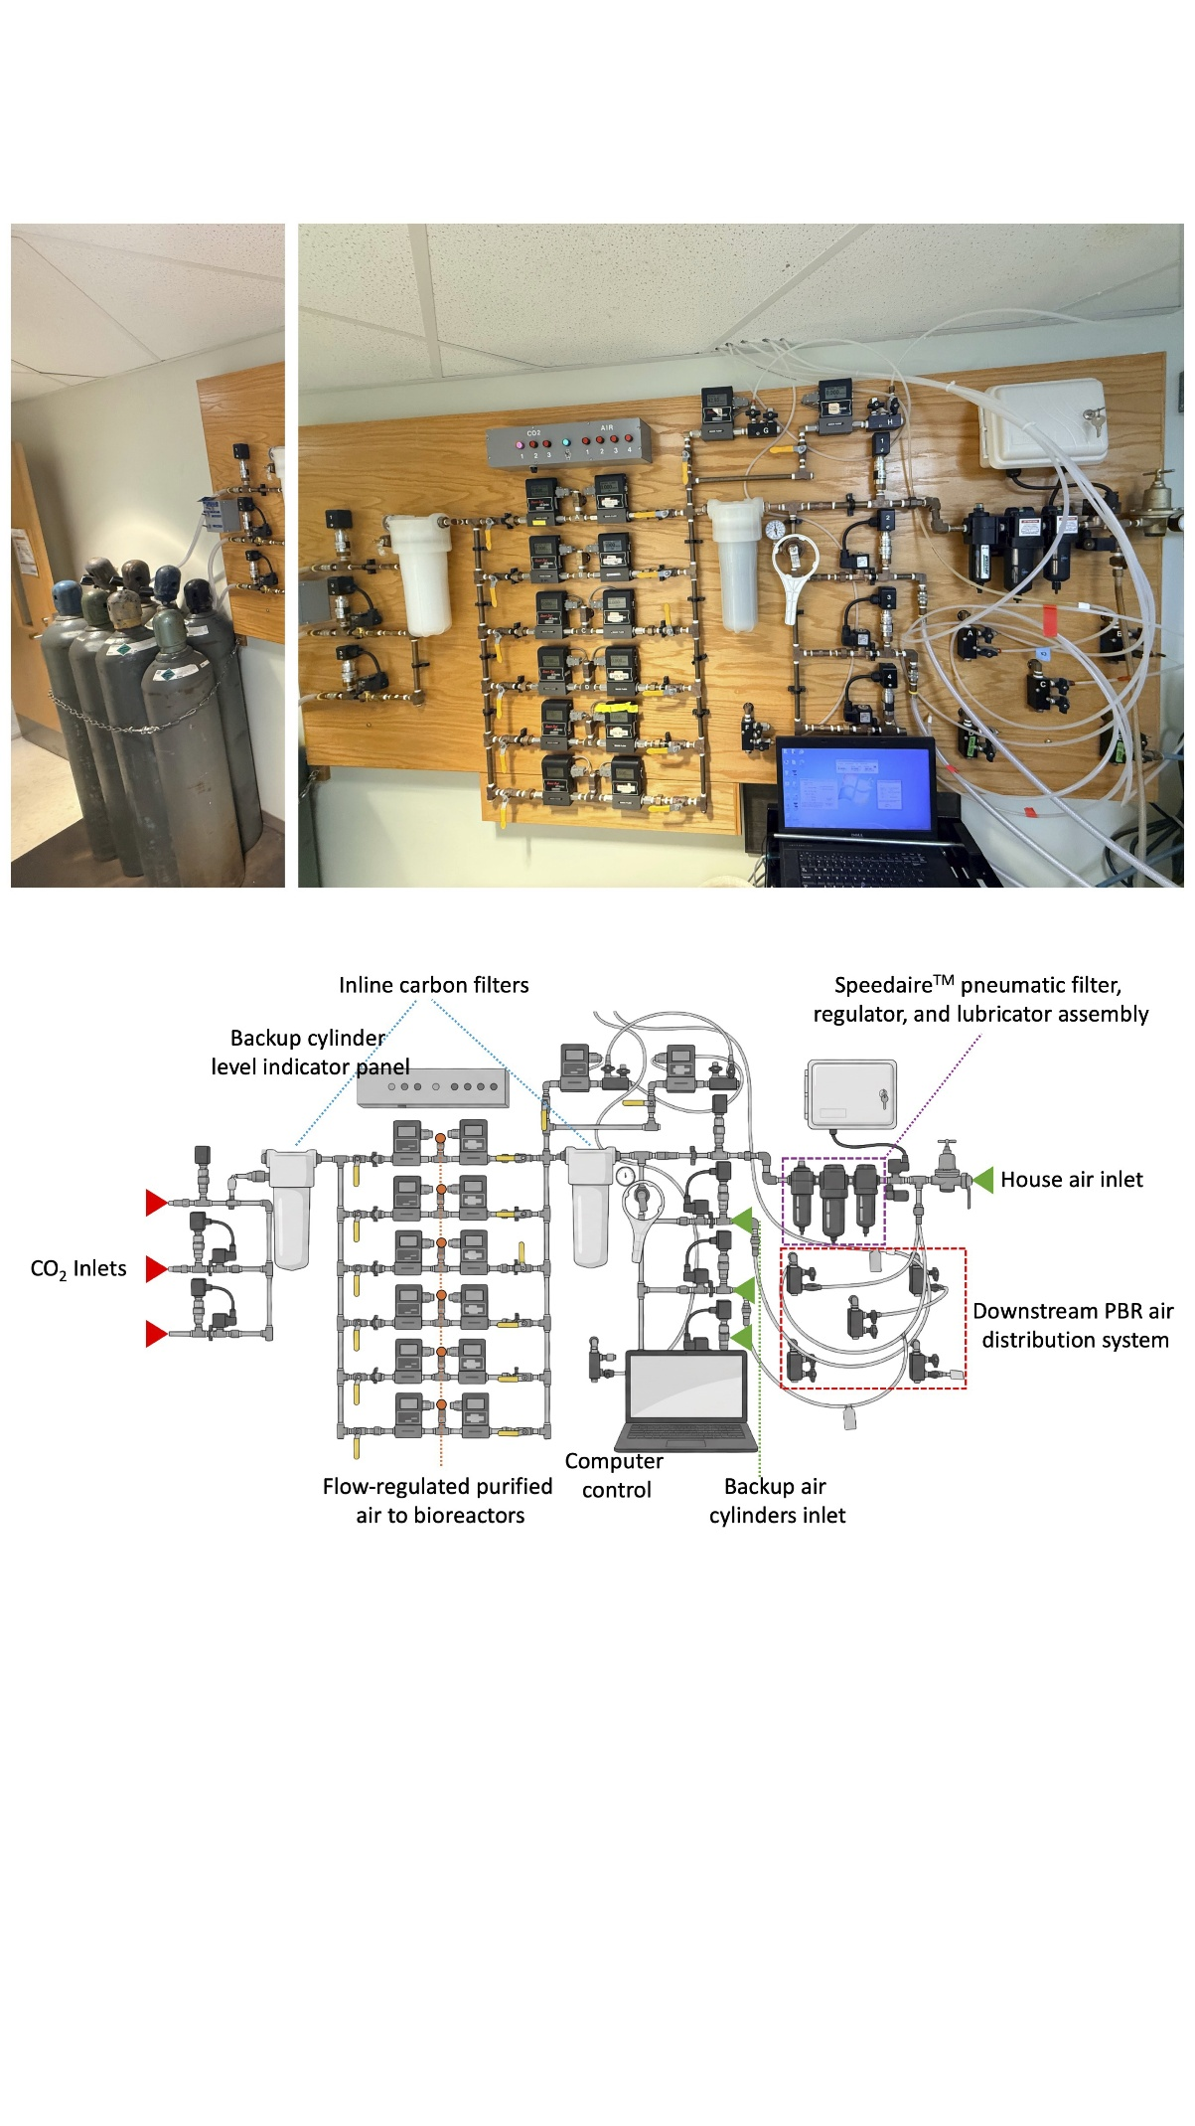

Fig. 1S. Gas delivery system to supply sterilized air to the culture incubators and photobioreactors. Photograph (top) and a diagram (bottom) of in-house air/CO₂ filtration and mixing manifold equipped with digital mass-flow controllers (Sierra Instruments). Extensive set of in-line filters to trap contaminations originating from pipeline and compressors.

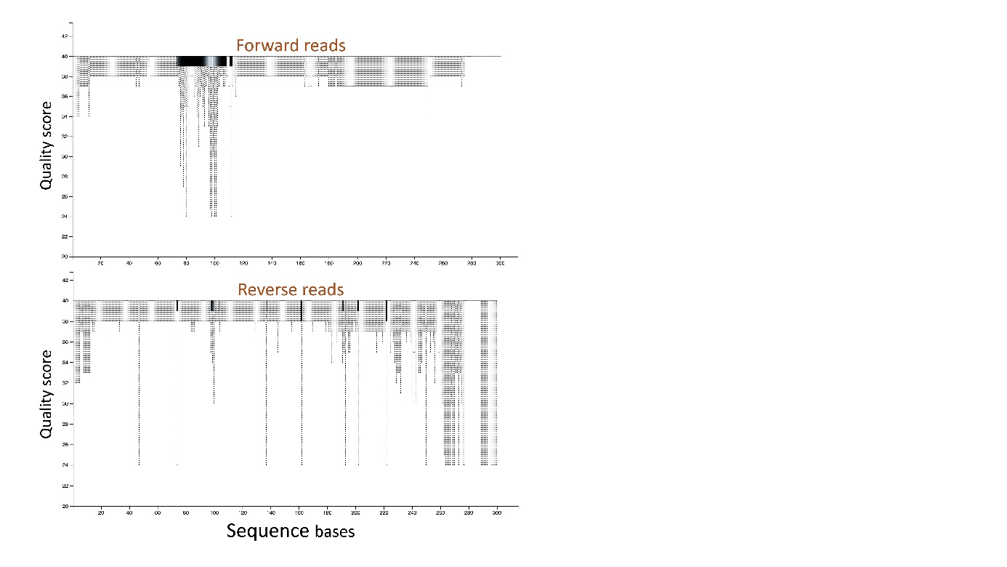

Fig. 2S. Sequence quality post DADA2 demultiplexing. Visualizing sequence quality score. Generated by randomly choosing 10,000 out of 6,523,974 sequences, this analysis was further strengthened by sampling sequences without replacement. Using this workflow, we assessed sequencing output and downstream read retention for each of the 24 libraries prepared. Across all samples, a total of 1,067,603 paired-end reads were recovered after quality filtering, with a minimum maintained quality score of Q32. Following denoising and chimera removal, up to the stage of operational taxonomic unit (OTU) assignment, approximately 852,229 reads were retained. These reads were then used for feature detection, resulting in the identification of 299 total features (OTUs) across the dataset, with a mean feature frequency of 44,854 per sample. These features served as the basis for subsequent taxonomic classification and comparative community analysis. Taken together, these metrics indicate that the libraries were of sufficient quality and sequencing depth to support robust taxonomic profiling. The substantial retention of reads following quality control and denoising further suggests that the library preparation, sequencing, and analytical workflow performed consistently across a diverse set of cyanobacterial samples.

