Supplementary data
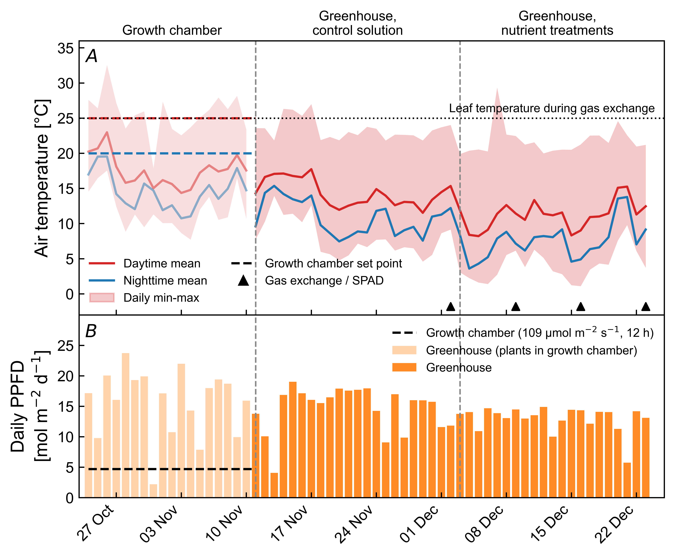
Fig. 1S. (A) Air temperature and (B) daily integrated PPFD from sowing to harvest. In (A), lines show the daytime (red) and nighttime (blue) mean air temperatures, and the shaded area shows the range between the daily minimum and maximum. Triangles indicate the dates of the gas exchange and SPAD measurements, and the dotted line indicates the leaf temperature during the gas exchange measurements (25 °C). From 24 October to 10 November, the seedlings were raised in a growth chamber; dashed lines show its set points (25/20 °C; 109 μmol m^{–2} s^{–1} for 12 h), and the greenhouse data for this period (pale colors) are shown for reference only. Vertical dashed lines indicate transplanting (11 November) and the initiation of nutrient treatments (3 December). Daytime and nighttime were defined as periods with PPFD > 0 and PPFD = 0, respectively.

Fig. 2S. Intercellular CO₂ concentration (C_{i}) measured at a saturating CO₂ concentration (1,200 μmol mol⁻¹). (A–C) Third true leaves (L3) and (D–F) fifth true leaves (L5). In (D–F), values for L3 in the control treatment group are also plotted for comparison. Day 0 after treatment (0 DAT) represents the baseline measurement before treatment initiation. The data points are presented as the means ± SDs (n = 3). Symbols indicate significant differences between the control group and each treatment group on each DAT (* P<0.05; ** P<0.01; and *** P<0.001).

Fig. 3S. Time courses of the electron transport rate (ETR) at 400 μmol mol⁻¹ CO₂ before and after the initiation of nutrient treatments. (A–C) Third true leaves (L3) and (D–F) fifth true leaves (L5). In (D–F), values for L3 in the control treatment group are also plotted for comparison. Day 0 after treatment (0 DAT) represents the baseline measurement before treatment initiation. The data points are presented as the means ± SDs (n = 3). Symbols indicate significant differences between the control group and each treatment group on each DAT (* P<0.05; ** P<0.01; and *** P<0.001).

Fig. 4S. Time courses of the electron transport rate (ETR) at 1,200 μmol mol⁻¹ CO₂ before and after the initiation of nutrient treatments. (A–C) Third true leaves (L3) and (D–F) fifth true leaves (L5). In (D–F), values for L3 in the control treatment group are also plotted for comparison. Day 0 after treatment (0 DAT) represents the baseline measurement before treatment initiation. The data points are presented as the means ± SDs (n = 3). Symbols indicate significant differences between the control group and each treatment group on each DAT (* P<0.05; ** P<0.01; and *** P<0.001).

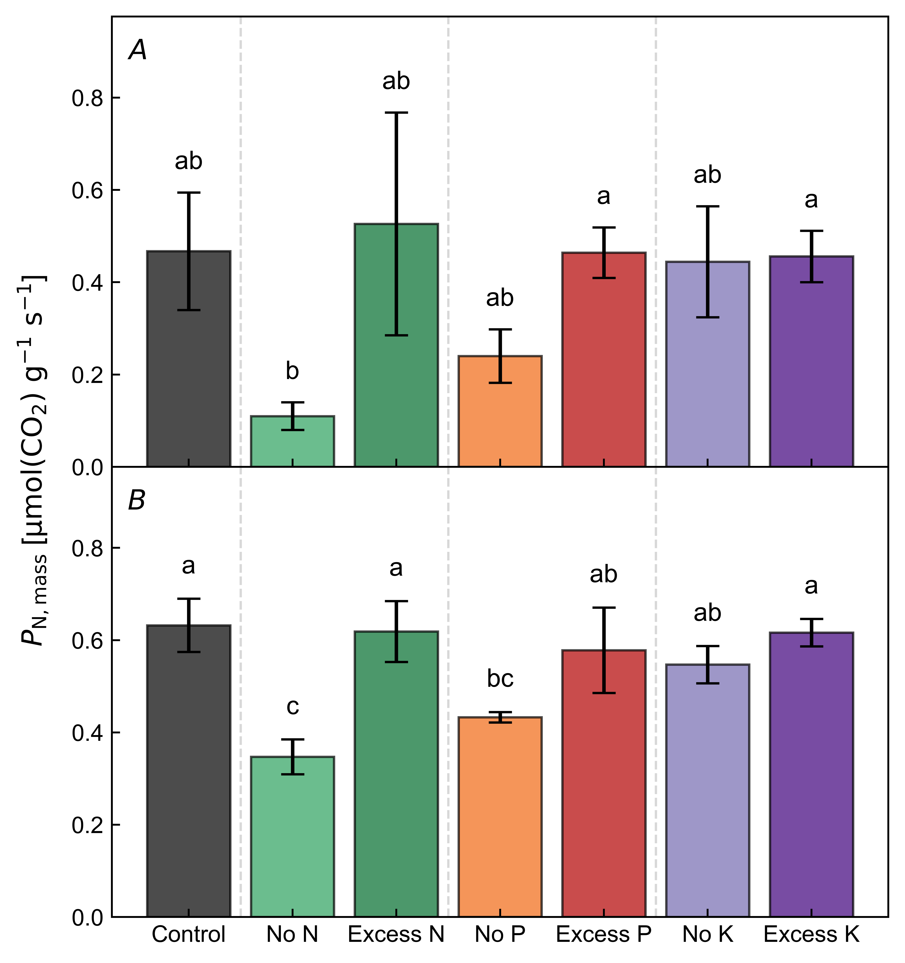
Fig. 5S. The leaf net photosynthetic rate on a dry mass basis (P_{N,mass}) measured at harvest (21 DAT) with a saturating CO₂ concentration (1,200 μmol mol⁻¹). (A) Third true leaves (L3) and (B) fifth true leaves (L5). The values are presented as the means ± SDs (n = 3). Different lowercase letters indicate significant differences among nutrient treatment groups (P<0.05).

Fig. 6S. Time courses of SPAD values before and after the initiation of nutrient treatments. (A–C) Third true leaves (L3) and (D–F) fifth true leaves (L5). In (D–F), values for L3 in the control treatment group are also plotted for comparison. Day 0 after treatment (0 DAT) represents the baseline measurement before treatment initiation. The data points represent the means ± SDs (n = 3). Symbols indicate significant differences between the control group and each treatment group on each DAT (* P<0.05; ** P<0.01; and *** P<0.001).

